**GANDHI SQUARE**

The Gandhi Corner in our library is a dedicated space honouring Mahatma Gandhi's life and philosophy. It offers a collection of books, photos, and quotes that highlight his principles of non-violence, truth, and simplicity. This corner inspires readers to reflect on Gandhi’s enduring impact on peace and justice worldwide.

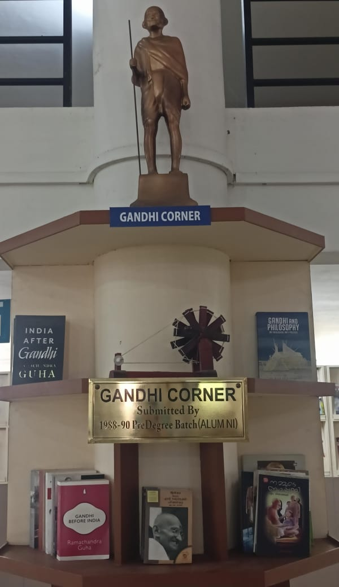

**Academic Chairs**

MES Keveeyam College Valanchery with the mission to contribute to society through the pursuit of education, learning and research at the highest levels of excellence envisages becoming a foremost centre of advanced learning fostering all-round academic excellence along with core human values. To promote scholastic studies and uphold the values defended by the three great visionaries, Dr. P.K Abdul Gafoor, Dr. N.K Mohammed and Sri. N. Damodharan, Academic chairs have been constituted in their names.

<https://meskeveeyamcollege.ac.in/Home/AcademicChairs/Academic%20Chairs>

**Dr. P K Abdul Gafoor Chair for promotion of Secular Values**

P. K. Abdul Gafoor was the founder President of Muslim Educational Society (MES) and one of the pioneers of education amongst the Muslim community in Kerala. He was a medical doctor by profession and served as a Professor of Medicine at Calicut Medical College. In 1964, Dr. Abdul Gafoor and a group of young educated Muslims established MES at Calicut, with the objective of cultural, educational and economic upliftment of Muslims. The glorious vision of the ‘Dr. P K Abdul Gafoor Chair for the promotion of secular values is to honour the contributions of the great leader towards the educational development of backward communities and for appraising his ideology of secular values throughout his life. The objectives are to act as a forum for discussion on contemporary issues threatening the concept of secularism; conduct lectures and seminars on issues related to protection of secular values in India; and to honour people and organizations working towards the protection of secular values.

<https://meskeveeyamcollege.ac.in/Home/AcademicChairs/Dr.P%20K%20Abdul%20Gafoor%20Chair/2363>

**Dr. N. K. Muhammed Chair for promotion of value based higher education**

It was the long and concerted efforts of the local population under the visionary leadership of Dr. N. K. Mohammed, the first practitioner of modern medicine in this locality, among others and involvement of Muslim Educational Society, which consummated in the establishment of MES Keveeyam College Valanchery in 1981. He was affectionately called as the ‘Doctor’ by the local people. The vision of Dr. N K Muhammed Chair is to honour the contributions of the great soul in the educational development of the region. The objectives are to conduct lectures, seminars and workshops on value- based higher education by inviting eminent personalities; to act as a forum for discussion on improvement of quality higher education and to provide scholarship for financially backward students pursuing research in premier institutes in India.

<https://meskeveeyamcollege.ac.in/Home/AcademicChairs/Dr.N%20K%20Muhammed%20Chair/2364>

**N. Damodaran Chair for Humanistic Studies**

N. Damodaran was an eminent follower of the great philosopher, MN Roy. He was one of the great humanists in Kerala who inspired a generation through his thoughts and deeds. He wrote many books and articles of which *M. N. Roy: Satyanweshiyaya Viplavakari* won the Kerala Sahitya Academy Award in 1990. The academic chair envisions a platform for studies on his humanistic thoughts for post graduate and research students.

[https://meskeveeyamcollege.ac.in/Home/AcademicChairs/N.Damodaran%20Chair/2365](link.docx)