OUR INITIATIVES IN PROVIDING INCLUSIVE ENVIRONMENT

SL. NO | PROGRAMME | DATE
1 | ENVIRONMENT DAY | 6/6/2022
2 | NATIONAL READING DAY | 20/6/2022
3 | EID FEST | 7/7/2022
4 | INDEPENDENCE DAY CELEBRATION | 15/8/2022
5 | ONAM CELEBRATION | 31/8/2022
6 | CHILDRENS DAY CELEBRATION | 14/9/2022
7 | WORLD CUP FOOTBALL FEST | 18/9/2022
8 | LAHAK KEVEEYAM FEST | 15/12/2022
9 | DATAK | 16/12/2022
10 | X -MAS CELEBRATION | 22/12/2022
11 | KALA JADHA | 25/1/2023
12 | REPUBLIC DAY CELEBRATION | 26/1/2023
13 | RANGOLI FEST | 30/1/2023
14 | THAKADHIMI - ART FEST | 31/1/2023
15 | HOLI CELEBRATION | 22/3/2023

ENVIRONMENT DAY

Environment Day was observed grandly in the college. Students of various departments took part in the celebration with great enthusiasm.
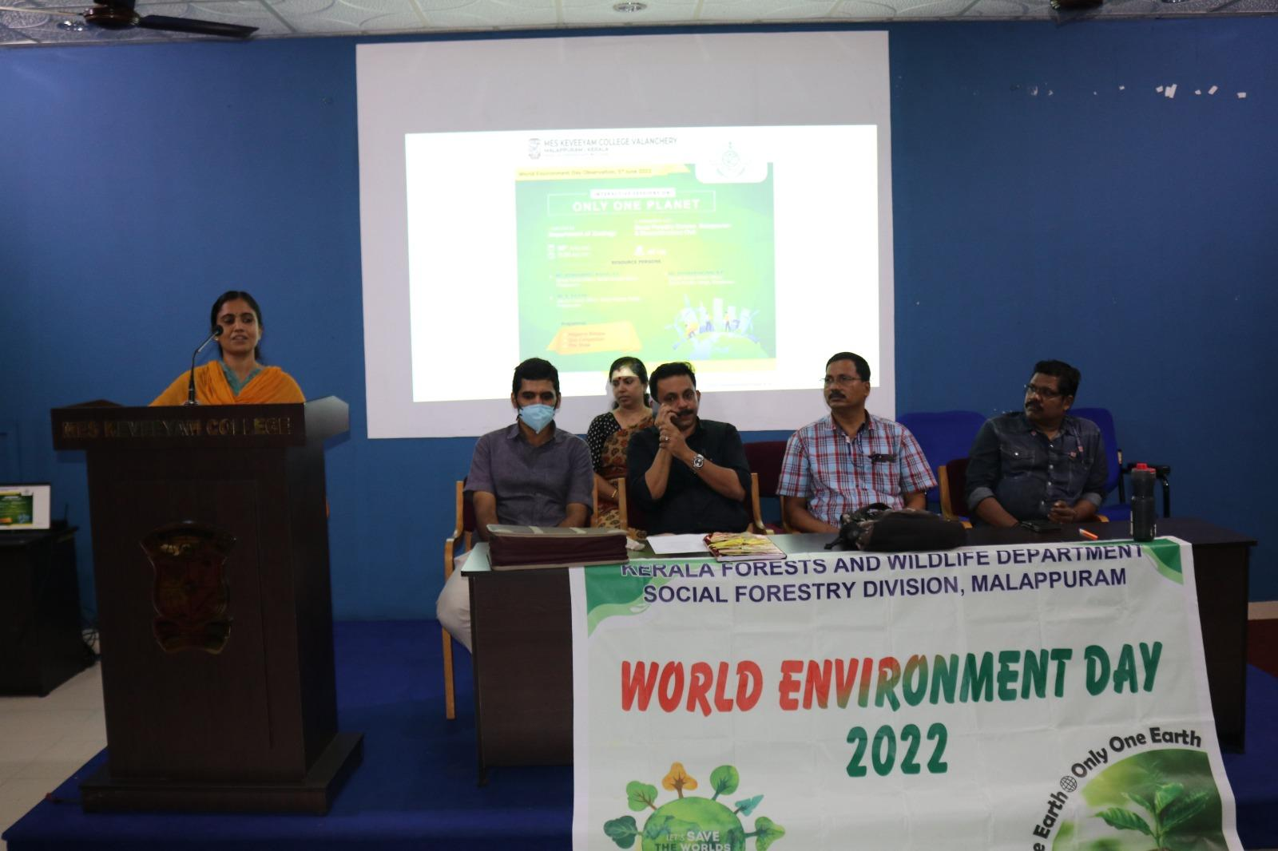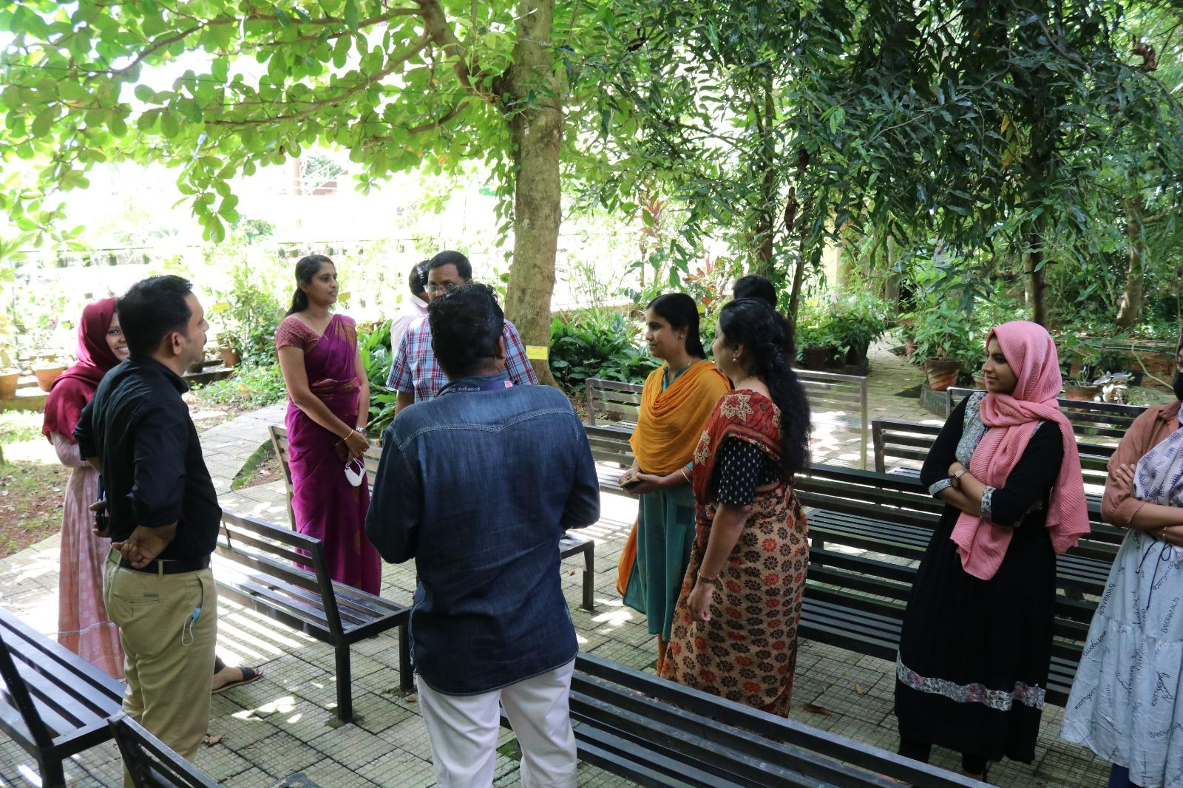

NATIONAL READING DAY

MES KEVEEYAM COLLEGE, Valanchery celebrated READING DAY under the joint auspices of language development. The event was inaugurated by Umar O Thasneem, Assistant Professor, Department of English, University of Calicut.

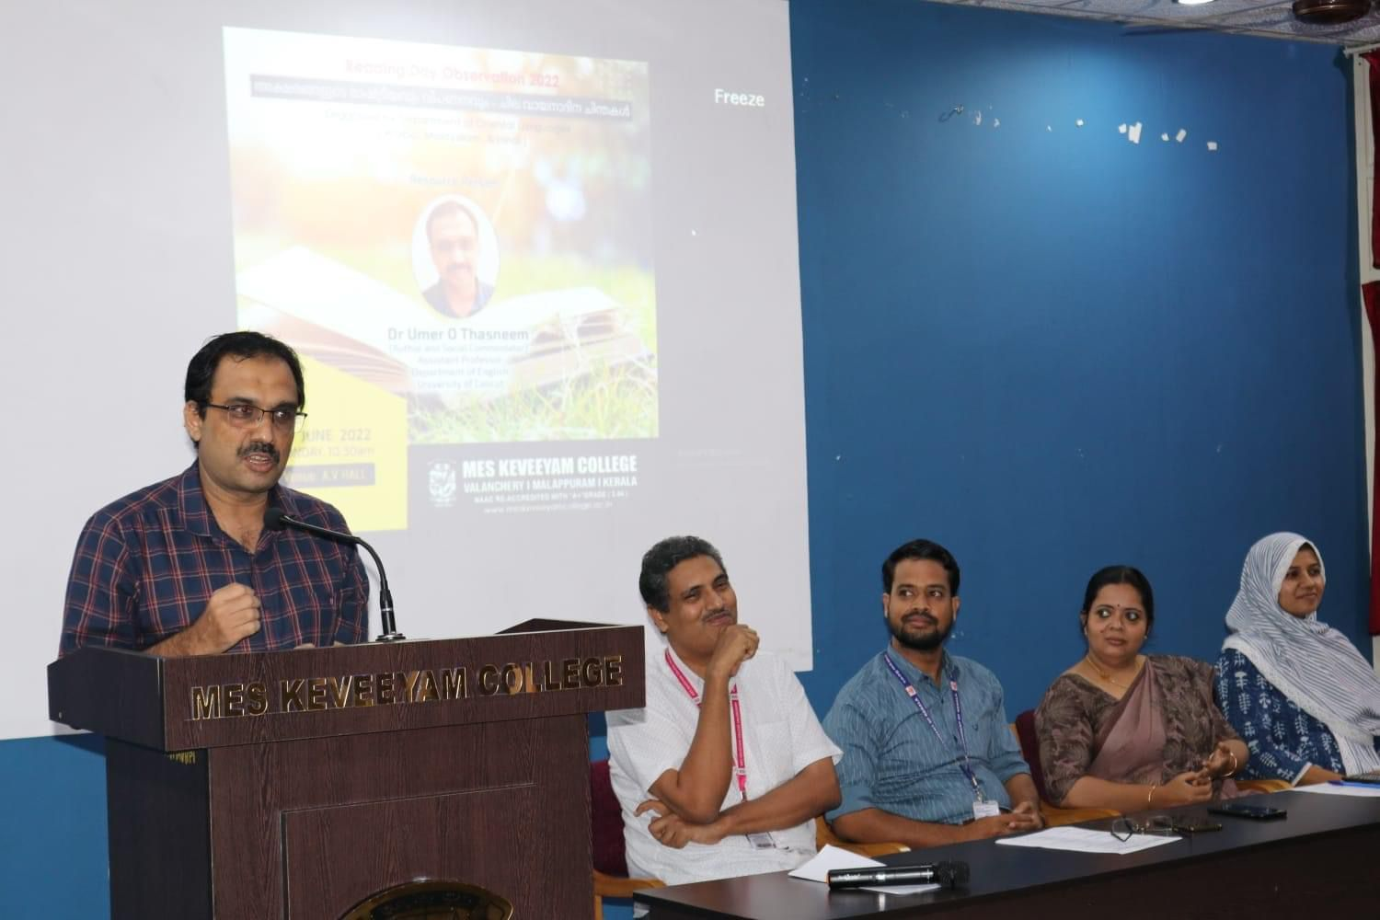
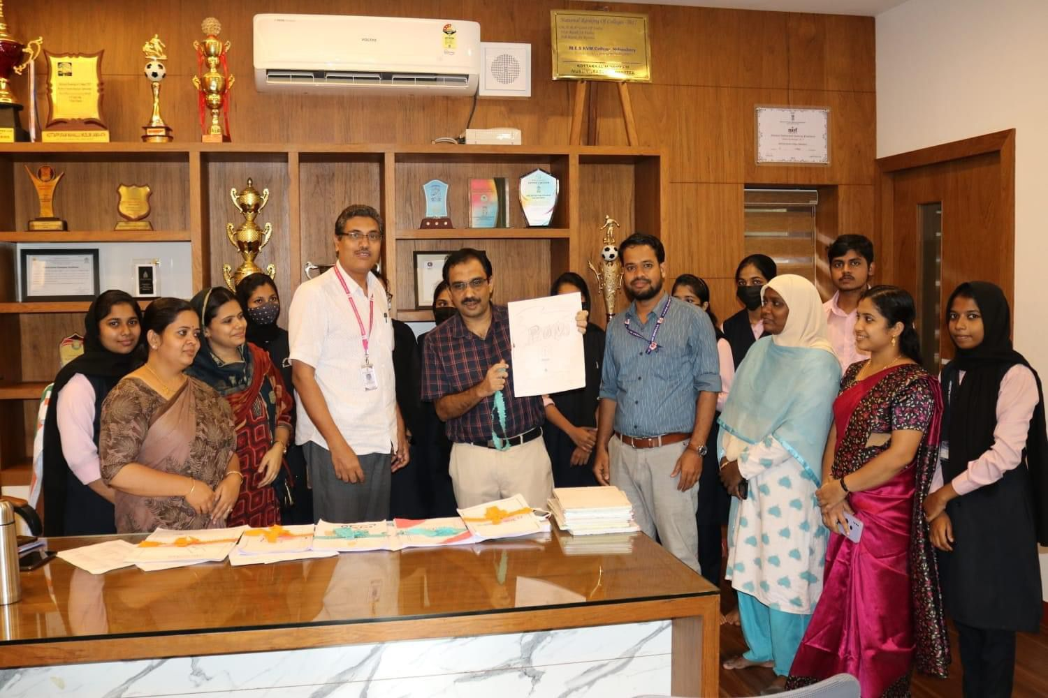

EID FEST

The college celebrated EID with great grandeur, and the event was conducted in a very festive manner. Everyone participated wholeheartedly, making the occasion joyful and memorable.

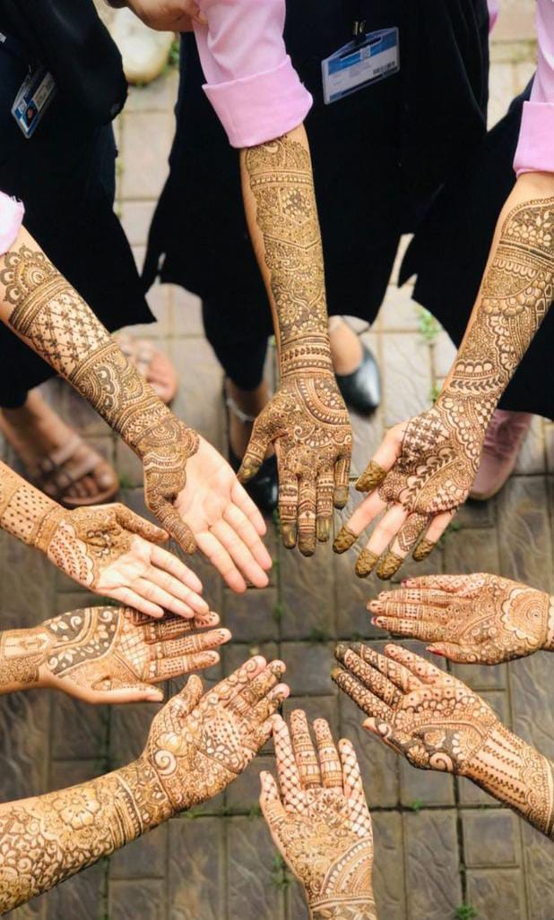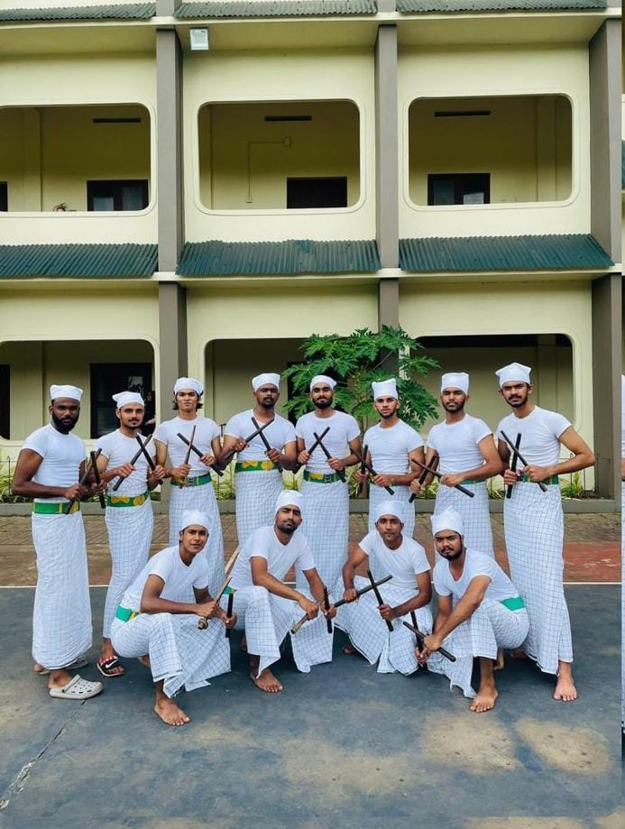

INDEPENDENCE DAY CELEBRATION

The 76th Independence Day was celebrated with great enthusiasm at college. The event included speeches and flag hoisting to honor the country's freedom fighters. Faculty, students and staff participated actively, making the event memorable.

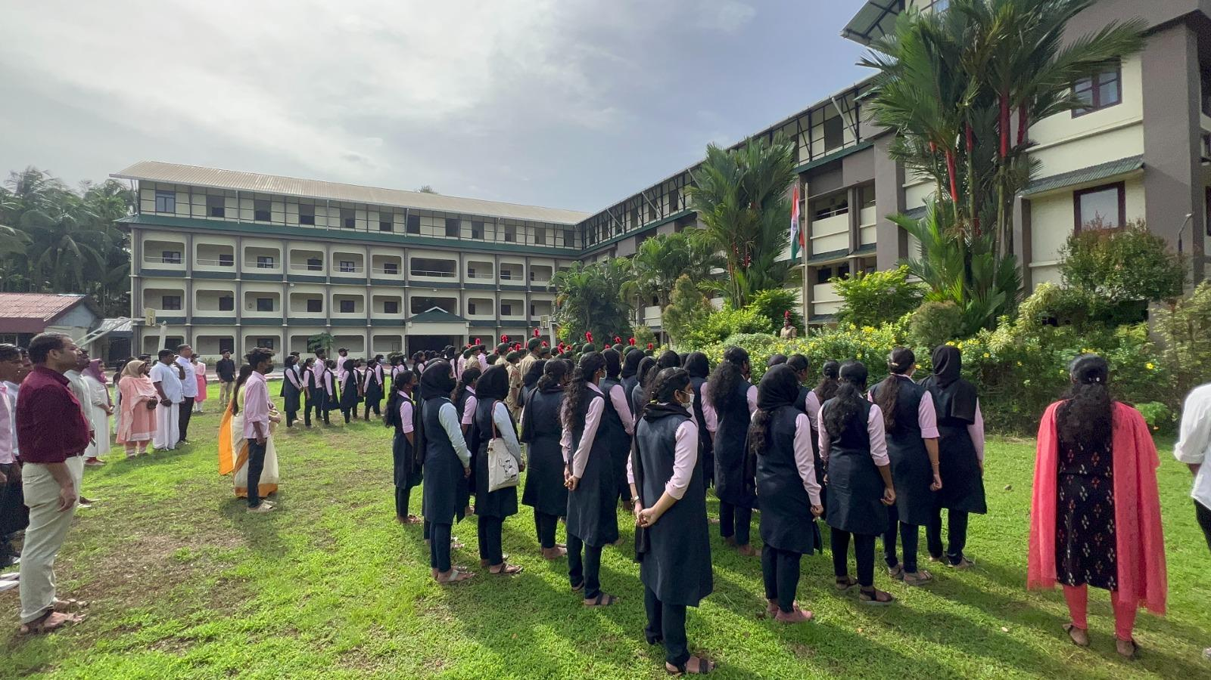

ONAM CELEBRATION 2022

On August 31, 2022 the college campus celebrated Onam in splendid manner. The students organized various programs, showcasing their talents and enthusiasm. The festivities included traditional and cultural events creating a vibrant and joyful atmosphere on the campus.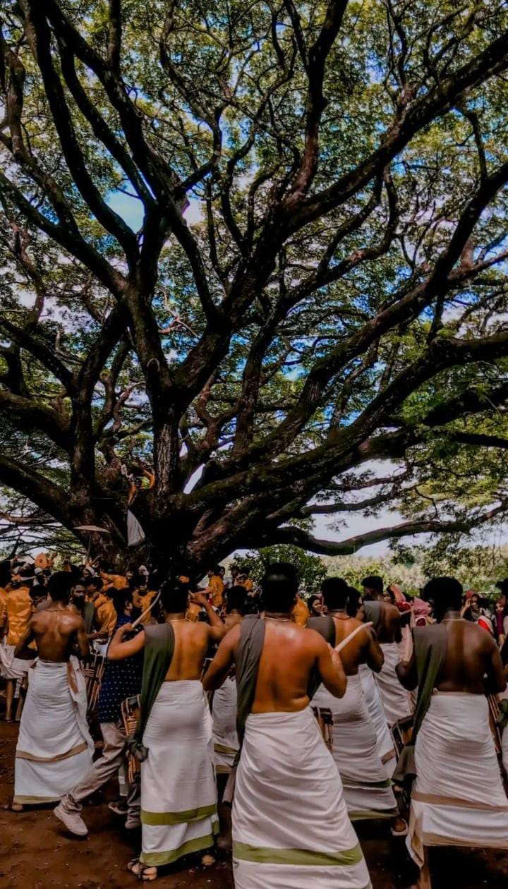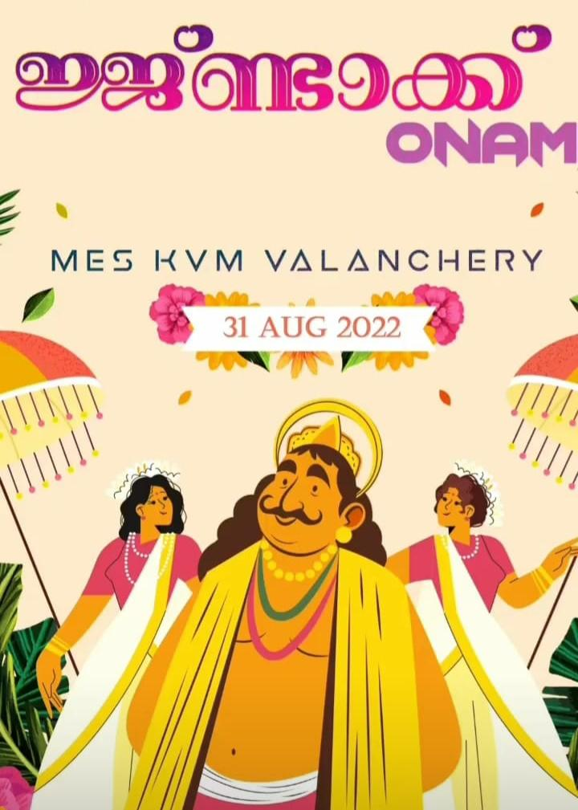
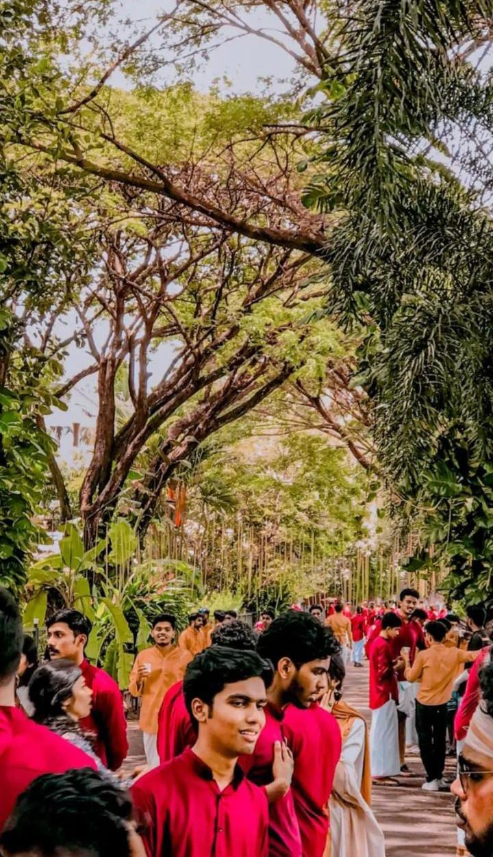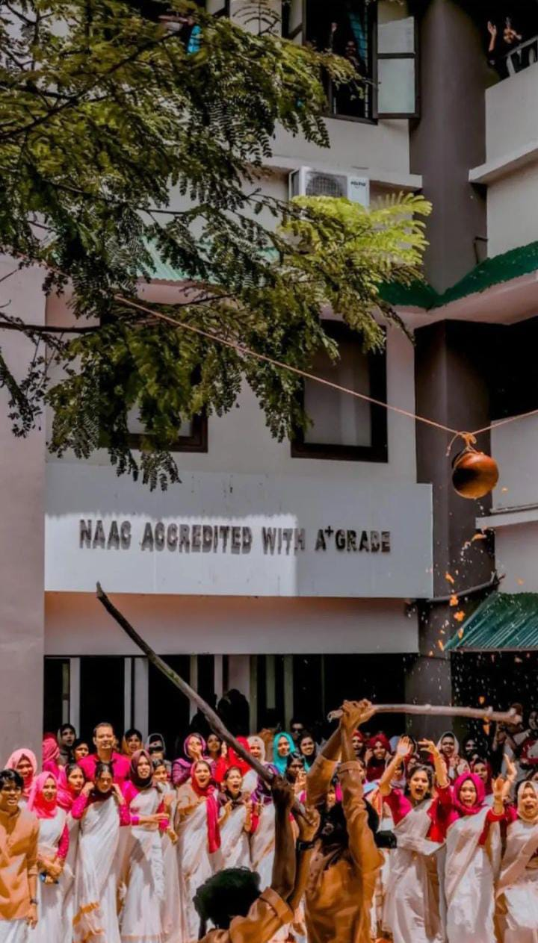

CHILDRENS DAY CELEBRATION

In connection with Children's Day, celebrations were held with sweets and joyful activities along with the children at the Anganwadi in Valanchery.

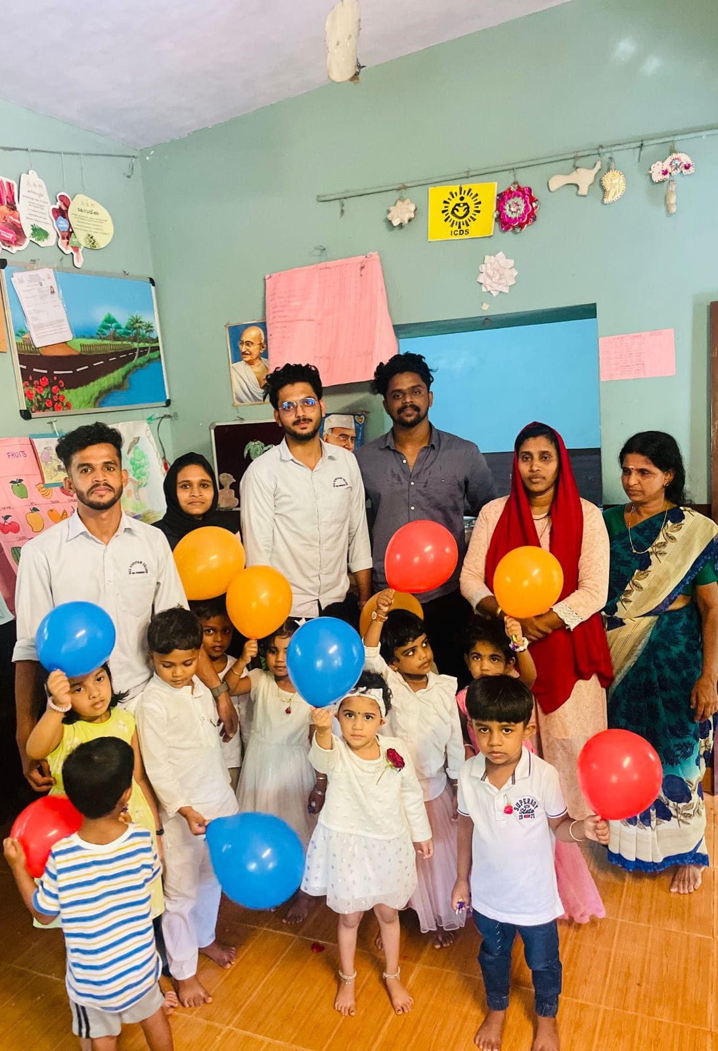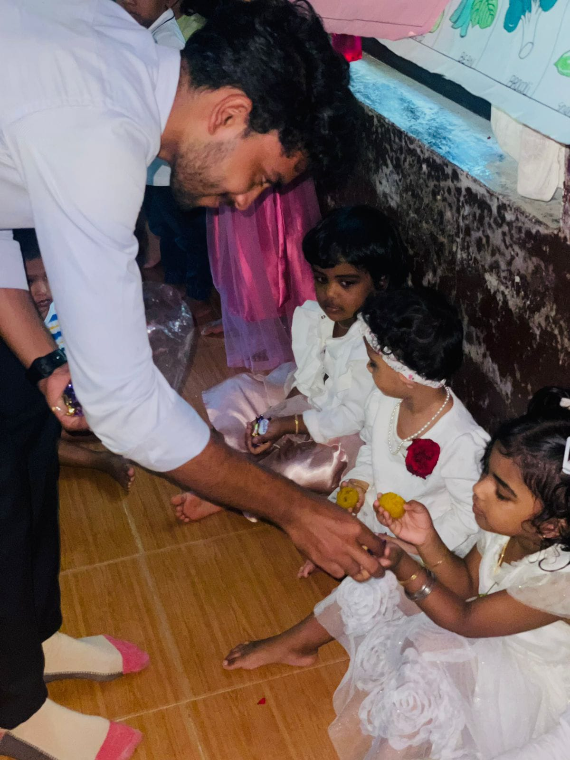

WORLD CUP FEST

In connection with the 2022 FIFA WORLD CUP, students held a fan meeting wearing jerseys of various countries participating in the world cup. As a part of the event various competitions were held .

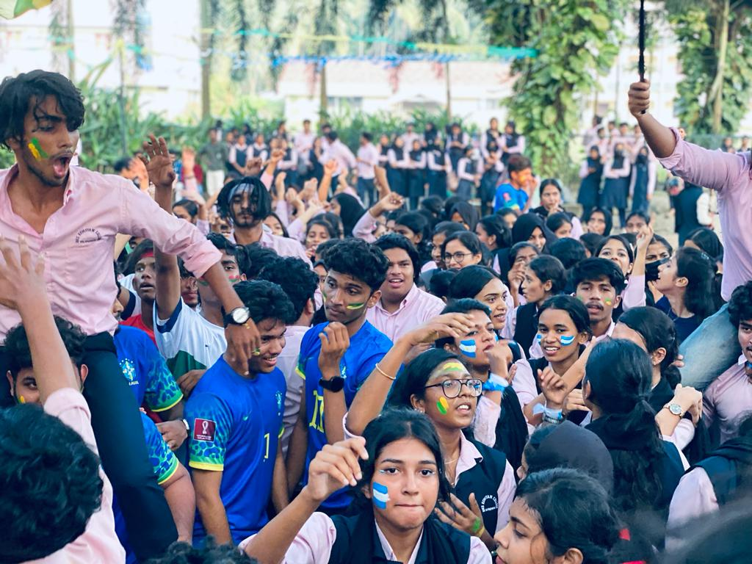
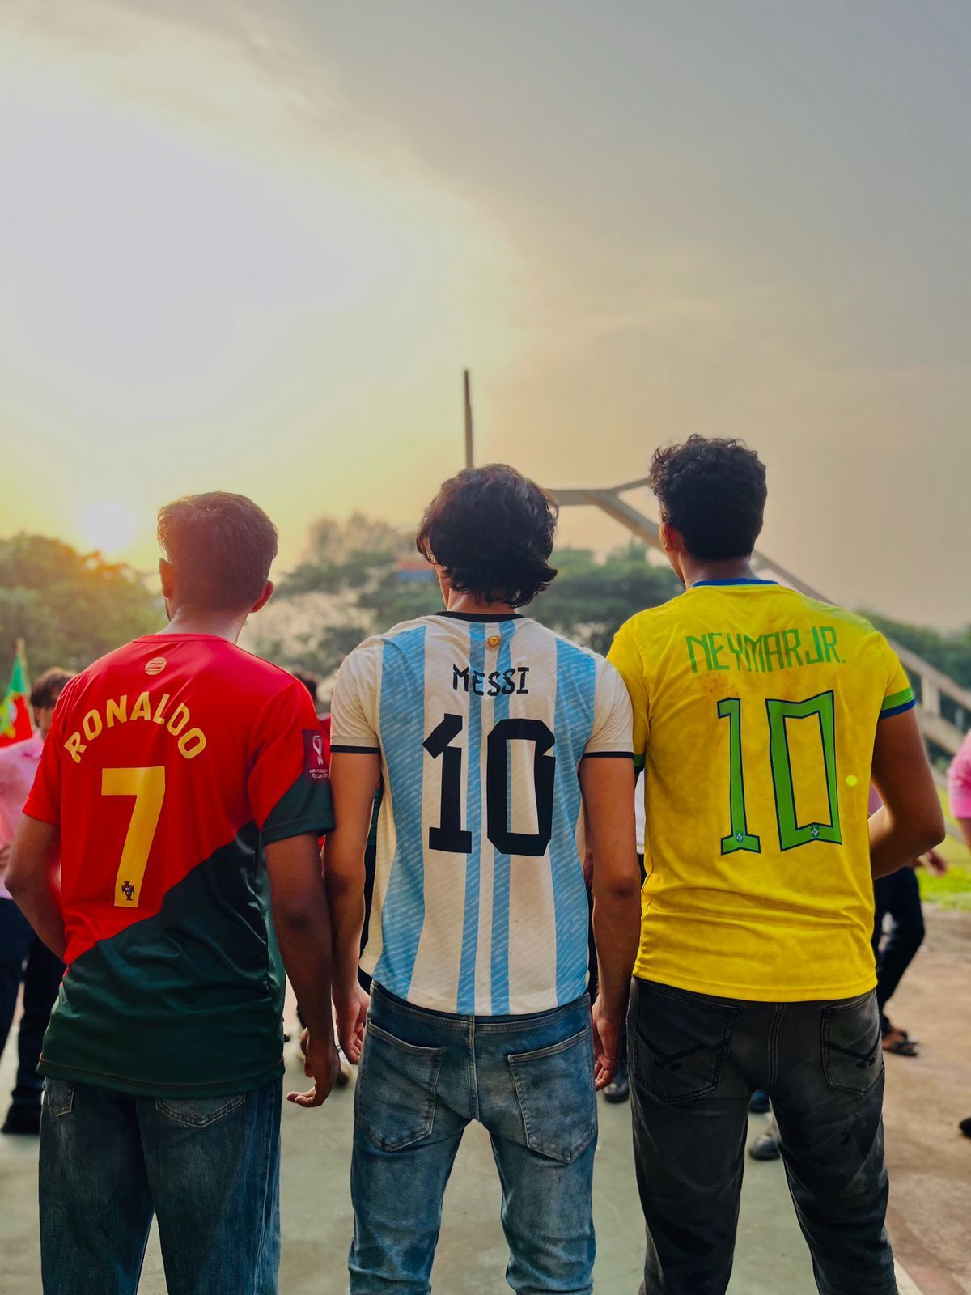
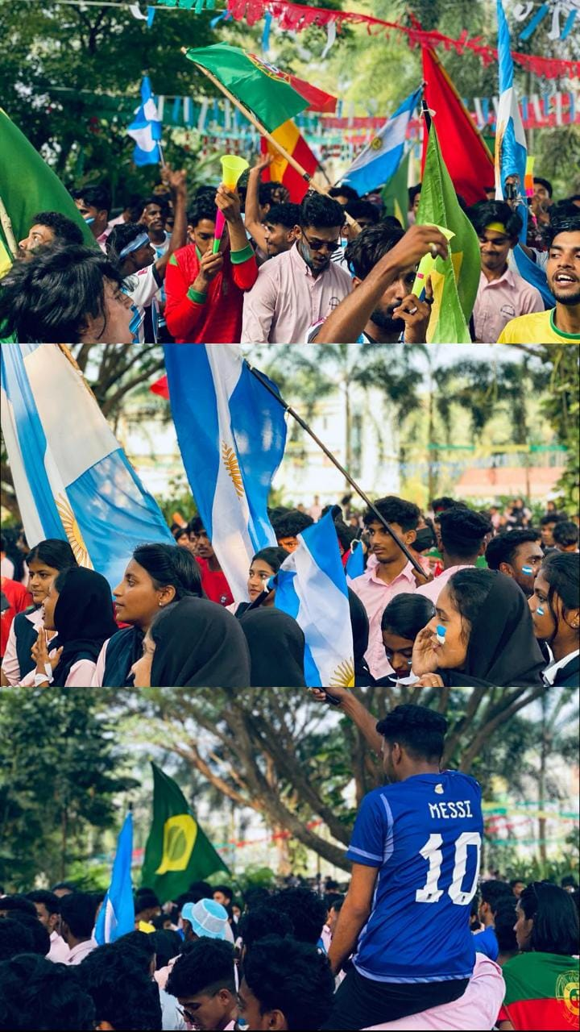

LAHAK KEVEEYAM FEST

In connection with the LAHAK FEST, a food fest was organized by the college union, focusing on the various tastes and flavors of chicken dishes in different cultures. It gave the students a new experience to students. It also brought a variety of different.

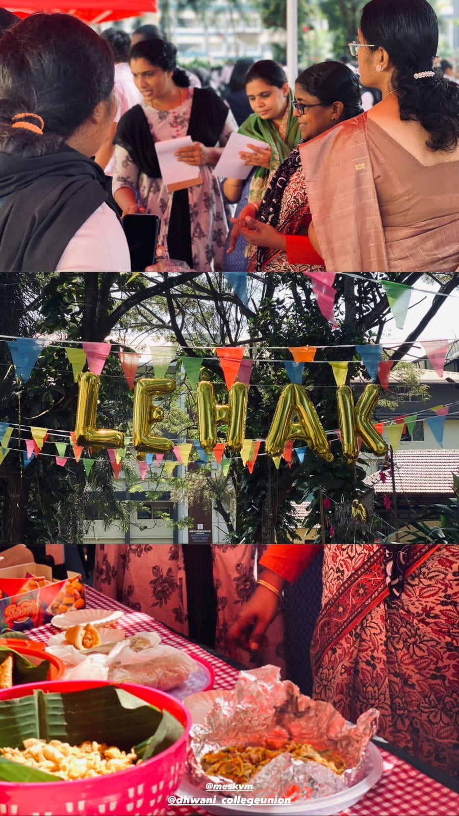
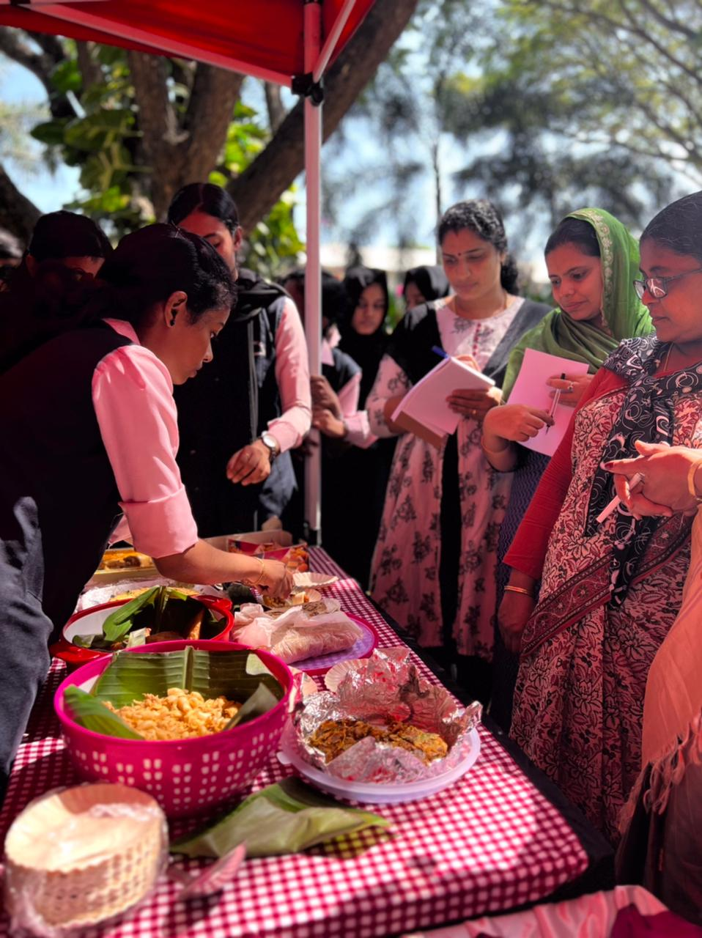

DATAK

A program named “star singer of Keveeyam” was organized to provide an opportunity for showcasing and recognizing the musical talents of the college. Social media stars performed songs at the event.

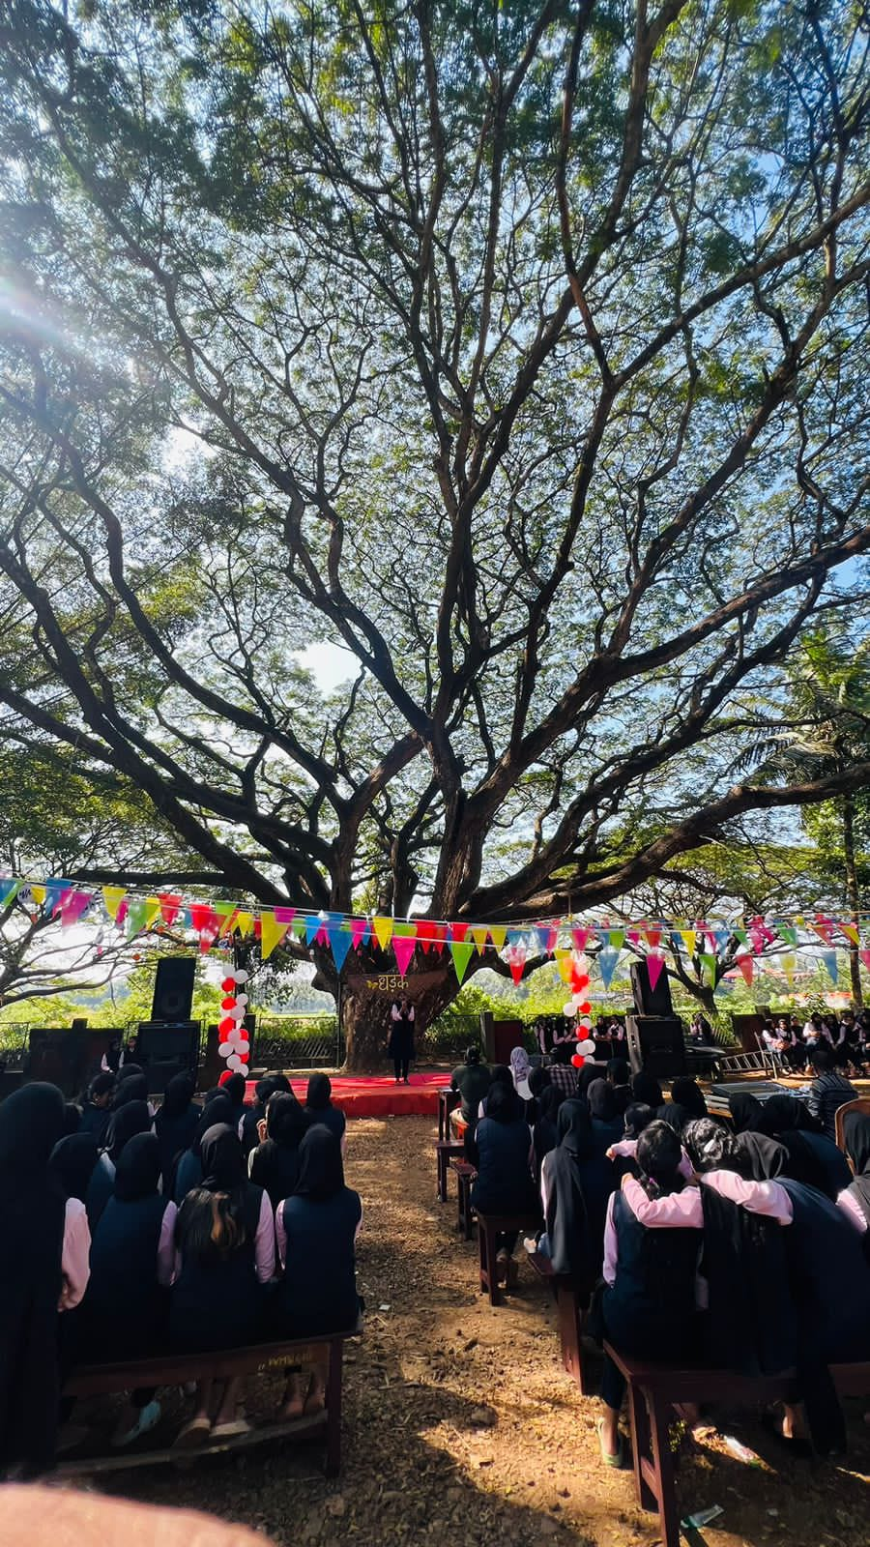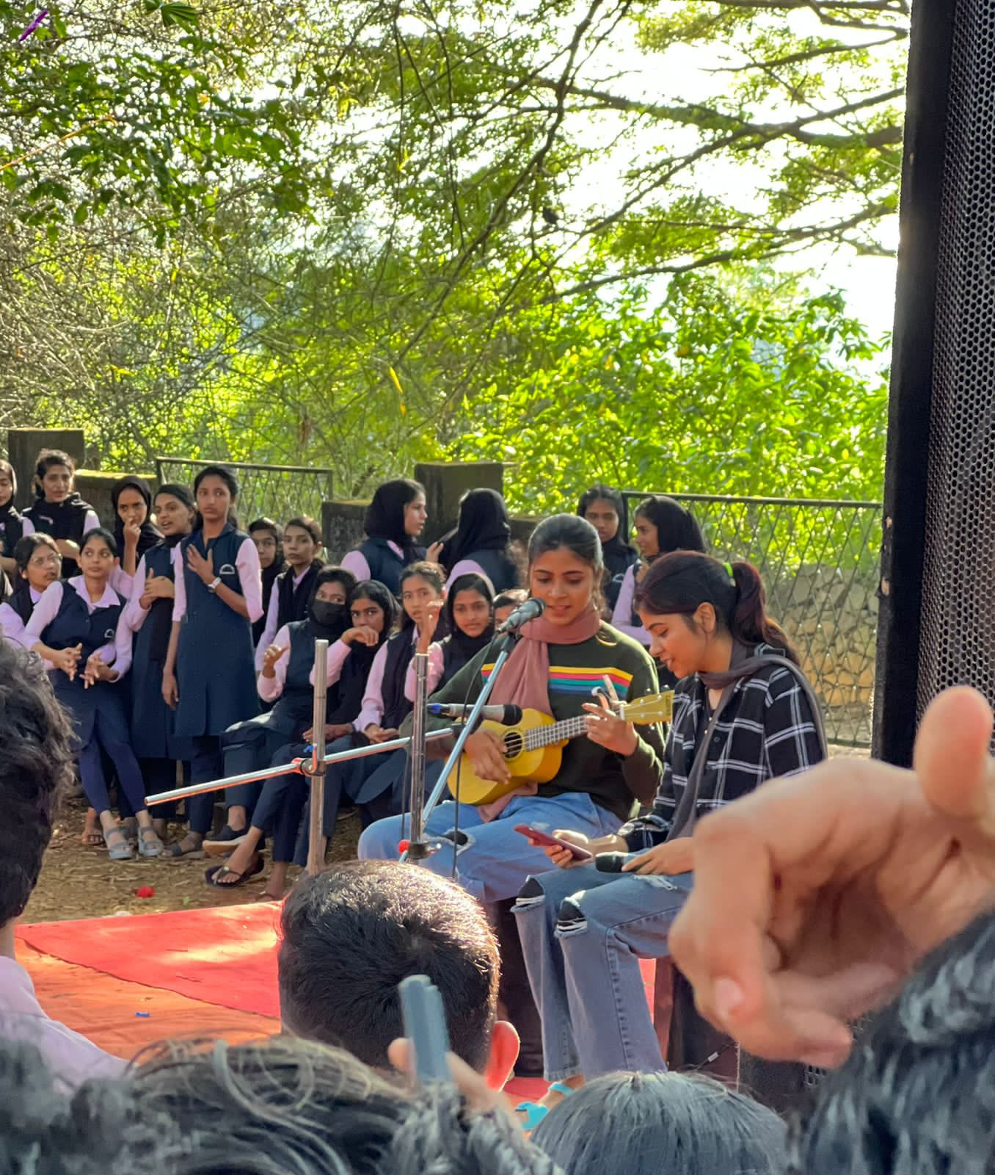
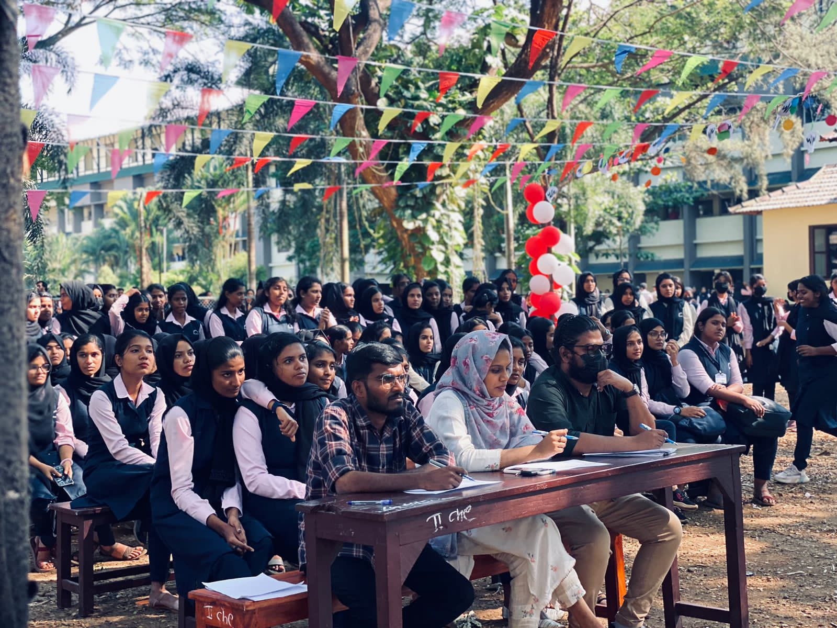

CHRISTMAS CELEBRATION

The college celebrated Christmas with enthusiasm, performing events like Carol singing, crib making contests and other festive games. The beautifully decorated campus created a joyful atmosphere, ending with a special Christmas feast

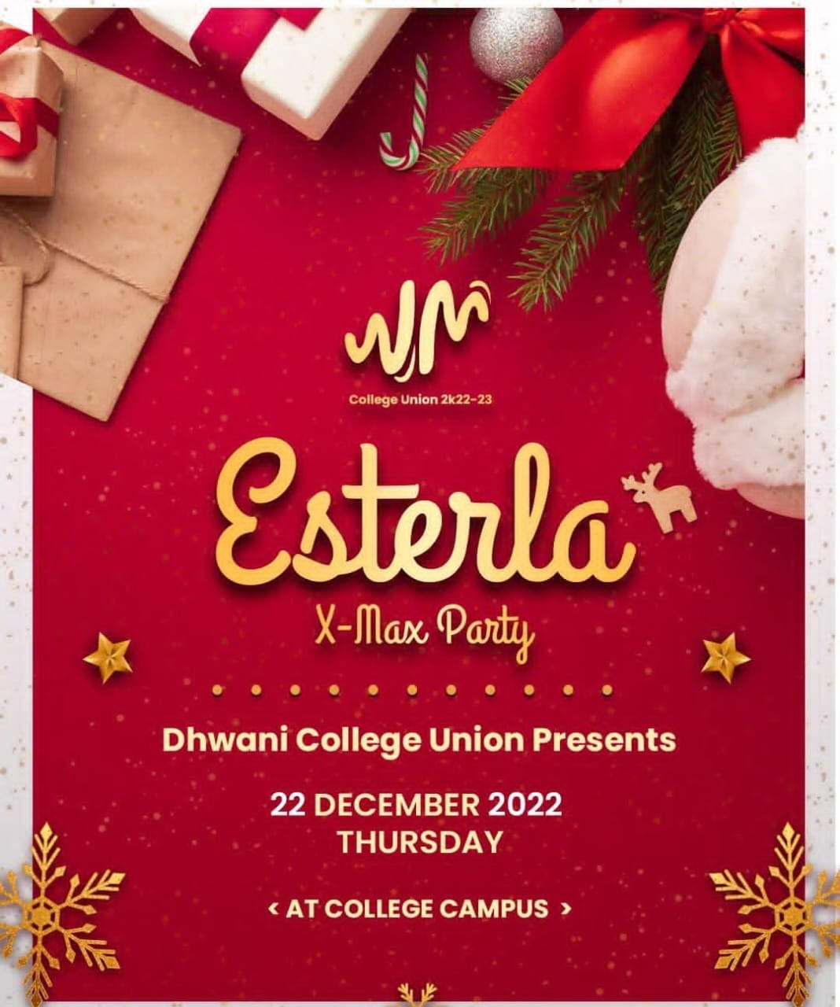
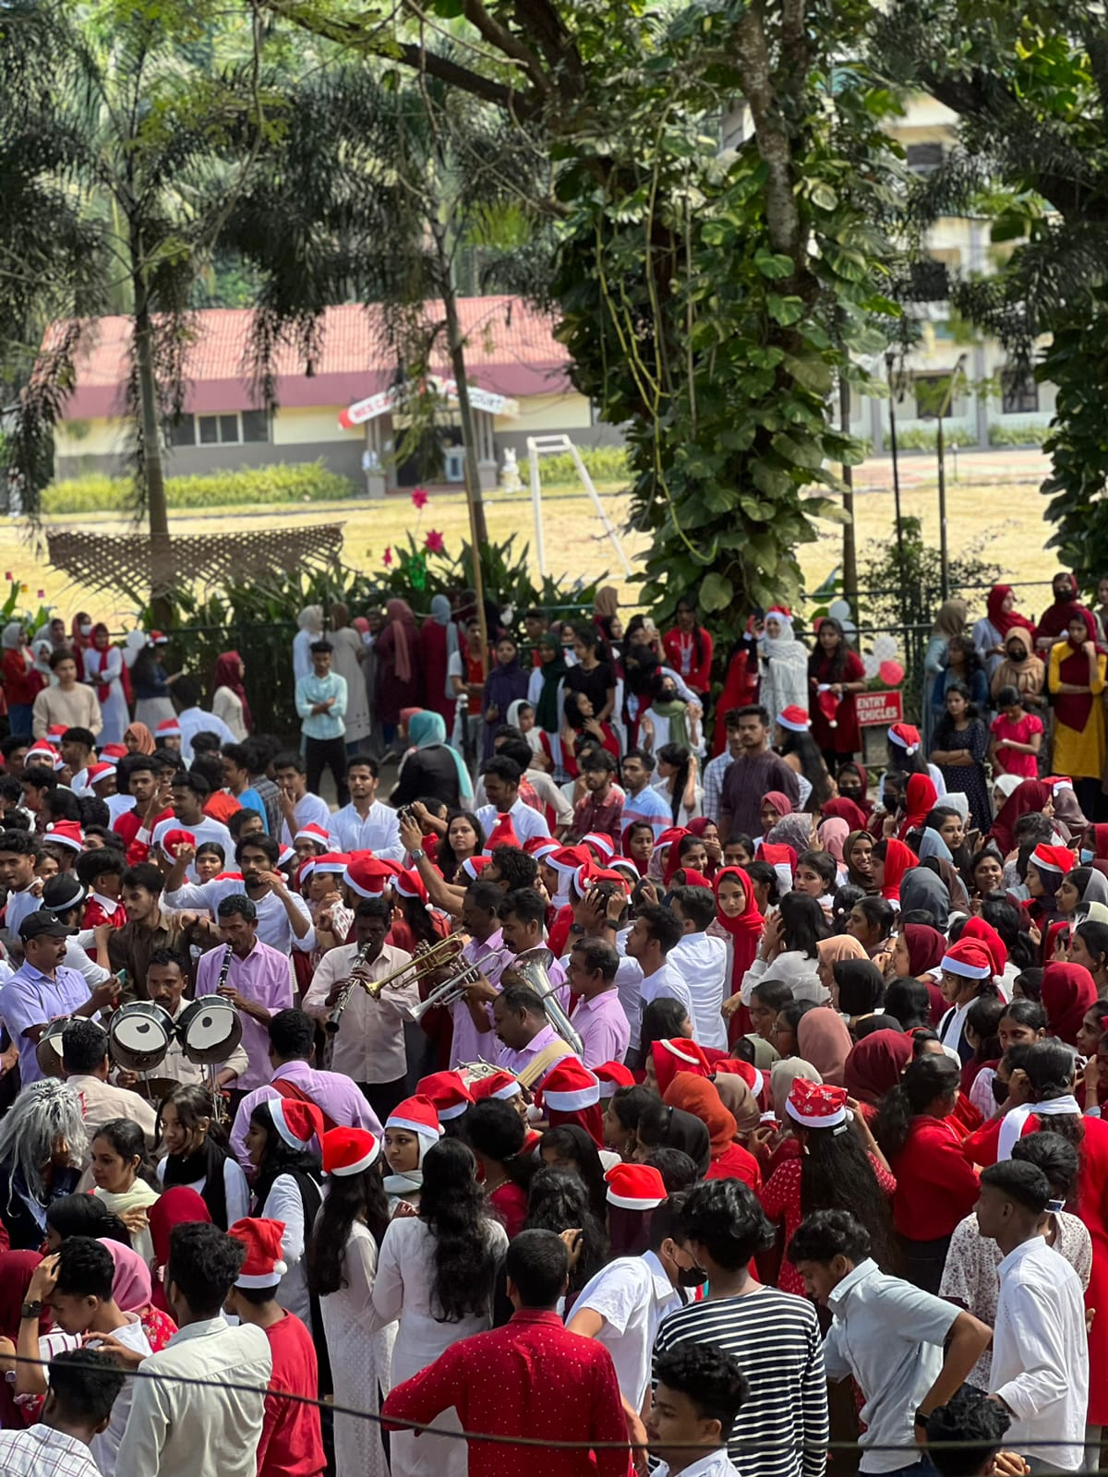

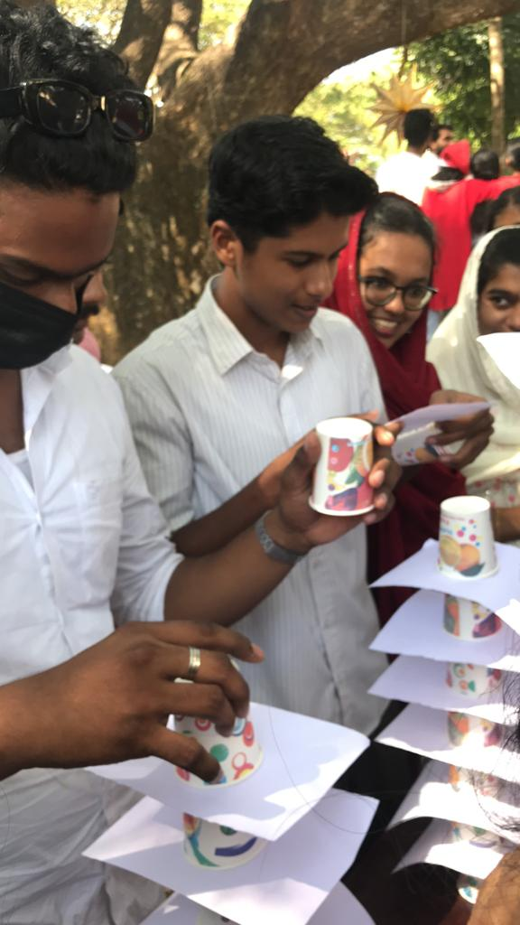
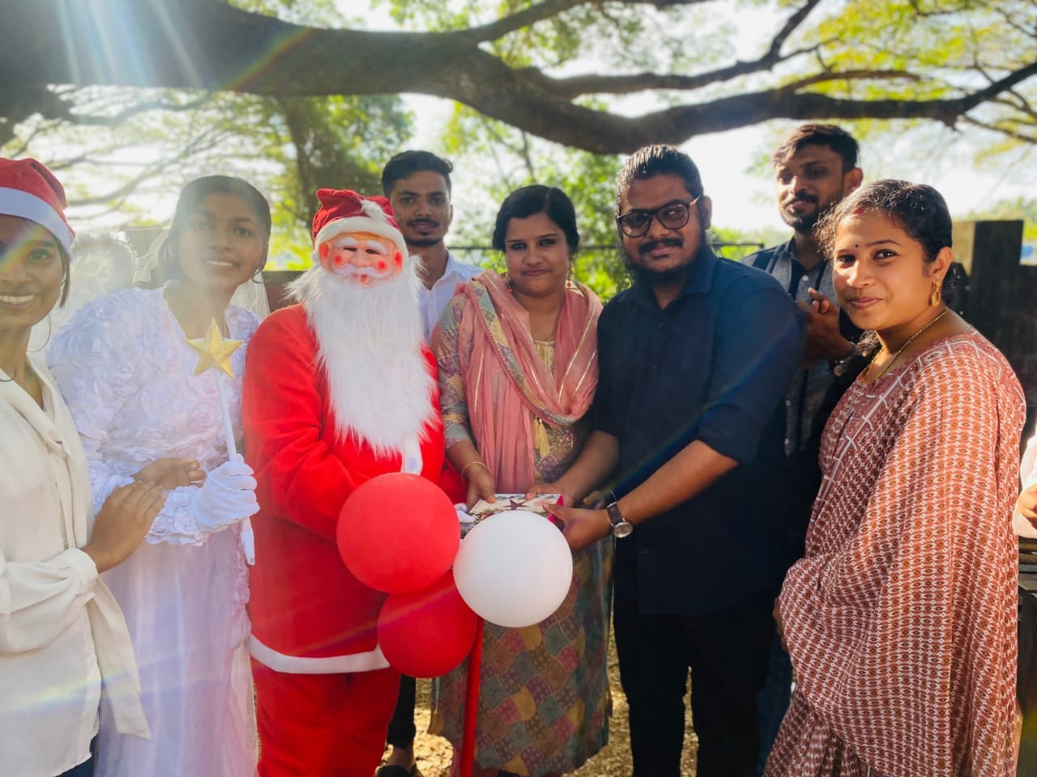

KALA JADHA

Under the college union, a cultural procession was organized with the participation of all departments of the college, showcasing the diverse cultures and art forms of various states of India.

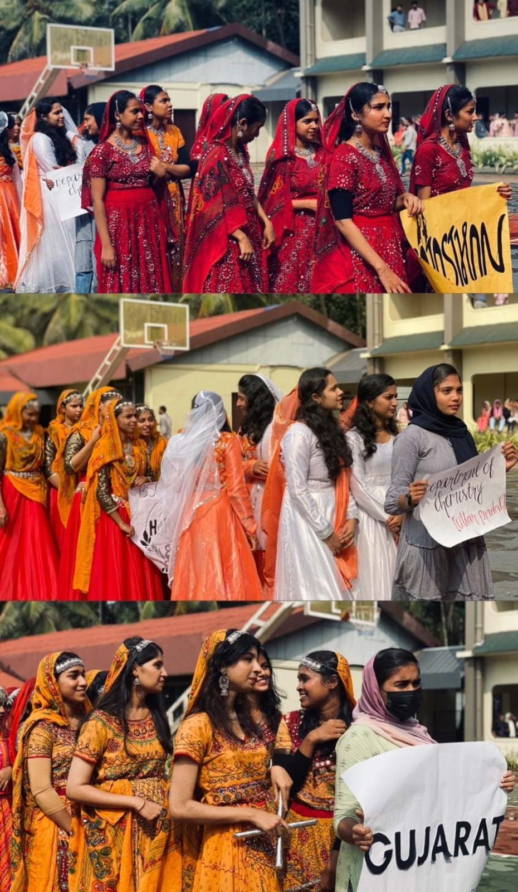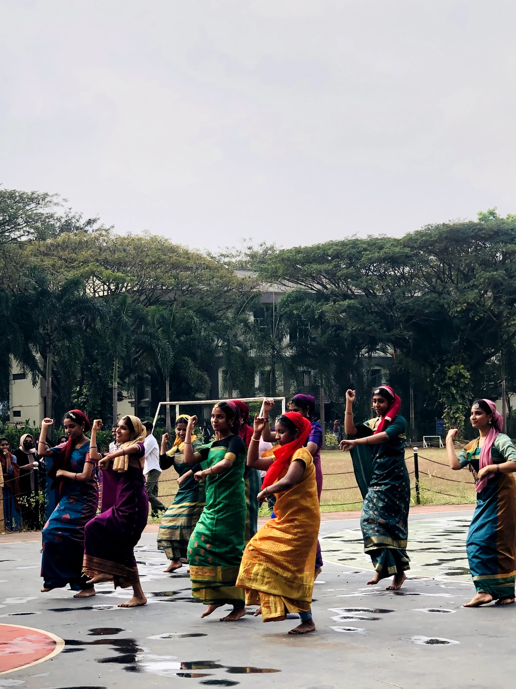

REPUBLIC DAY CELEBRATION

The 74th REPUBLIC DAY CELEBRATION featured flag hoisting and a speech emphasizing national unity, heritage and constitutional values.

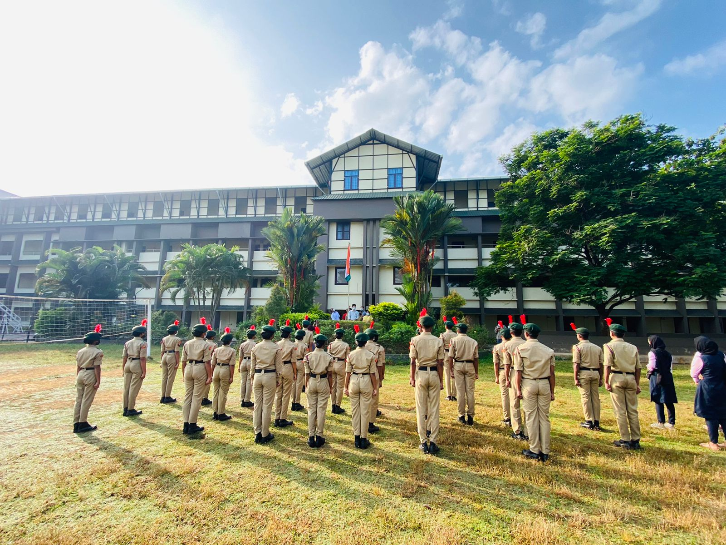

RANGOLI FEST

A Rangoli competition was organized in the college. Many students took part in it. They showed took part in it. They showed great creativity and effort. The event was filled with excitement and enthusiasm from all participants.

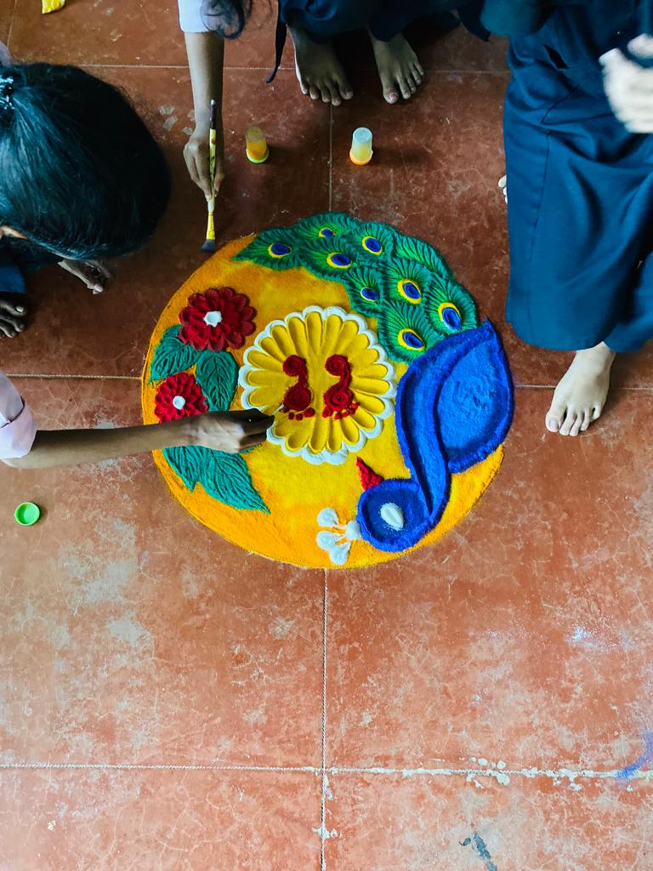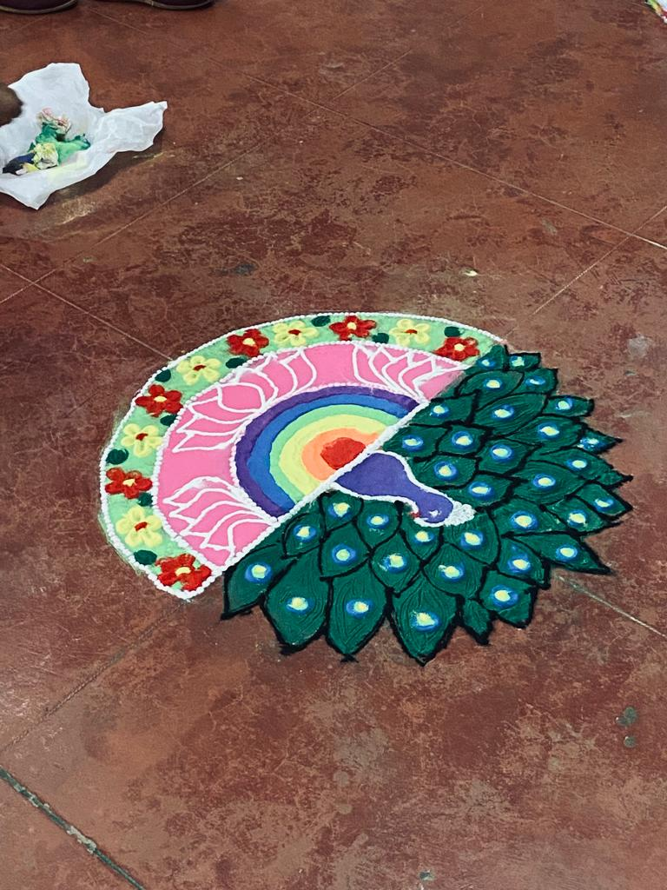

THAKADHIMI ARTS FEST

The THAKADHIMI ARTS FEST took place from January 30 to. February 3, inaugurated by social media influencer Nur Jaleela. It featured two days of stage events and two days of off-stage combinations. The event concluded with a valedictory ceremony, where winners were awarded.

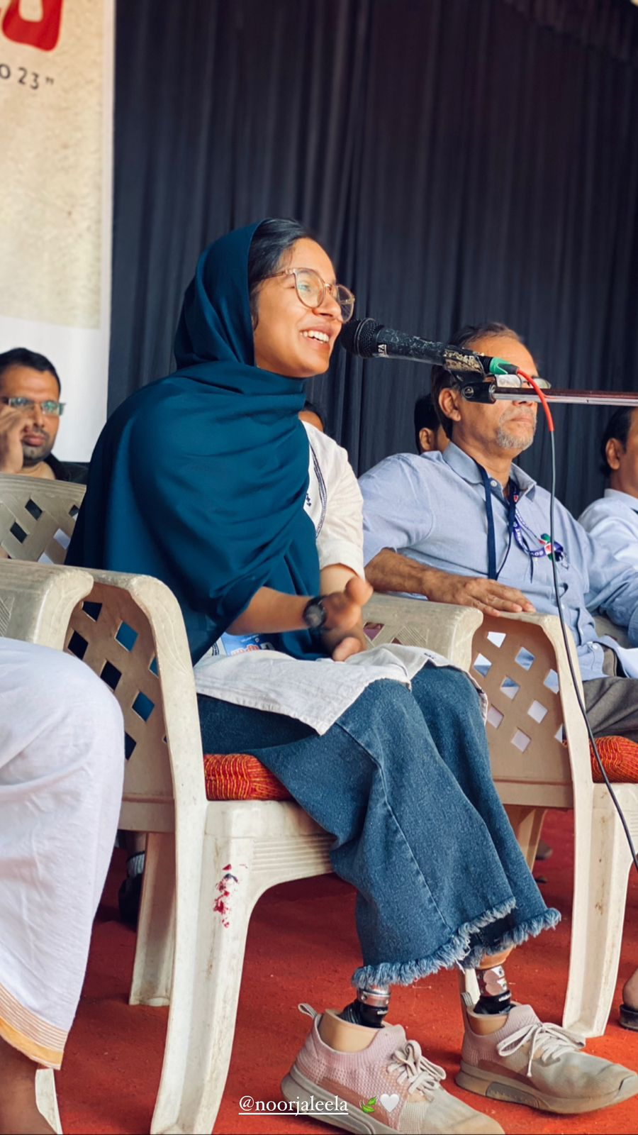
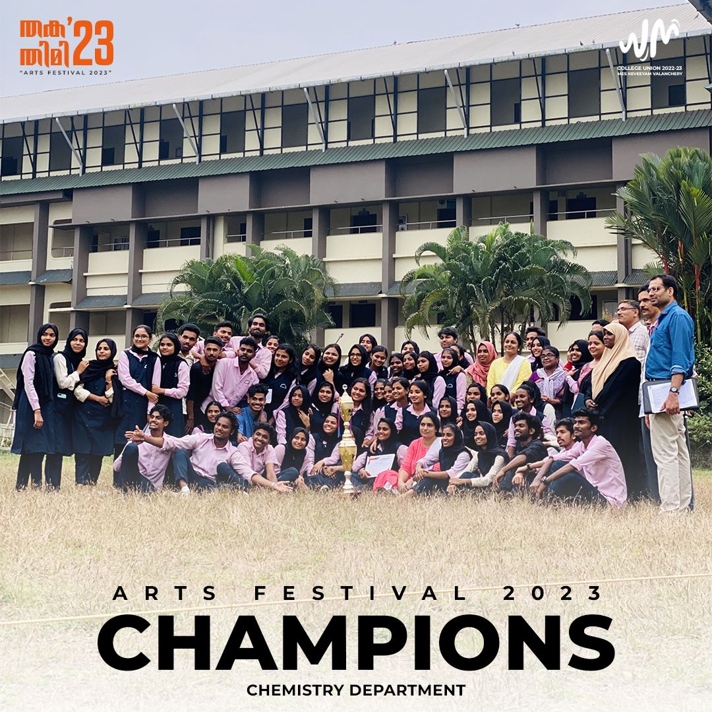

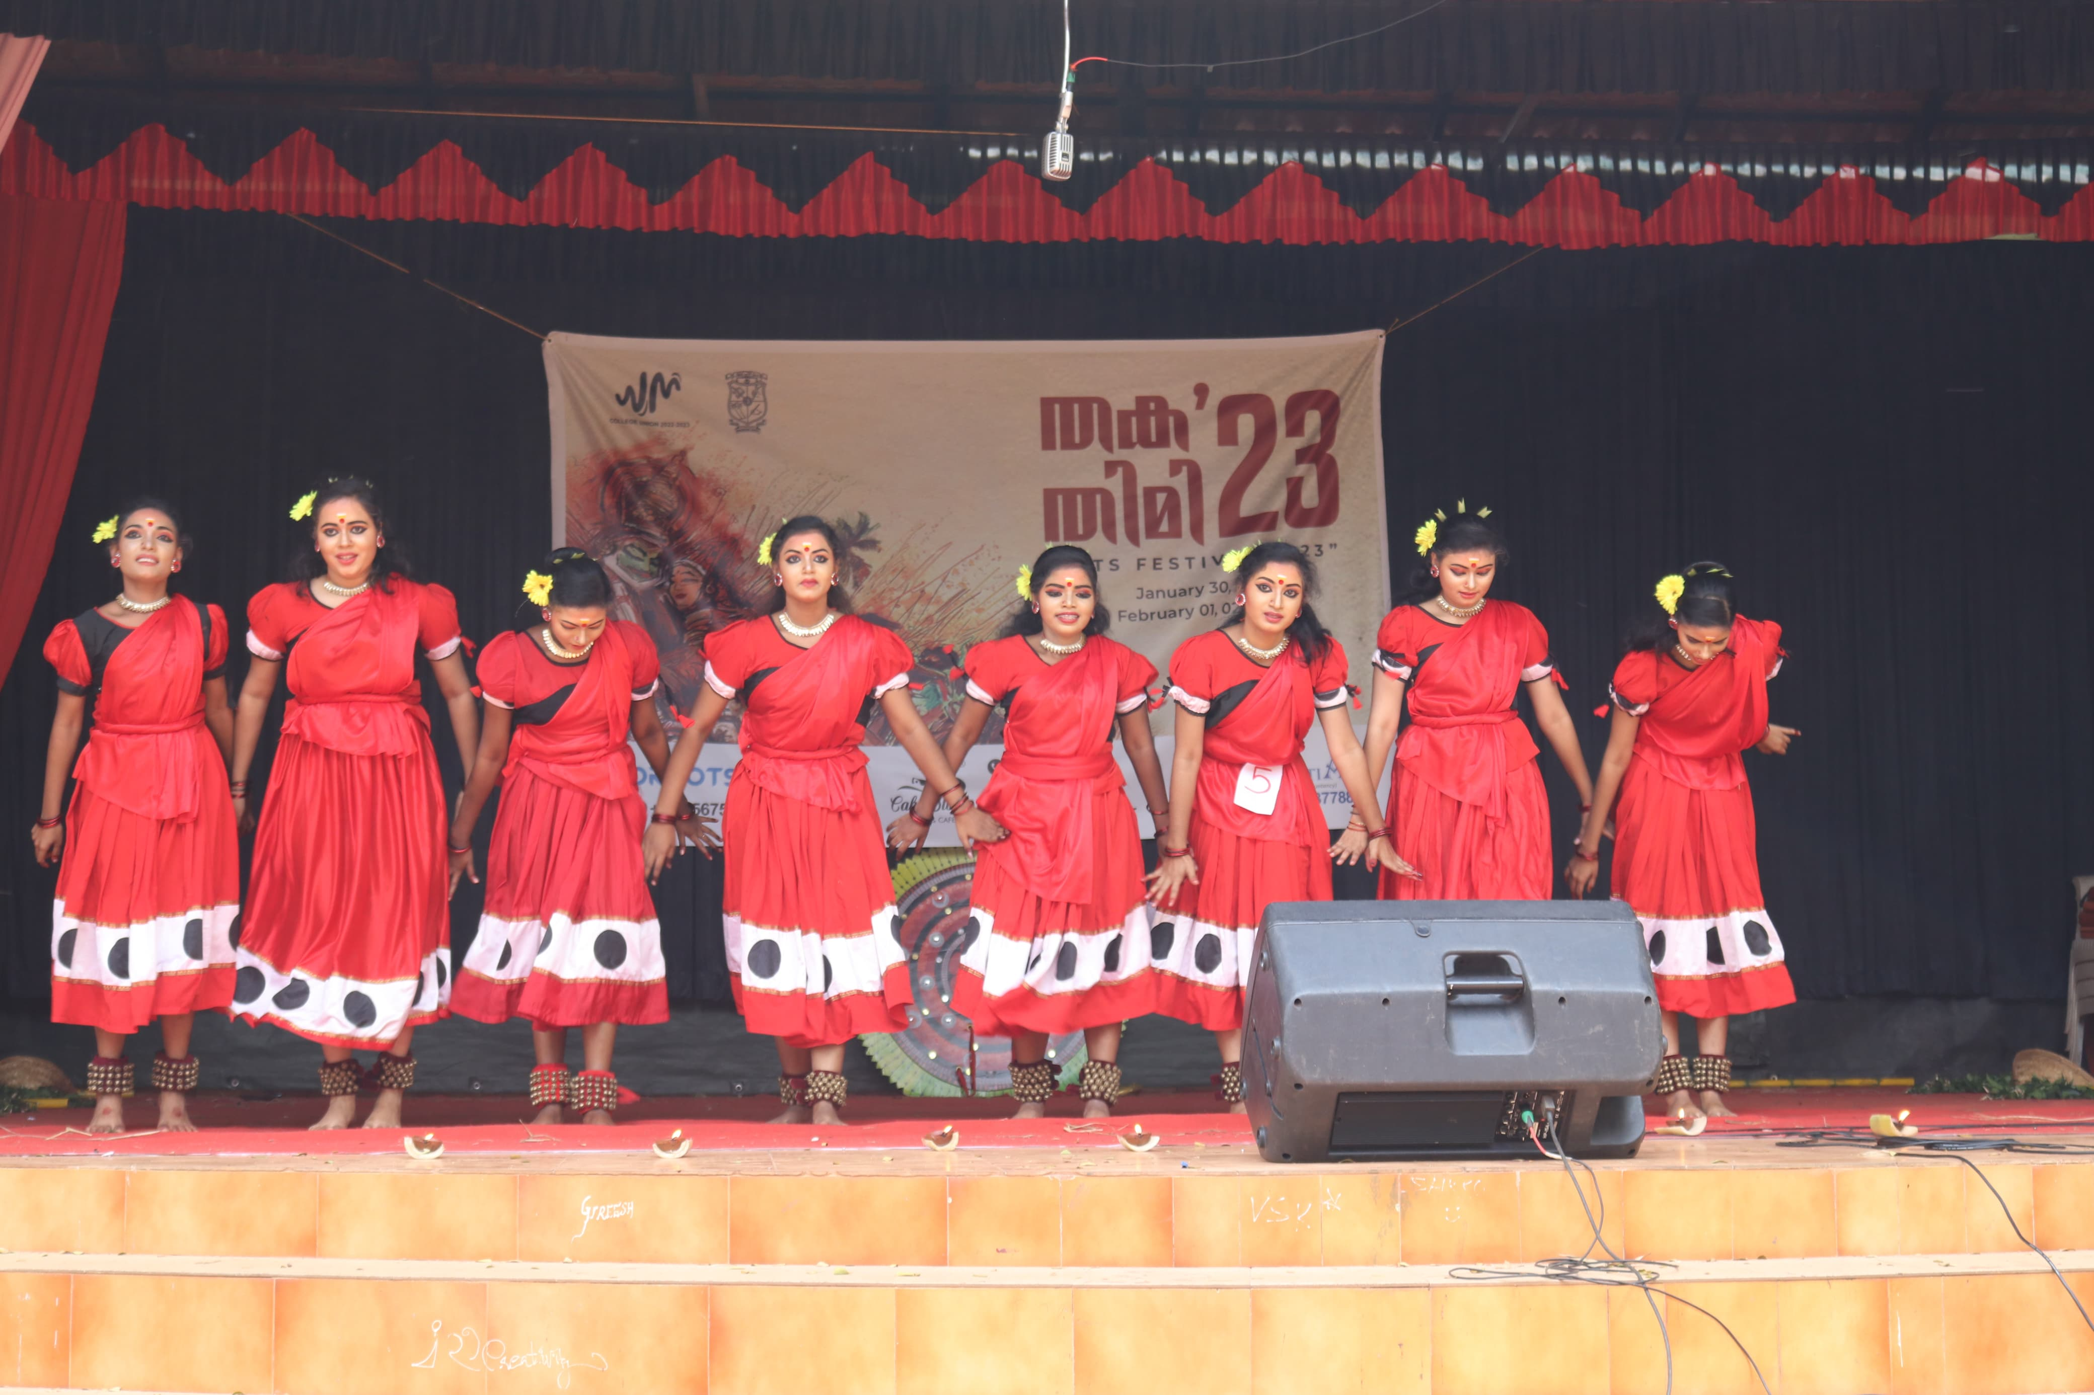

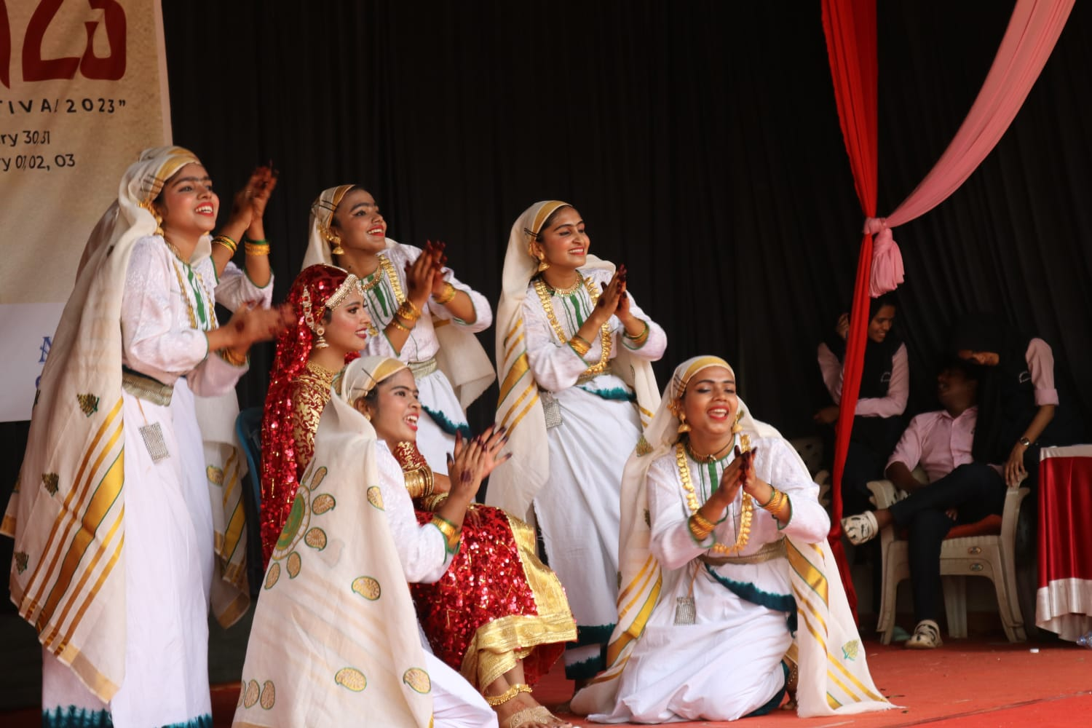

HOLI CELEBRATION

The college celebrated Holi with great enthusiasm, and the students participated with excitement. The vibrant colours and festive spirit brought joy to everyone.

