**BHOOMITHRA CLUB**

**(BMC-131/MPM/06/10)**

**MONITORING PERFORMA-A**

**Annual Report of the activities of BMC MES Keveeyam College, Valanchery for the year 2022- 2023**

**BMC number: BMC-131/MPM/06/10**

1. About BMC

Total student strength: 130

No. of boys: 20 No. of girls: 110

2. About the scheme

Details of Faculty in charge: Dr. Priya T.V.

How many students are taking part in the scheme: 130

Brake of boys and girls:

Have you received resource material: Nil

Have you received grant: No

3. **Details of the meetings held:**

* 1. The first meeting of the club members was held on 03-06-2022. Members discussed and decided about different activities to be conducted during the year. Decided to observe World Environment Day by conducting Quiz, Seedling planting, film show, invited talk etc
  2. An executive committee meeting was conducted on 06-06-2022.
  3. A meeting of the members was held on 13-09-2022. Decided to conduct a poster making competition and an exhibition in connection with Ozone Day and a field trip in connection with Bird watching day
  4. On 17-01-2023 a meeting was conducted to discuss about programmes that can be conducted by members to create awareness about protection of sacred grooves.

**II. Observance of environmentally significant days:**

1. June 5 : World Environment Day

2.August 12 : World Elephant Day

3. September16 : Ozone day

4. November 12 : Bird watching Day

5. December 1 : National Pollution Control Day

**III Activities**

**1.WORLD ENVIRONMENT DAY**

**No.of participants: 100 Date: 08/06/2022**

In connection with World Environment Day Observation, Bhoomithrasena organized many programs on 8th June 2022. All the programs were conducted in association with Social Forestry Division, Malappuram. Saplings of fruit trees were planted in the herbal garden by Mr. Muhammed Nishal P S, Range Forest officer, Social Forestry Range, Malappuram.

The interactive session on “Only One Planet” was conducted at 11AM at AV Hall. Dr. Krishna Prabha, HOD dept of Zoology delivered the welcome address. It was followed by the keynote address and the interactive sessions by Mr. Muhammed Nishal P S, Range Forest officer, Social forestry Range, Malappuram and Mr Divakaranunni N P, Deputy Range Forest officer, Social forestry Range, Malappuram. The resource persons shared their first-hand experience in forests of different parts of kerala.

The session was followed by a Quiz competition on the theme “Only one planet”. A team of 2 students from each department participated in the quiz. A film show on the need of protecting biodiversity and preventing pollution was also shown in the afternoon.

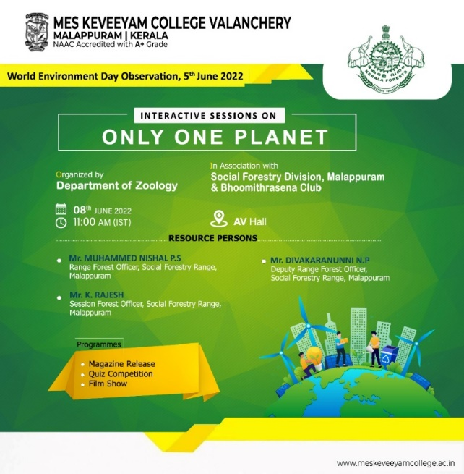 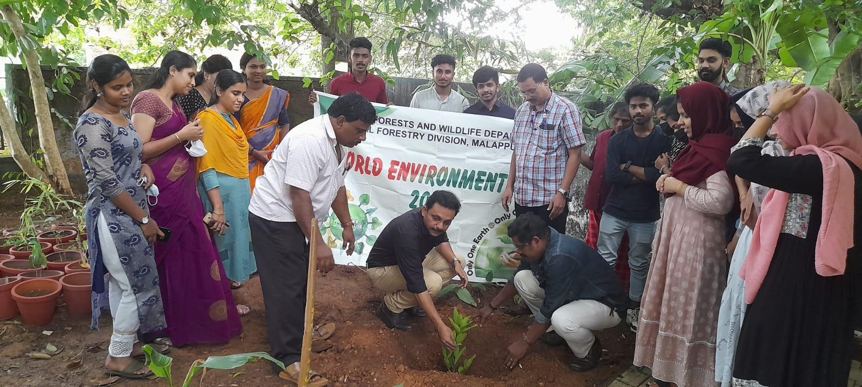

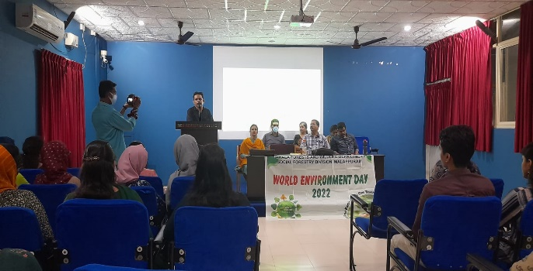 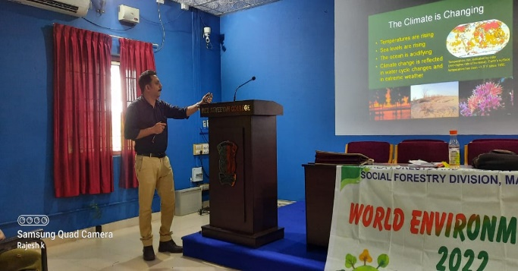

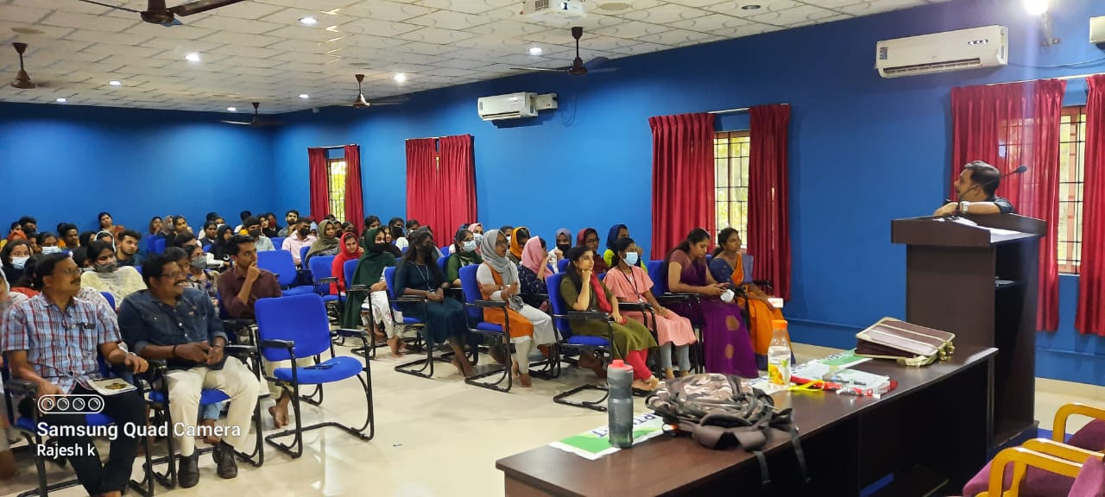

**2. DAY NATURE CAMP AT PARAMBIKULAM WILD LIFE SANCTUARY**

**No.of Participants: 30 Date: 20/06/22 & 21/06/22**

The Club members of PG classes attended a two- day nature camp at Parambikulam Tiger Reserve on 20th and 21st of June 2022.

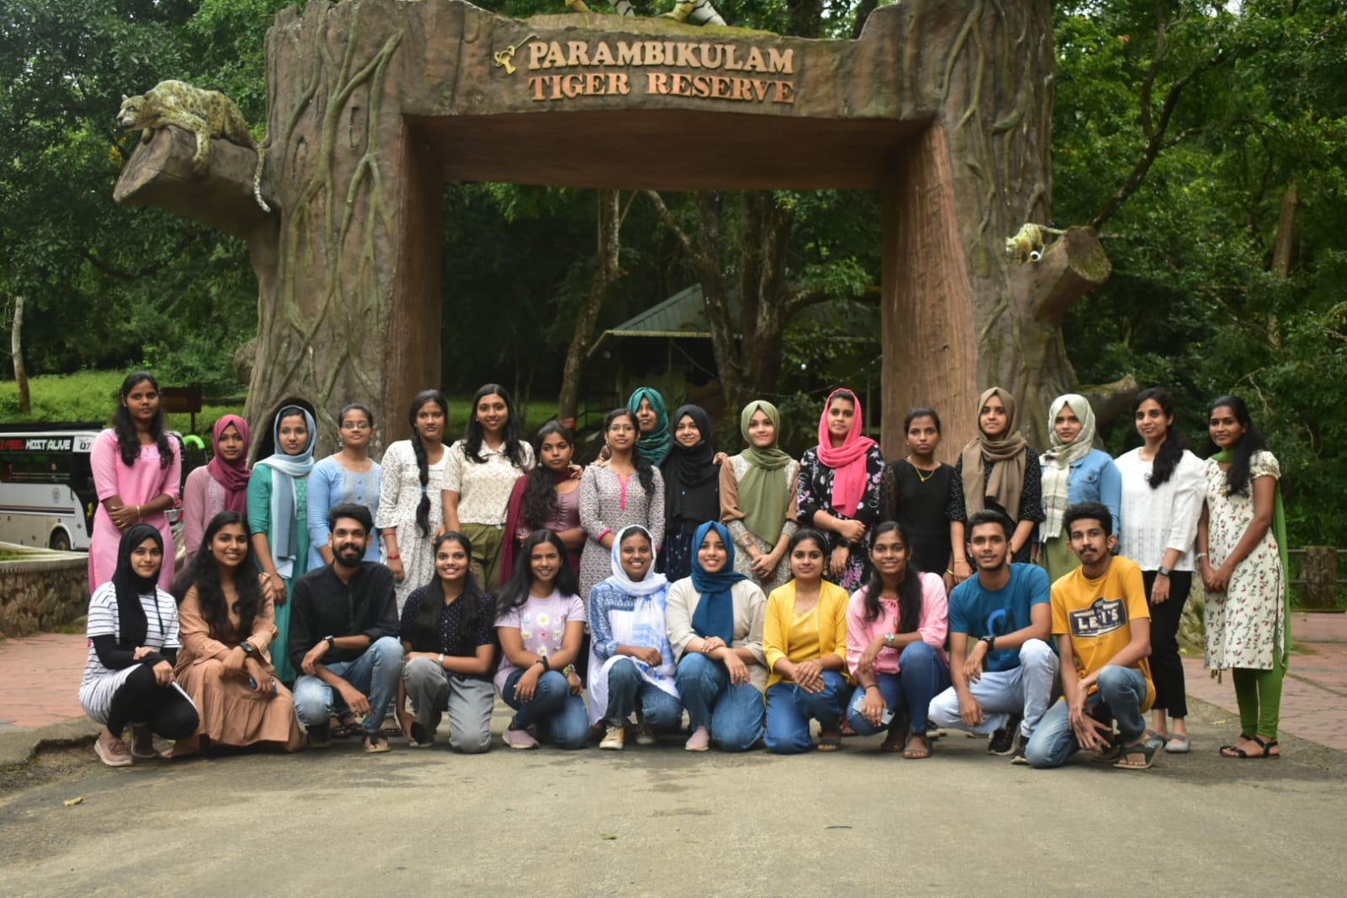

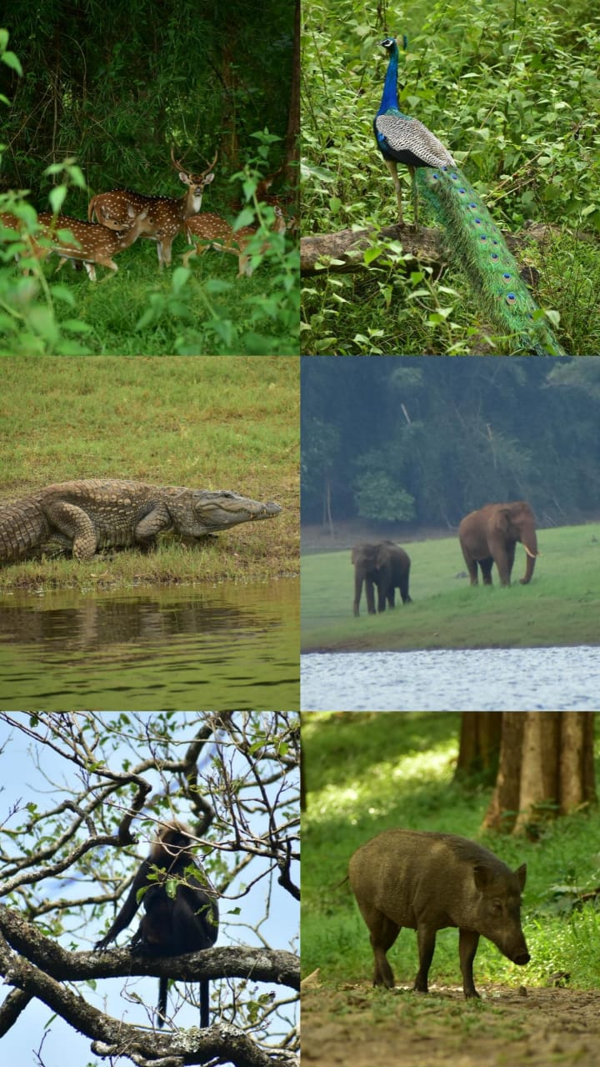

**3.WORKSHOP ON PREPARARTION AND DIGITALISATION OF BIODIVERSITY PARK**

**No.of participants: 85 Date: 23/06/2022**

A Workshop on “Preparation & Digitalisation of Biodiversity Park” was conducted on 23-06-2022 by Mr Dinesh Souparnika, a member of Open agricultural Team. The club members from Dept of Zoology as well as Botany participated in the training on how to prepare QR coding and how to record details of biodiversity. After a Session in AV hall, the students were given classes at herbal garden on how to set a biodiversity park. Sir distributed a handbook on different components to be present in a biodiversity park. Volunteers were selected to work on collecting data for digitalization activities.

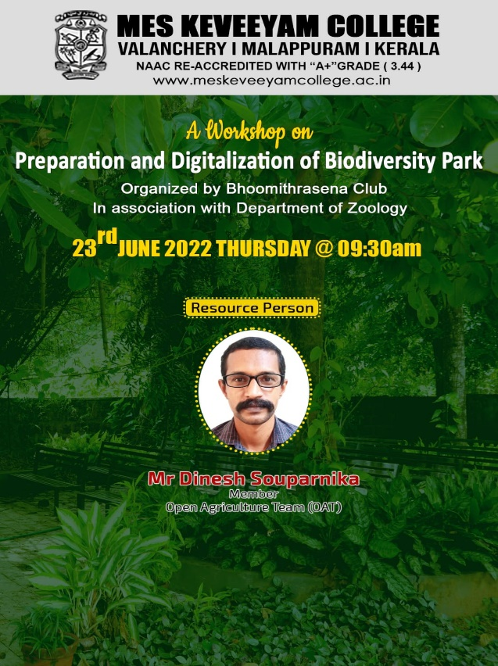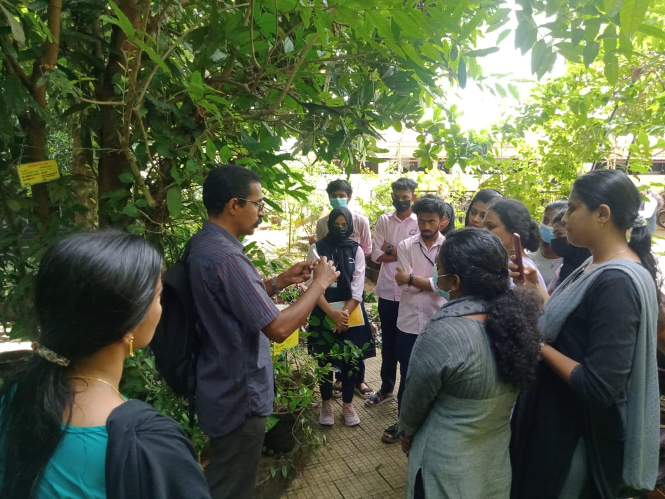

1. **DAY NATURE CAMP AT SHENDURUNY WILD LIFE SANCTUARY**

**No.of participants: 41 Date: 1 to 3/08/2022**

A nature camp was conducted by Bhoomithrasena and Zoology Department in association with the Kerala Forest Department from 1st August 2022 to 3rd August 2022 at Shendurney Wildlife Sanctuary, Kollam for 3rd B.Sc. Zoology students. The camp was guided by Assistant Wildlife Warden Mr. Shijin. The students reached the wildlife sanctuary by 5:00 p.m. of the first day. An introductory class was conducted by the guide introducing the basics of camp and the animals and birds that students can see on the forest. They also shared their earlier experiences during the camps and listed the rules and regulations that should be followed during the camp. In the second day, trekking was conducted in Kalamkunnu forest and showed the traces of animals, different kinds of insects, types of trees, peculiarities of each types, dam and lakes. The day ended with the cultural programs organised by the students. The forest range officer V P Jayan was the guest for the cultural programs. He shared about his experiences and interacted with the students. In the third day, the students were taken for bird watching. The students were made aware of the different ways of observing birds, difference in sounds and the physical appearance of birds and how such features can be used for identifying birds. The students were taken to a deer park. A quiz was conducted for the students at the end of the session. Closing ceremony was held where students shared their experiences of the camp and certificate were distributed to the students. The camp concluded by 5:00 p.m. of 3rd August 2023.

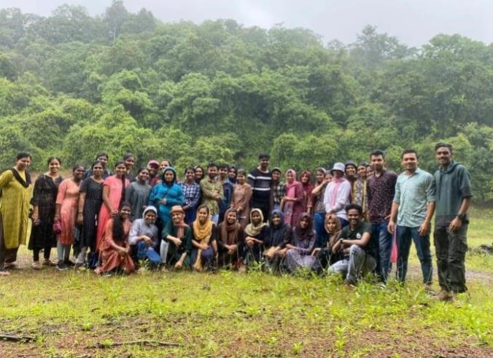

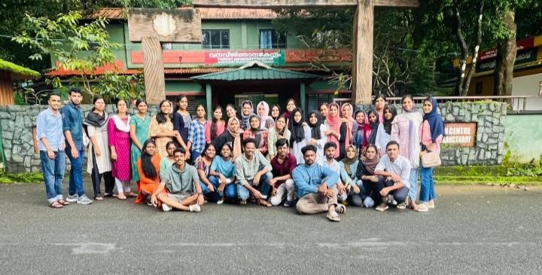

1. **WORLD ELEPHANT DAY OBSERVATION (12/08/2022)**

**No.of participants: 70 Date: 12/08/2022**

World Elephant Day was observed on 12-08-2022 to create awareness on the need for protection of elephants as well as the need for reducing Elephant Human conflicts. The theme of the day observation was “Personifying pre- historic beauty, theological relevance and Environmental importance. Dr Shereena K M, HoD, Dept of Zoology, MES Ponnani College, the chief guest of the day addressed the gathering. Dr Priya T V handled a session on Diversity of Elephants and their behaviour. The talk was followed by a film show on “Elephants- role in biodiversity conservation in the forests”.

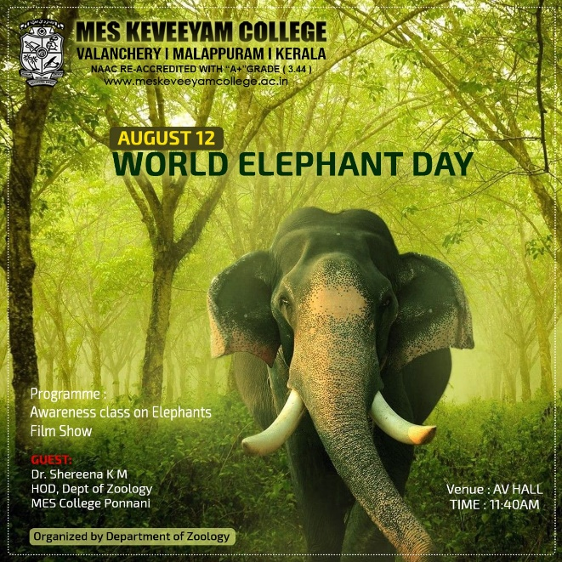 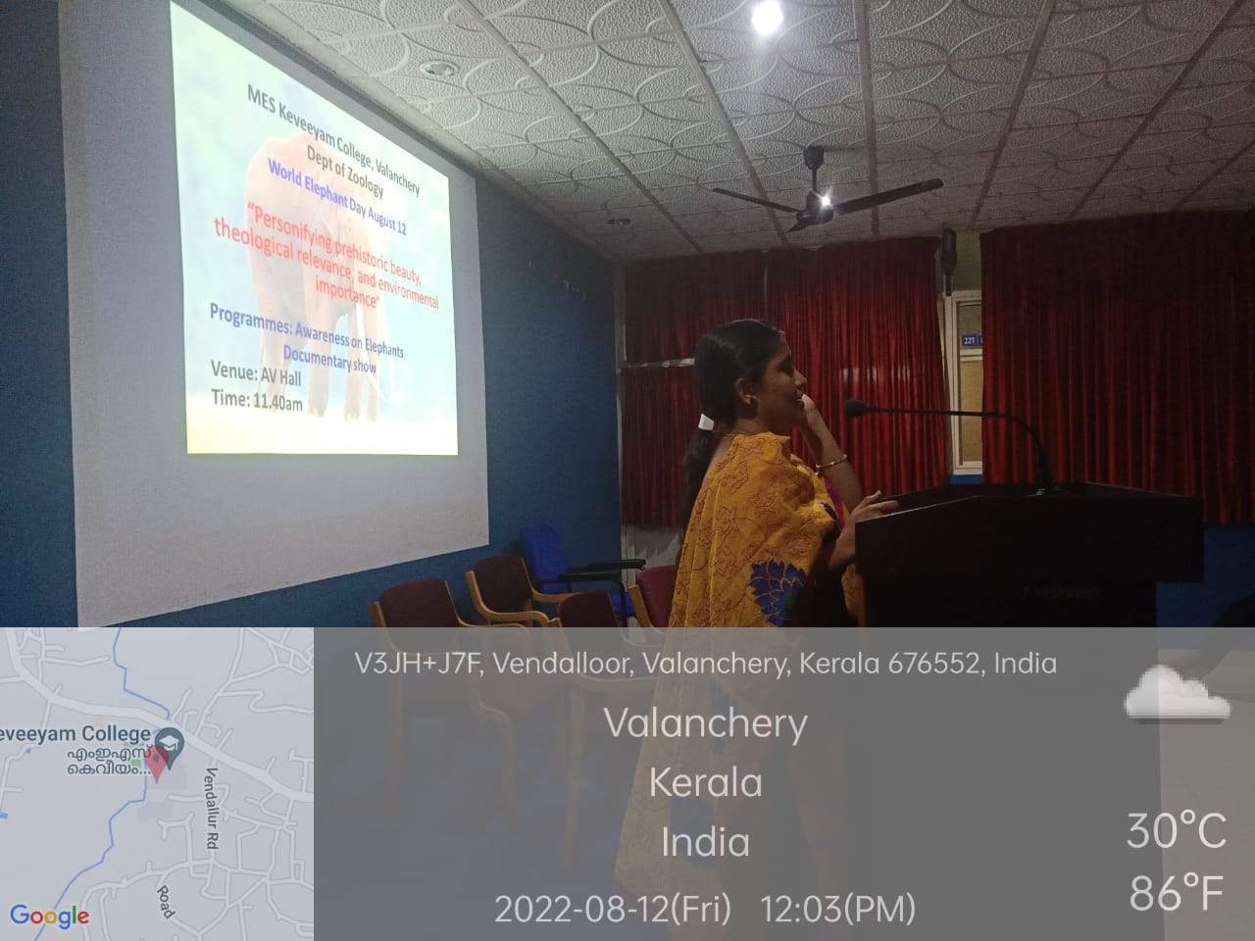

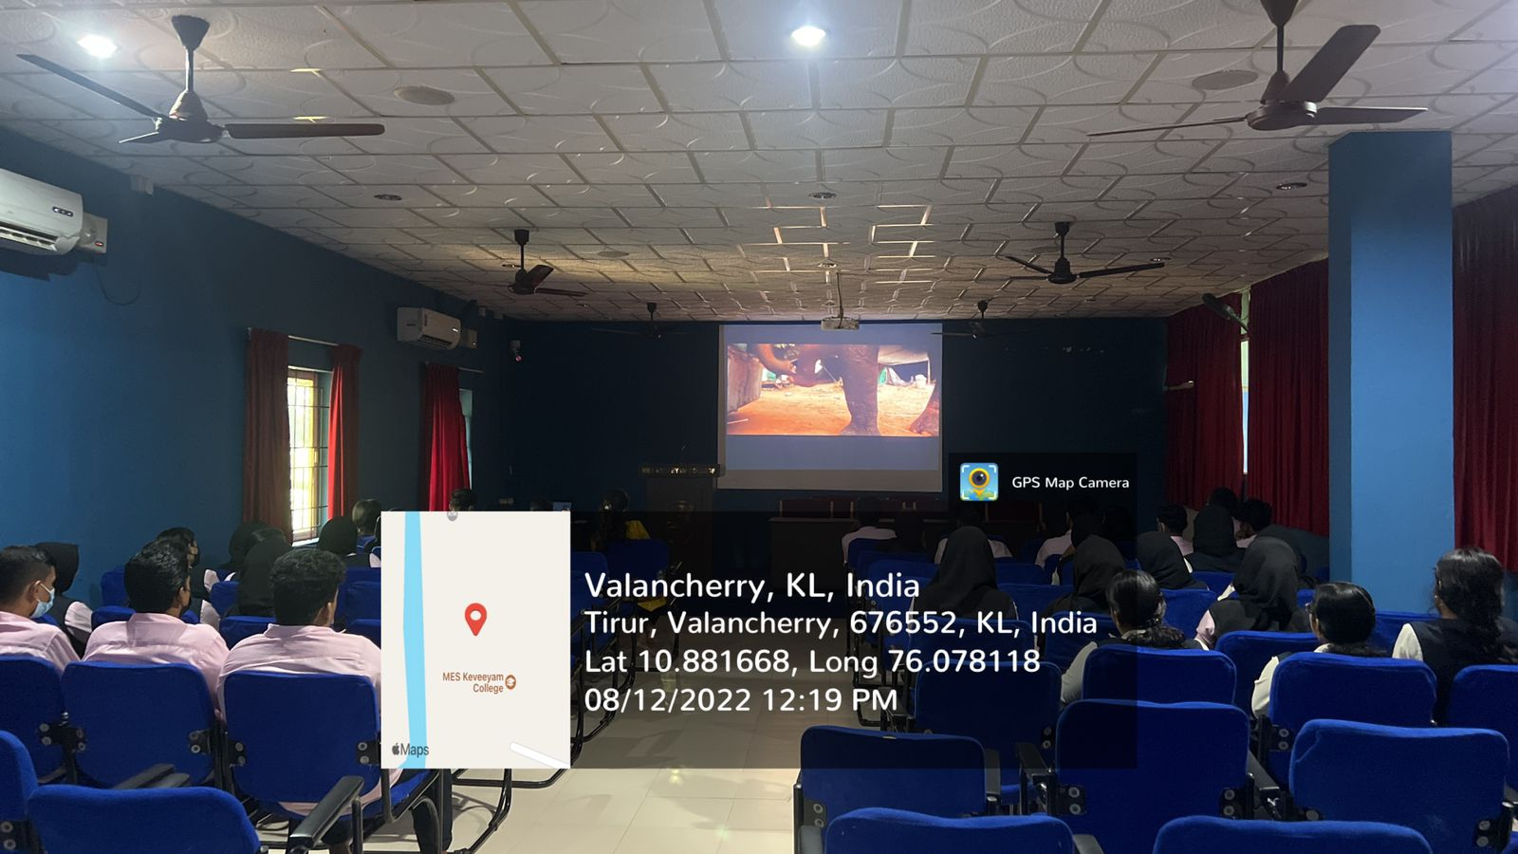

1. **WEBINAR ON PLASTIC FROM STARCH- A NOVEL APPROACH in connection with Swachahata Pakwada September 1-15**

**No.of participants: 60 Date: 14/09/2022**

A webinar on the topic “Plastic from Starch- A Noval Approach” was conducted on 14.09.2022 at 2.30 PM. Mr. Vysakh P. was the resource person. The session was on the studies and the development of bioplastics from plant products through different techniques. The session was followed by an interactive session.

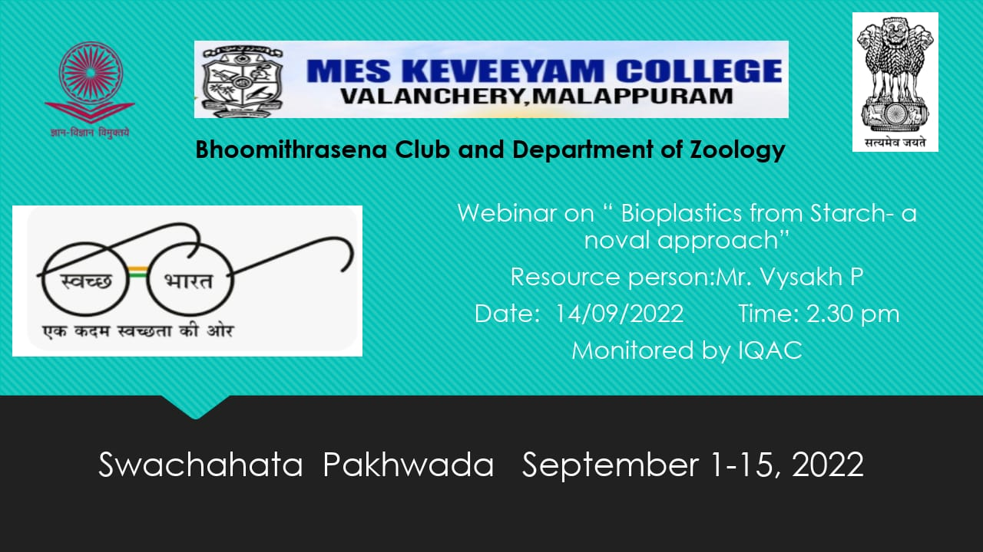

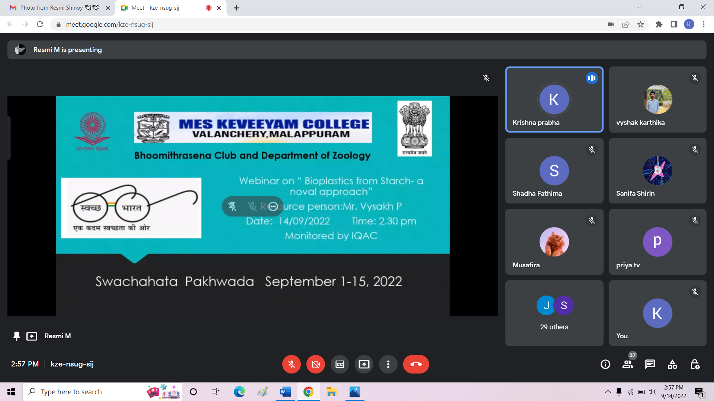

1. **ESSAY WRITING & POSTER MAKING COMPETITIOS**

**No. of participants: 40 Date: 13/09/2022**

In connection with Swachhtha awareness campaign, Essay writing and poster making competitions were conducted for students on 13.09.2022 from 11 AM to 12.30 PM. The themes were “Problems and solutions for plastic and water pollution”. 40 students participated in the programme and expressed their ideas on reducing pollution in the environment.

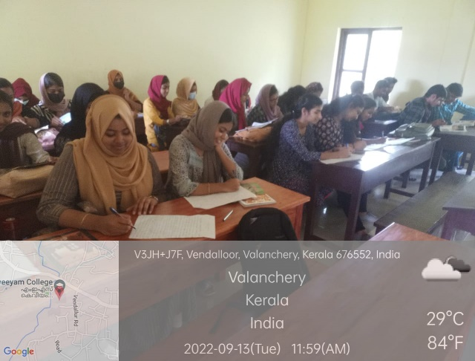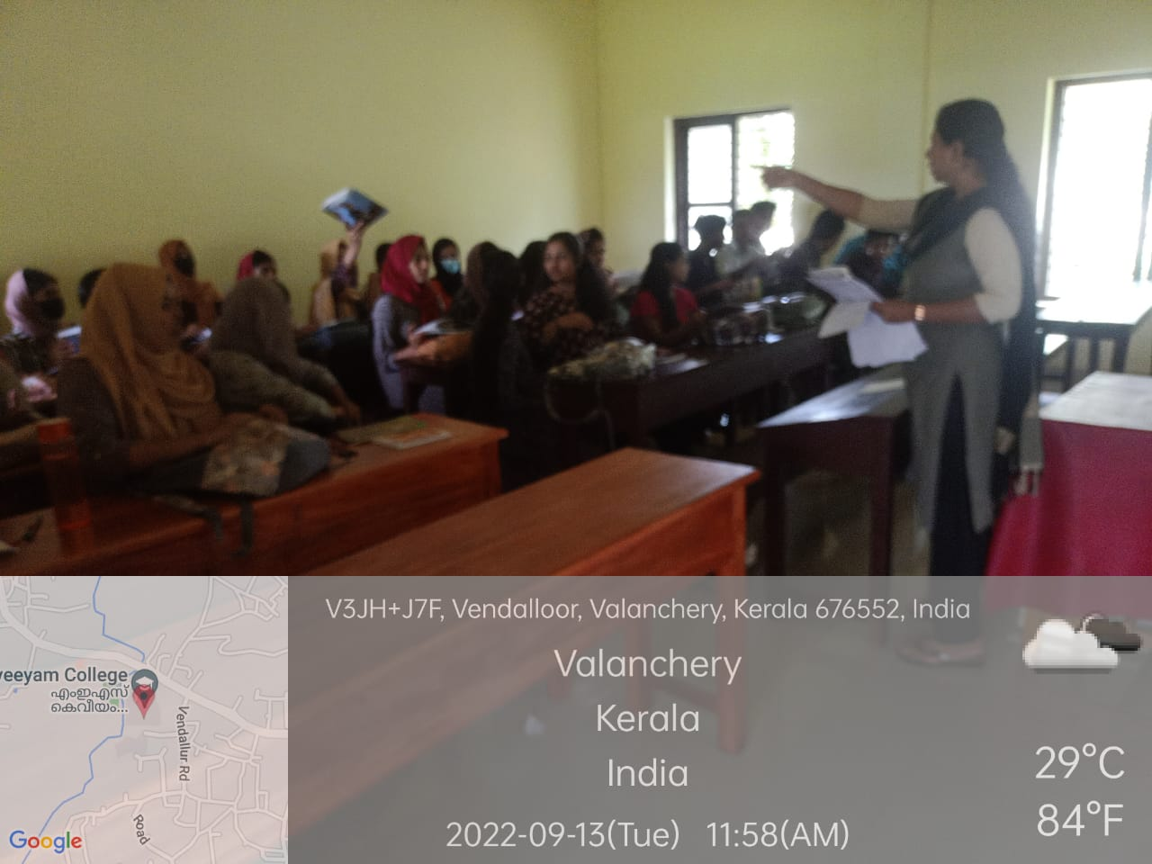

1. **OZONE DAY OBSERVATION (16/09/2022)**

**No.of participants: 12 teams Date: 16/09/2022**

In connection with Ozone Day observation 2022, a poster making competition was conducted on 16-09-2022 at 10. 30 AM. More than 10 teams participated in the competition. All the posters were exhibited in the poster exhibition which was conducted at 2 PM on 16-09-2022 at the department of Zoology. The Exhibition was inaugurated by Professor Shajid PP, Principal of MES keveeyam college. The students and faculties from various departments participated in the exhibition The Winners were selected and were given prizes.

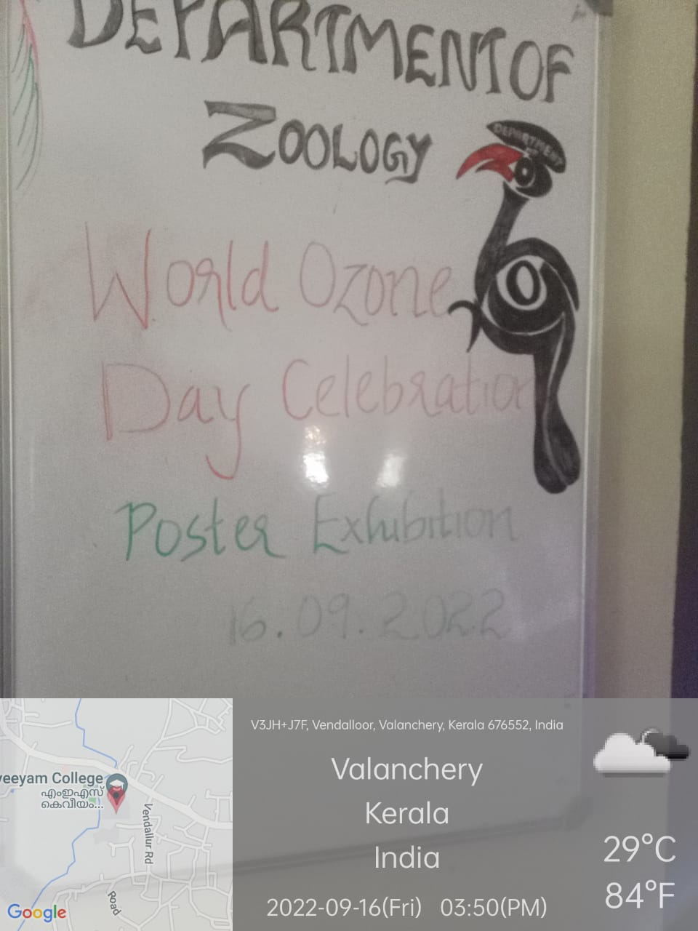 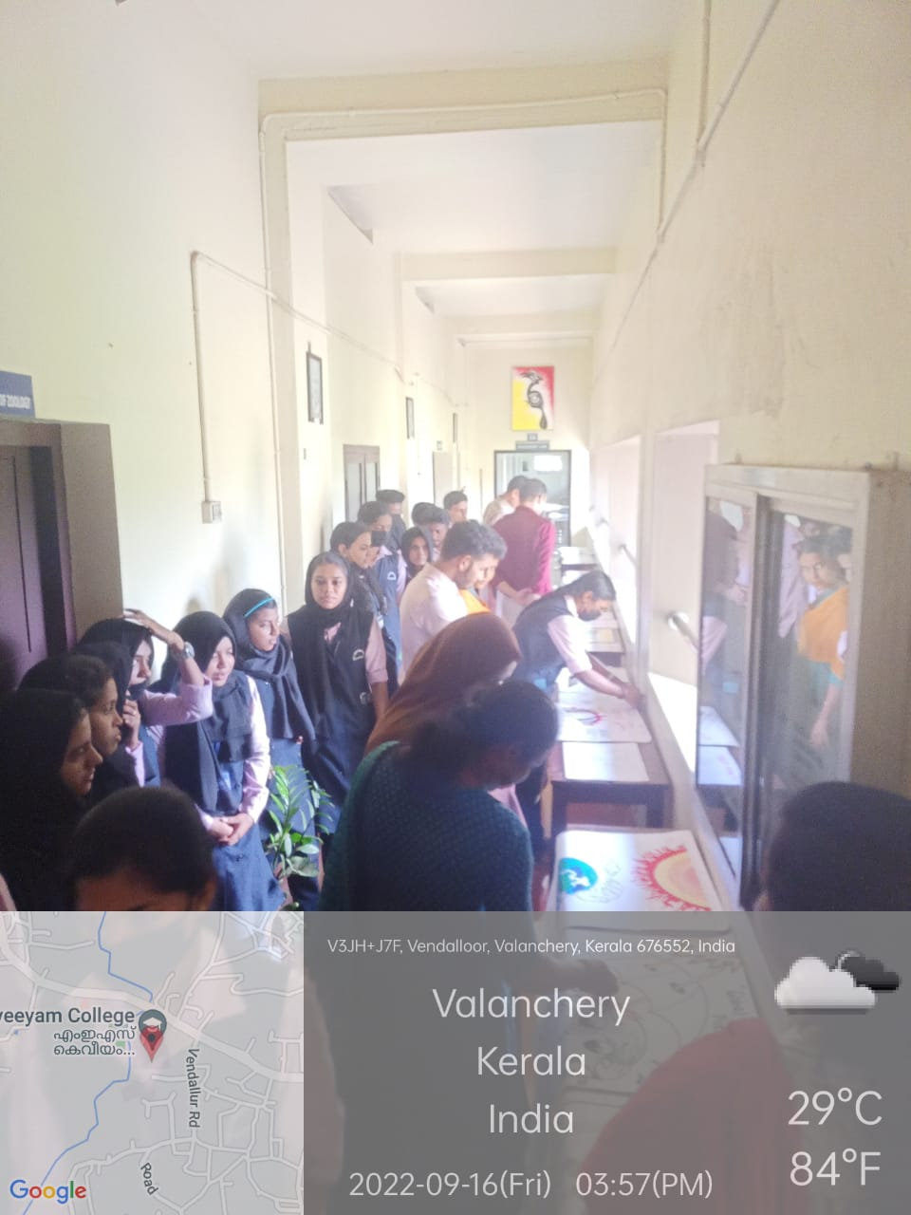

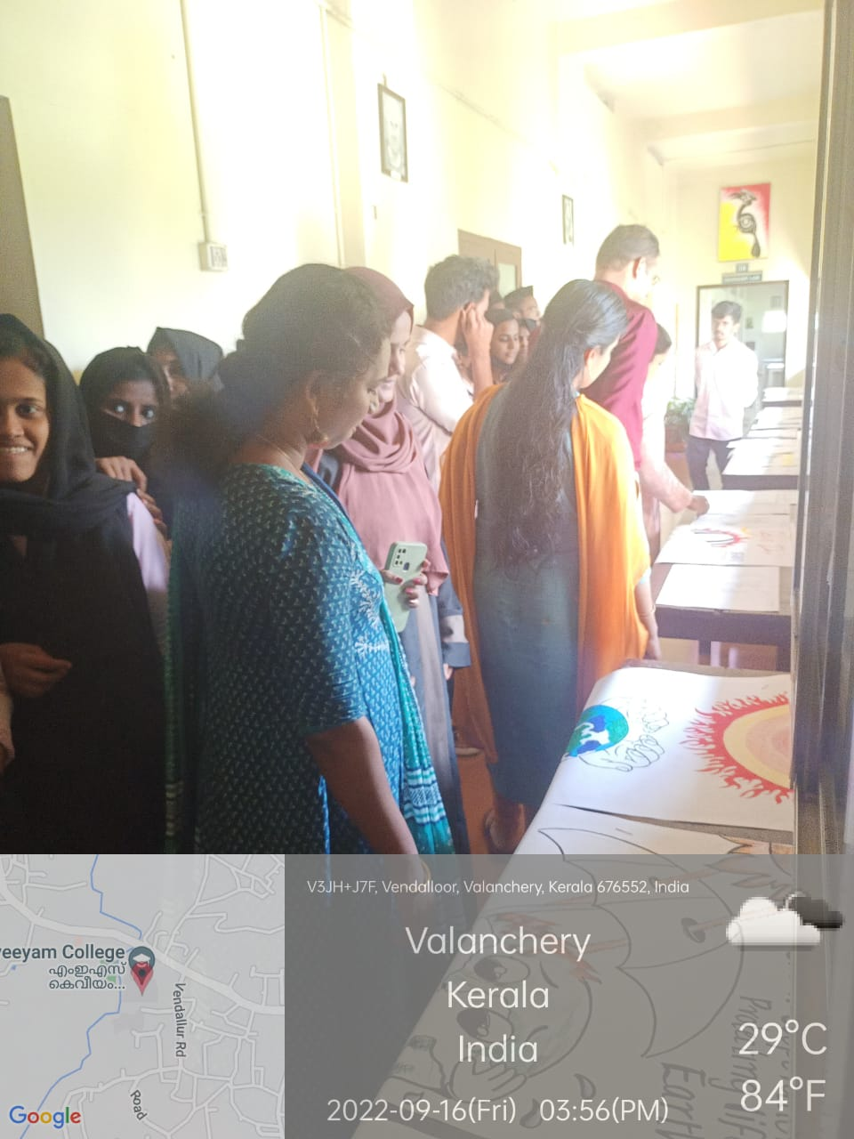

1. **ONE DAY CAMP AT PRAKRITI GRAMAM, TIRUR GANDIAN NATURAL HYGIENE HOME**

**No of students participated: 37 Date: 21/10/2022**

A team of 37 students of II BSc Zoology and 2 faculties, Dr Jisha krishnan and Dr Ayisha Banu visited Tirur Gandhiyan Natural Hygiene Home on 21-10-2022. It was a visit to get trained on how to prepare and consume “Prakrithi Food”, a way of preparing food with natural ingredients with less toxins. Students involved in making “Prakrithi Sadhya” a feast with special food items. After the feast a class was conducted by Dr.Radhakrishnan. It was followed by a feedback session by the students on the whole programme.

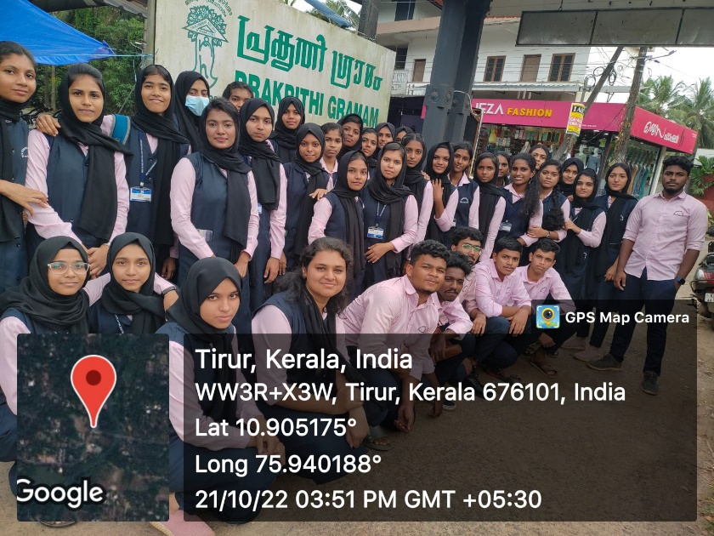 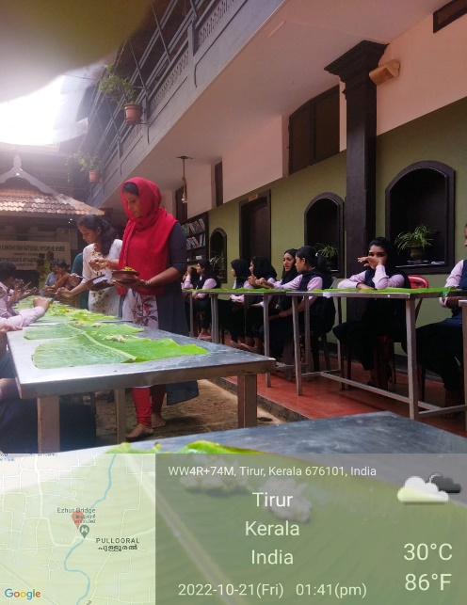

1. **TRAINING ON SEEDLING PREPARATION AND DISTRIBUTION OF SEEDLINGS**

**No.of participants: 25 Date: 15/11/2022**

Students were given training on preparation of seedling with banana leaf as the seed holder on 15/11/2022 as a part of reducing the use of plastic. Prepared seedlings were distributed.

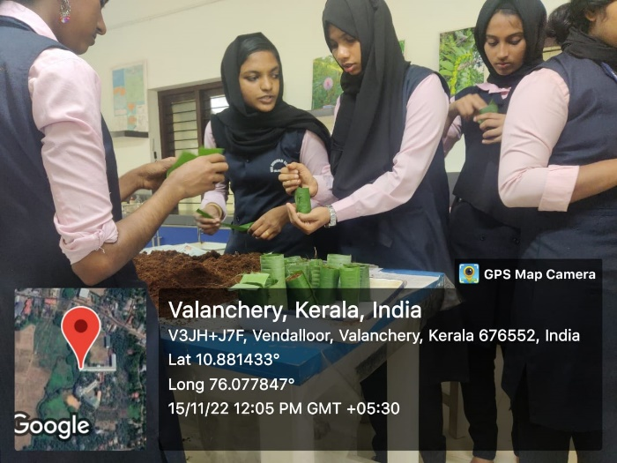 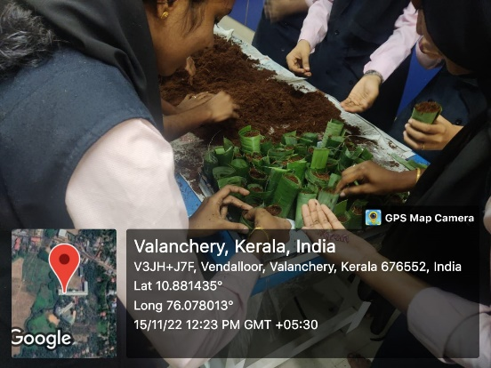

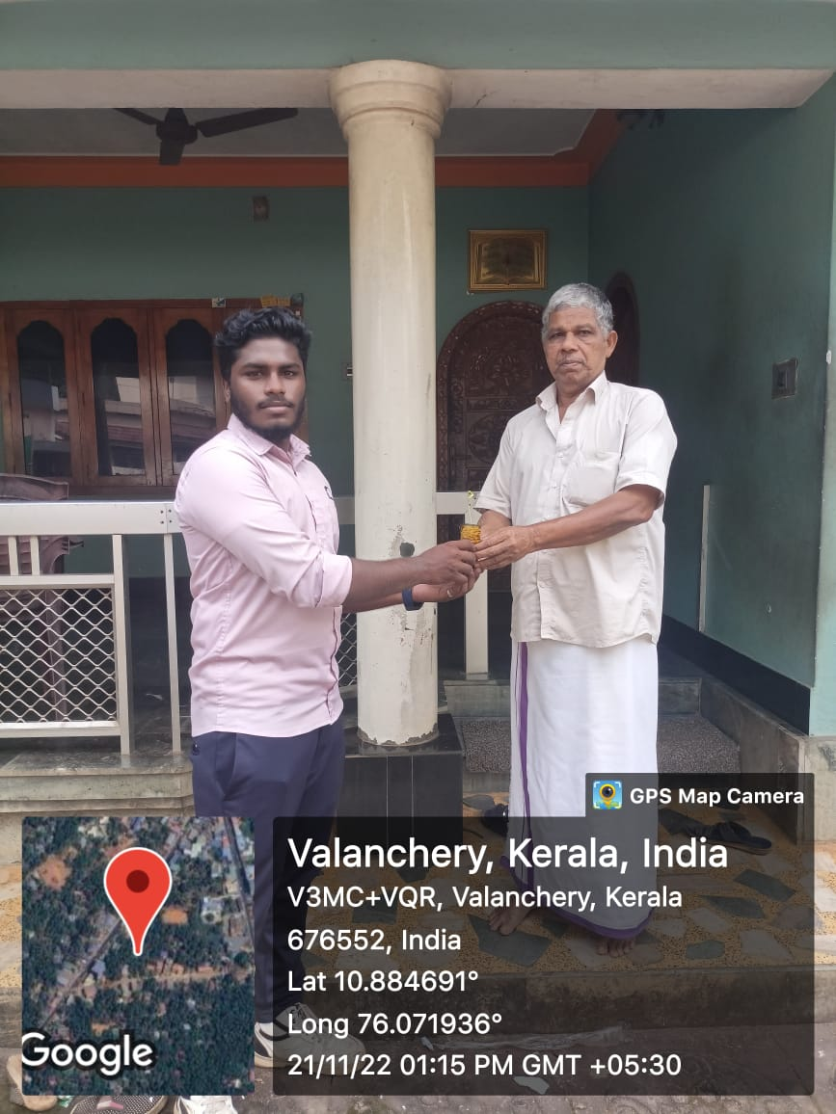 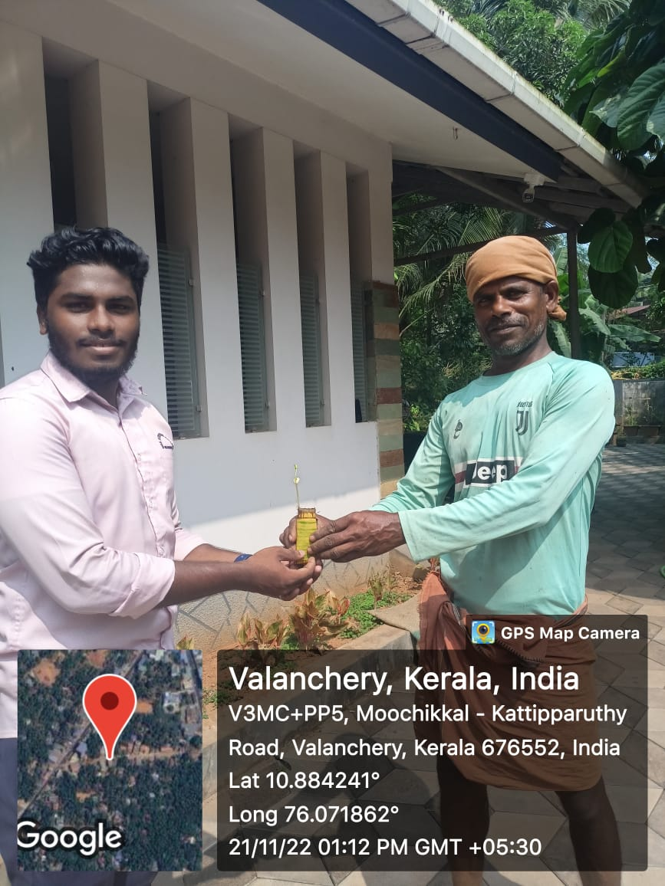

1. **FIELD VISIT TO MAVOOR WETLANDS**

**No.of participants: 44 Date: 24/11/2022**

A field trip was conducted to Mavoor Wetlands, Kozhikkode for birdwatching on 24-11-2022.39 students which included club members and 5 faculties participated in the programme. The students were given training on birdwatching by Mr. Vishnu and Ms. Shifa C T, research scholars and experts in birdwatching who have authored international papers on birds.

The students were mad aware of the need to protect wetlands to preserve the birds and the environment.

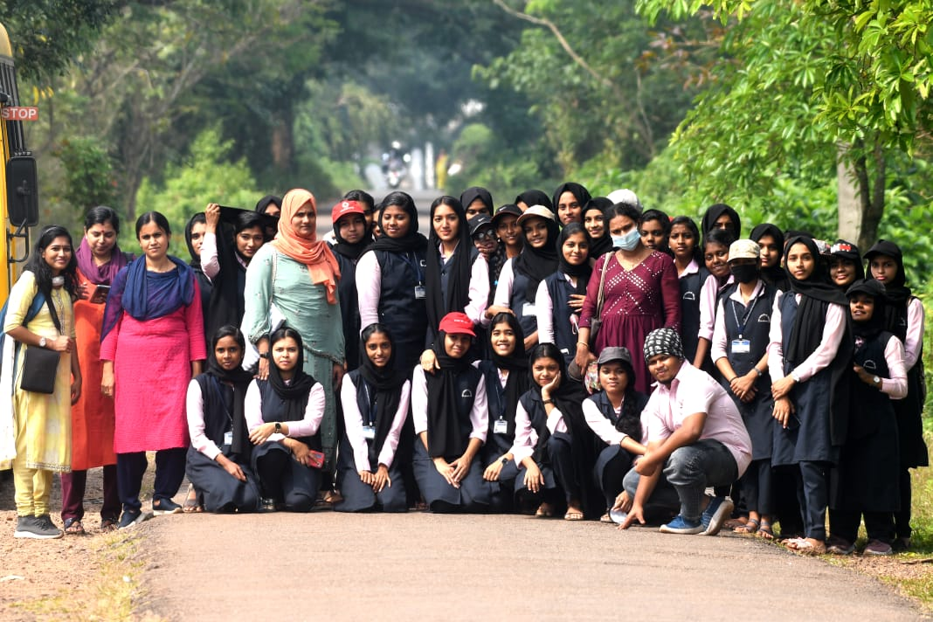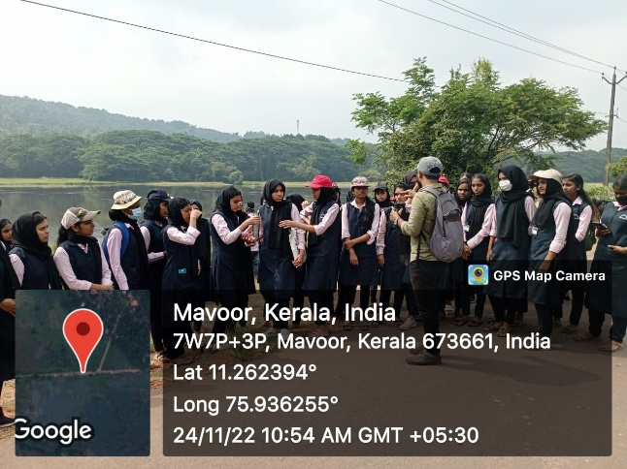

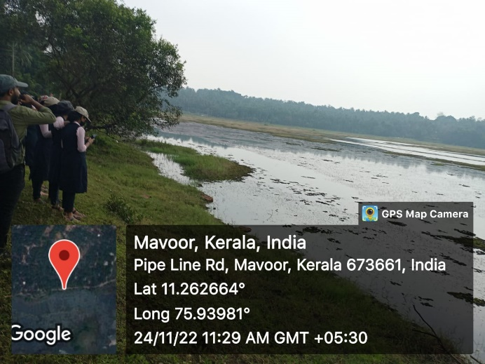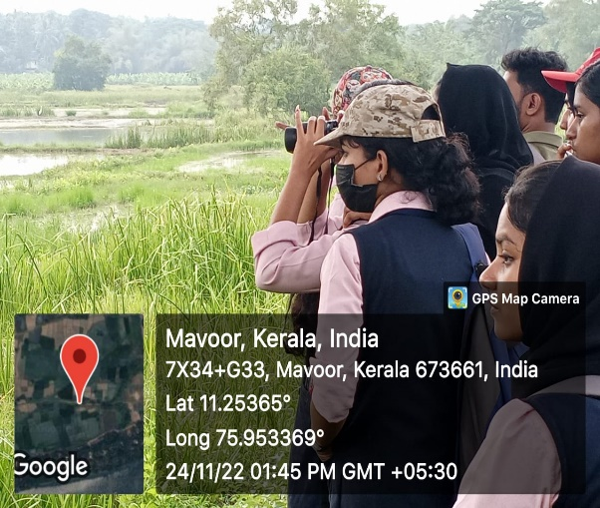

1. **EXPERT TALK IN CONNECTION WITH NATIONAL POLLUTION CONTROL DAY**

**No.of participants: 50 Date: 01/12/2022**

National Pollution Control Day was observed by IIC in association with IQAC and Bhoomithra Sena Club of MES Keveeyam College, Valanchery on 1st and 2nd December 2022. An expert talk on “Innovative methods of soil profiling to combat Soil Pollution” was conducted on 1st December 2022 at the Zoology lab. Mr. Subramanian. V C, Assistant Soil Chemist, District Soil Testing Laboratory, Malappuram was the resource person of the day.

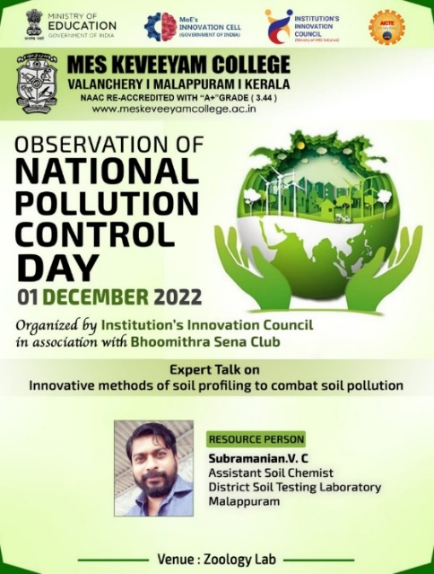 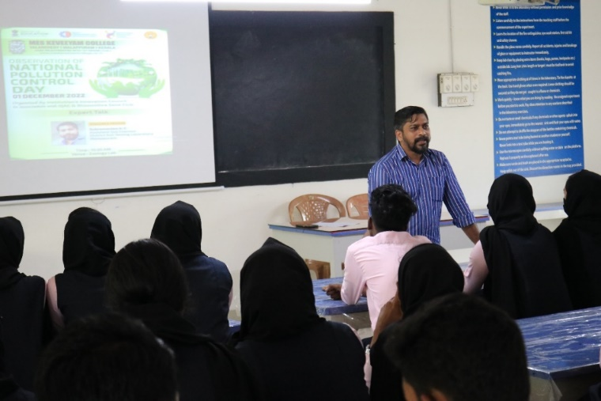

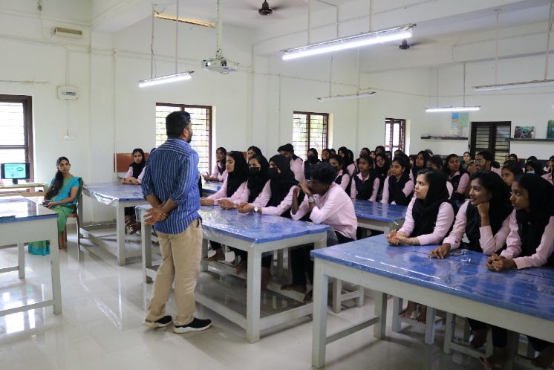

1. **IDEA HUNT IN CONNECTION WITH NATIONAL POLLUTION CONTROL DAY**

**No.of participants: 116 Date: 02/12/2022**

On 2nd December an Idea Hunt was conducted by circulating a google form among the students and faculties of the college seeking innovative ideas to combat pollution through simple ideas that even a common man can take up. 116 participants responded and contributed their ideas.

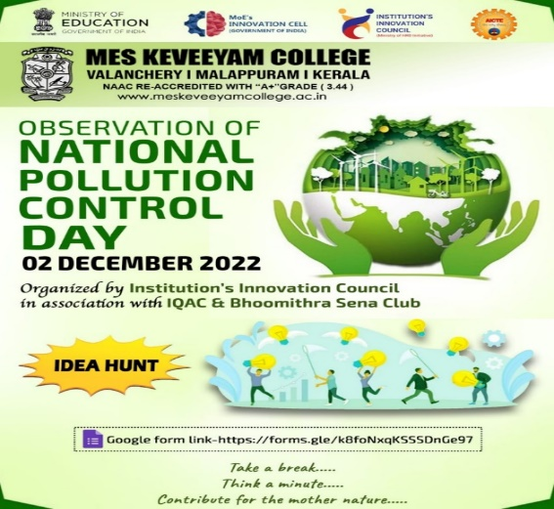

1. **SACRED GROVE CONSERVATION- AWARENESS ACTIVITIES**

**No.of Participants: All Students from MES Keveeyam College & Students and teachers who visited Mespo’23, an exhibition conducted by the College**.

**Date: 7/02/2023 to 9/02/2023**

A stall was set in a classroom depicting A sacred grove, through which all the visitors were allowed to explore the diversity and the serenity of the environment. A film show on “Kaavukal” was also showed**.**

1. **ENVIRONMENTAL AWARENESS ON TOURISM MANAGEMENT**

**No.of participants: 30 Date: 10/03/2022**

An Interactive talk on the need of responsible tourism was conducted on 10-03-2023 at Badaam Gallery at 12 PM. Students from Zoology department as well as some Alumni members joined the session. The resource person was Mr. Hamidali Vazhakad, District Coordinator of National Green corps, Malappuram. Through his talk, sir insisted on developing a sense of responsible tourism among the tour operators, guides and participants in the present scenario of forest fires happening near different tourist spots.

Students expressed their concerns about the threats faced by the biodiversity. Sir advised the participants to make a group of responsible tourists in and around the College campus and thus make people aware of the problems. Mr Arun from MSc Zoology proposed Vote of thanks for the function.

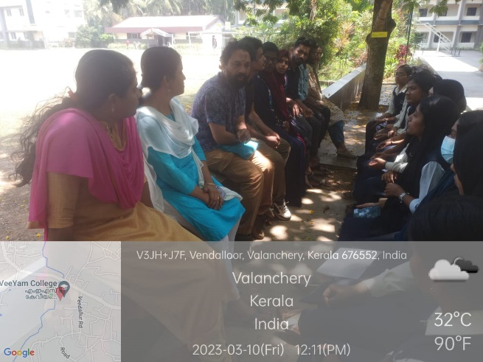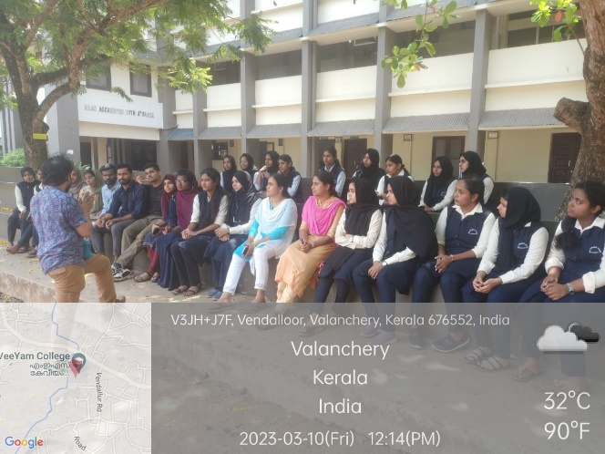

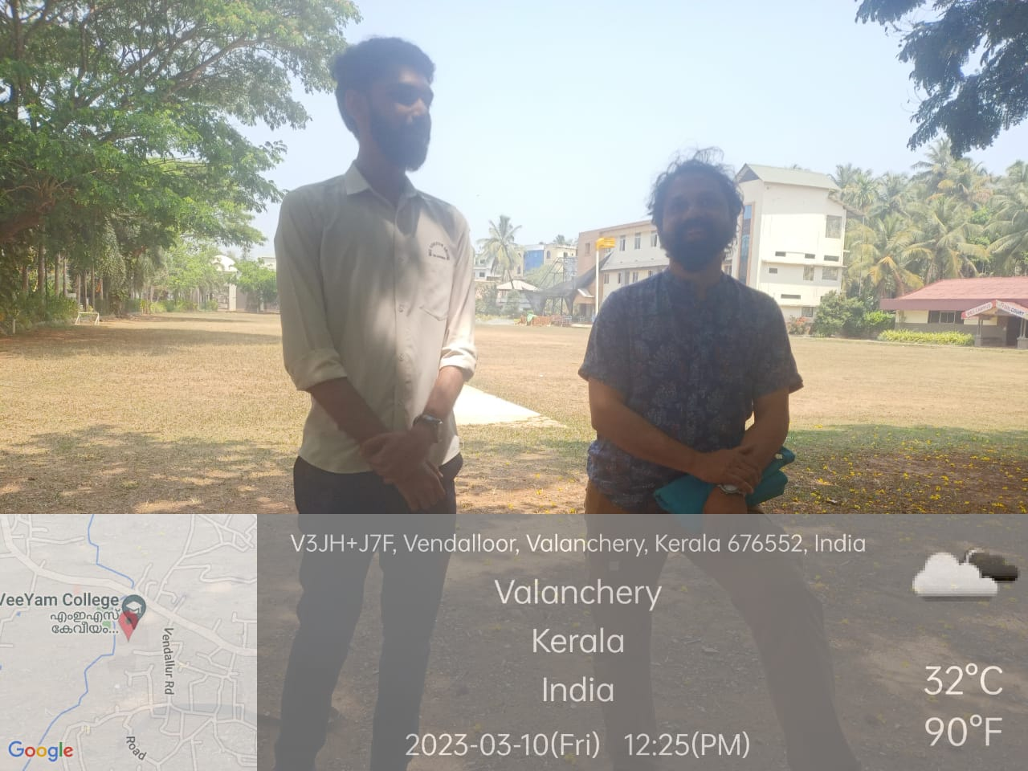

Date: Name & Signature of FIC - Priya T V

Principal

To

The Director,

Environment Developmental Agency,

Department of Environment and Climate change,

Thiruvananthapuram.

Sir,

Sub: Forwarding of Report of Activities of Bhoomithra Sena Club:BMC-131/MPM/06/10–reg:-

I am forwarding the Annual Report and Photographs of activities of BMC in our college from June 2022 to March 2023.

Thanking You,

Yours faithfully,

Principal