**Waste Management**

In collaboration with waste management programme of Valanchery Municipality, MES Keveeyam College have furnished a three separate waste management system for the collection and segregation of non-biodegradable and biodegradable waste from MES Keveeyam canteen, hostel and campus. Through these multifaceted roles, waste management system of Keveeyam College and local government significantly contributes to environmental conservation and sustainable development in the campus, serving as a model for community-driven waste management.

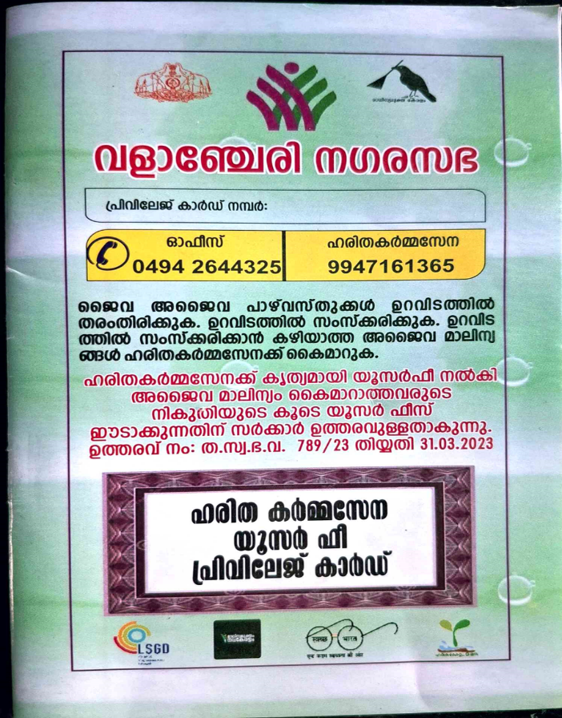 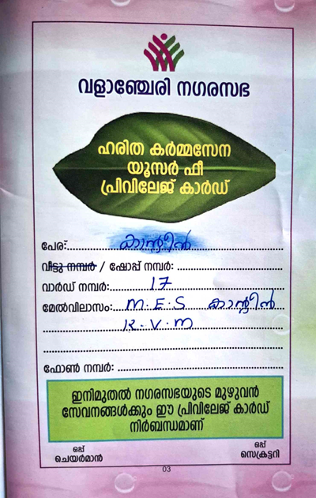

Privilege card given by Valanchery municipality for Canteen

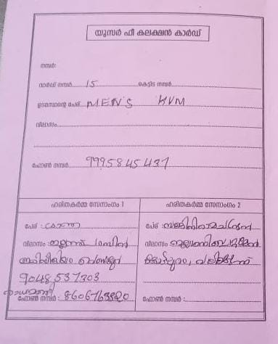

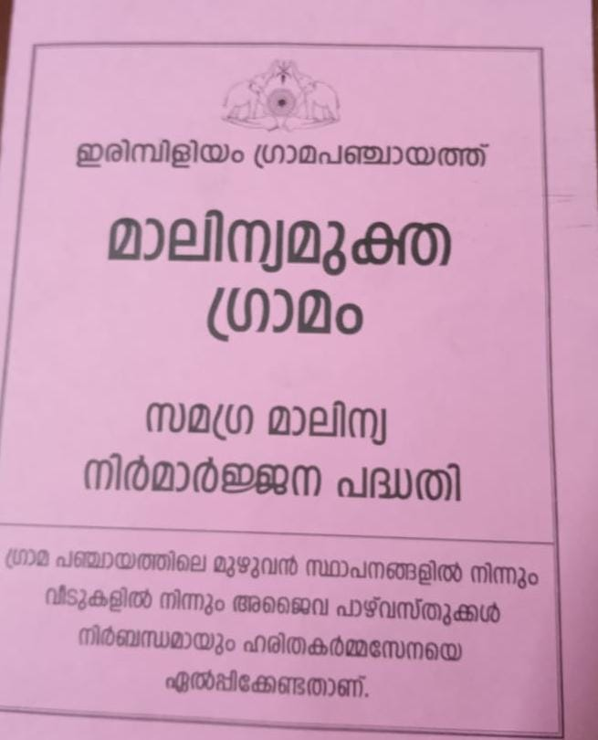

User fee collection card given by Irimbiliyam Grama Panchayath for collecting waste from the college