7.1.3 – Describe the facilities in the institution for the management of the following types of degradable and non-degradable waste.

1. Solid waste management.

2. Liquid waste management.

3. Biomedical waste management.

4. E-waste management.

5. Waste recycling system.

6. Hazardous chemicals and radioactive waste management.

WASTE MANAGEMENT PROVISIONS

|  |  |
| --- | --- |
| Figure No. | Facility |
| 1 | Colour-coded Waste Bins |
| 2 | Biogas Unit |
| 3 | Incinerator |
| 4 | Drainage Canal. |

1. Waste Management

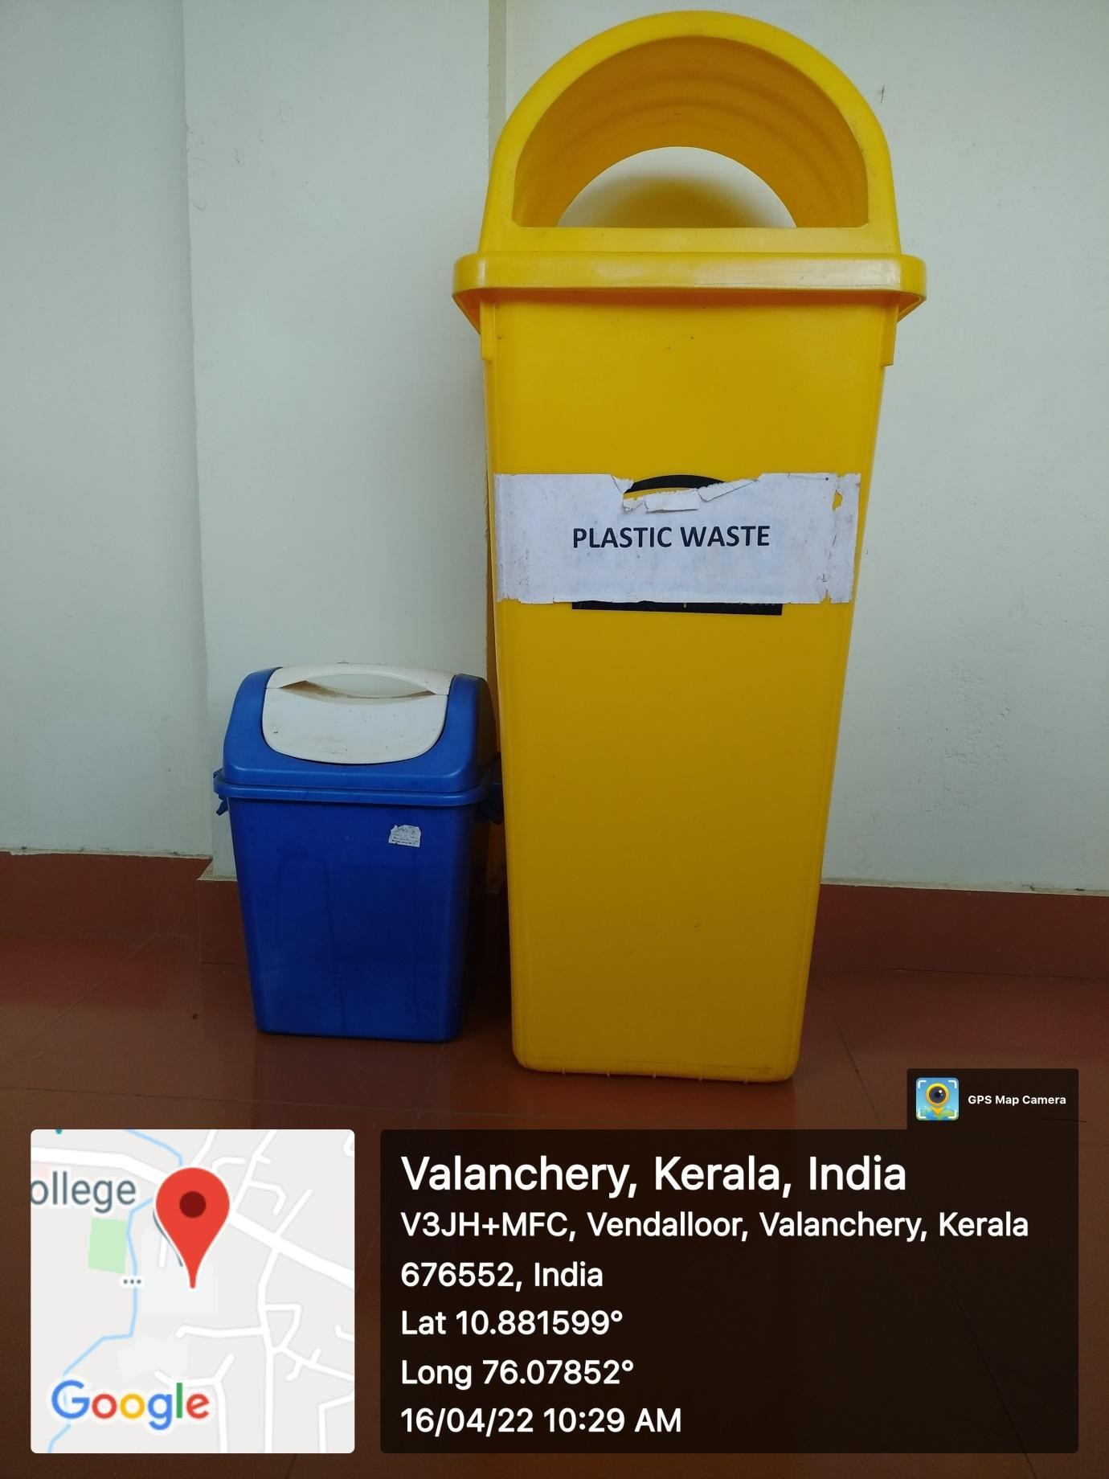

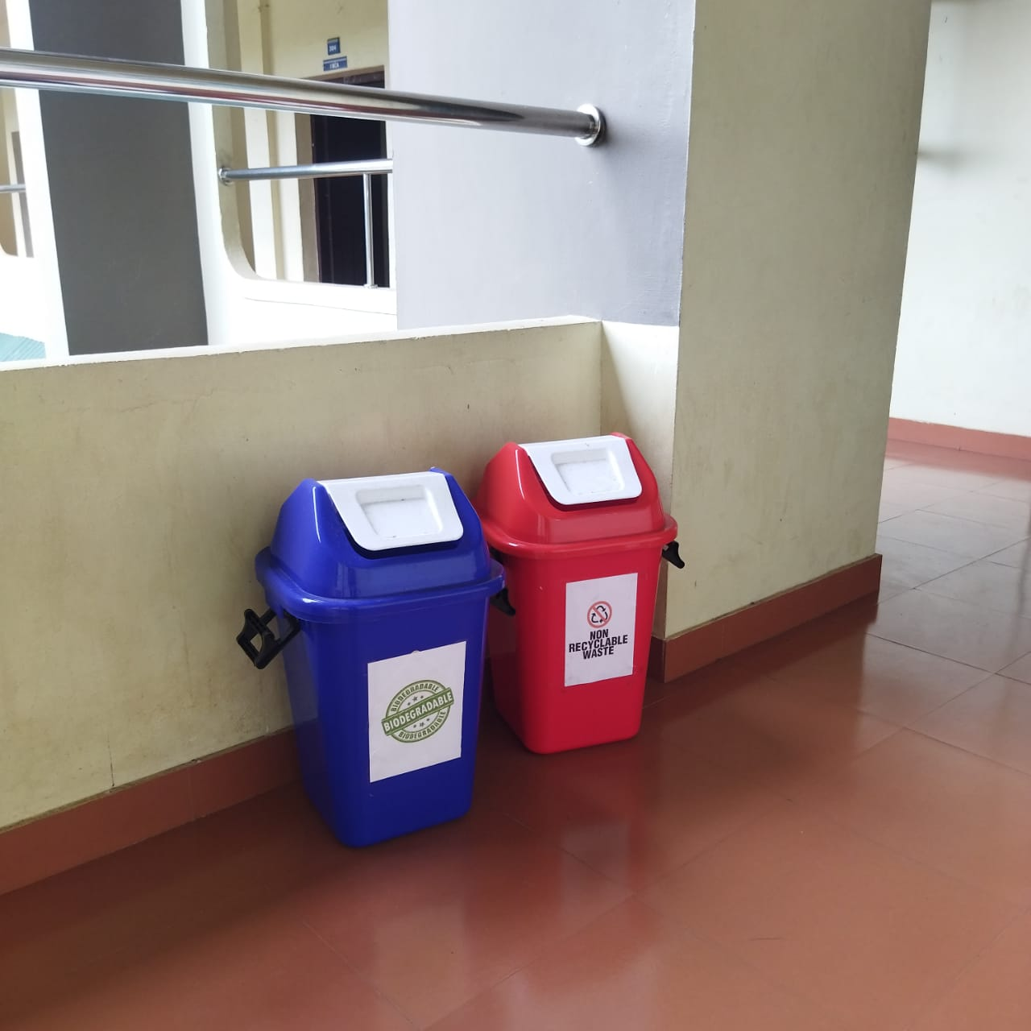

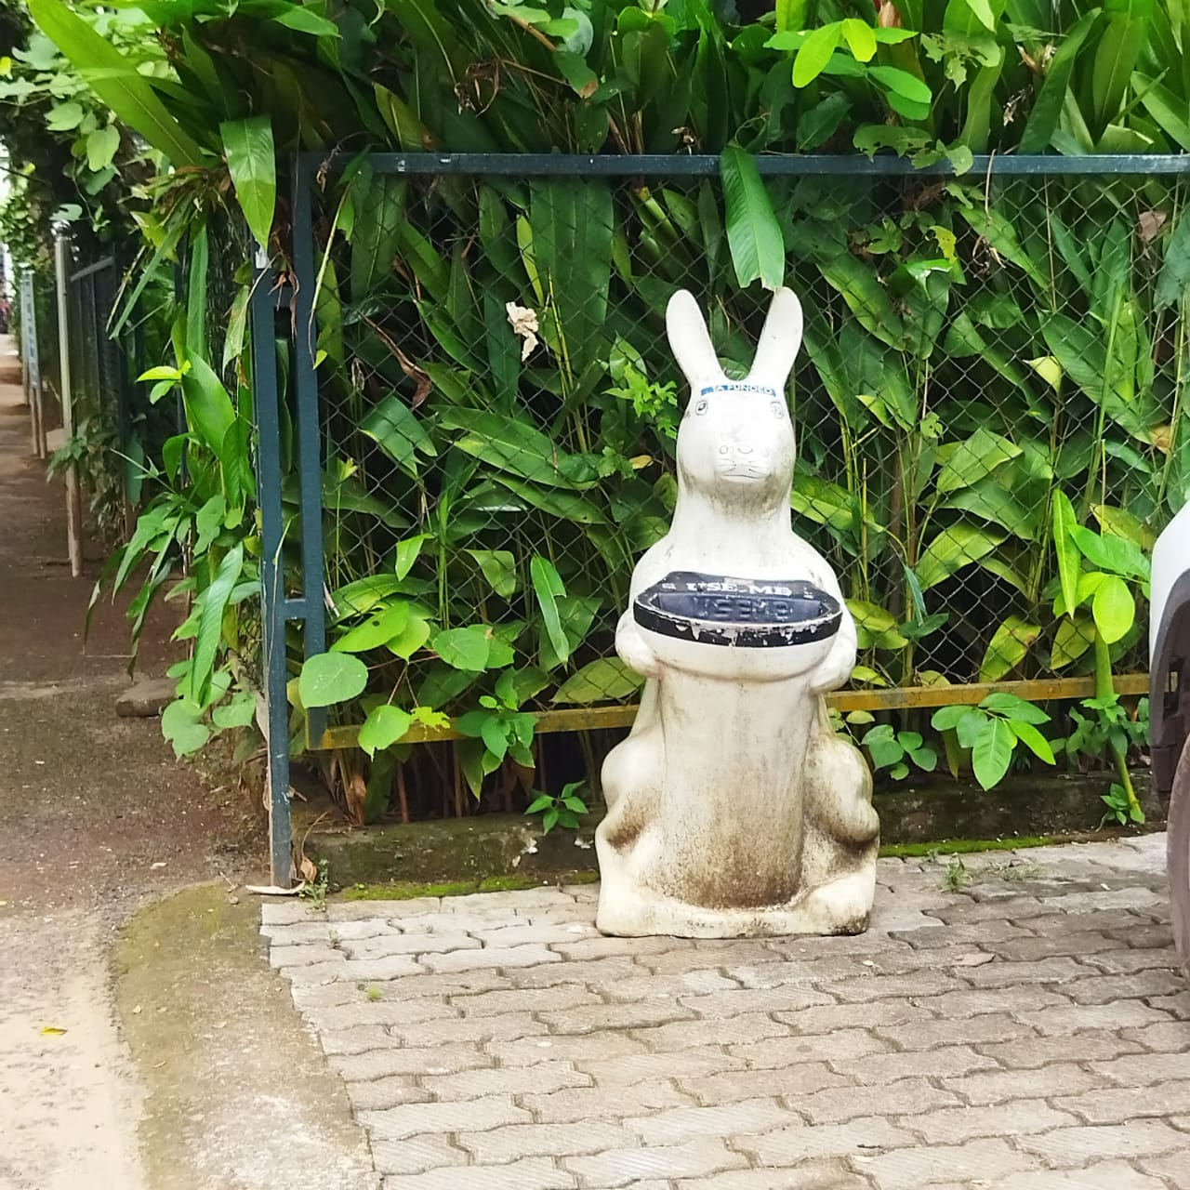

We have introduced colour-coded waste bins across campus to enhance our recycling efforts and promote environmental awareness. Each bin is designated for specific types of waste: blue for recyclables, green for organic waste, and black for general trash. This initiative aims to simplify waste disposal and encourage everyone to contribute to a cleaner, more sustainable campus. Let's work together to make a positive impact!

1. Biogas Unit.

The biogas plant on our campus plays a crucial role in sustainable waste management by converting organic waste into renewable energy. This innovative facility processes food scraps and other biodegradable materials, reducing landfill waste while generating biogas that can be used for cooking or electricity. In addition to minimizing our environmental footprint, the plant educates the campus community about waste reduction and the benefits of renewable energy. By supporting this initiative, we not only promote a cleaner campus but also contribute to a more sustainable future.

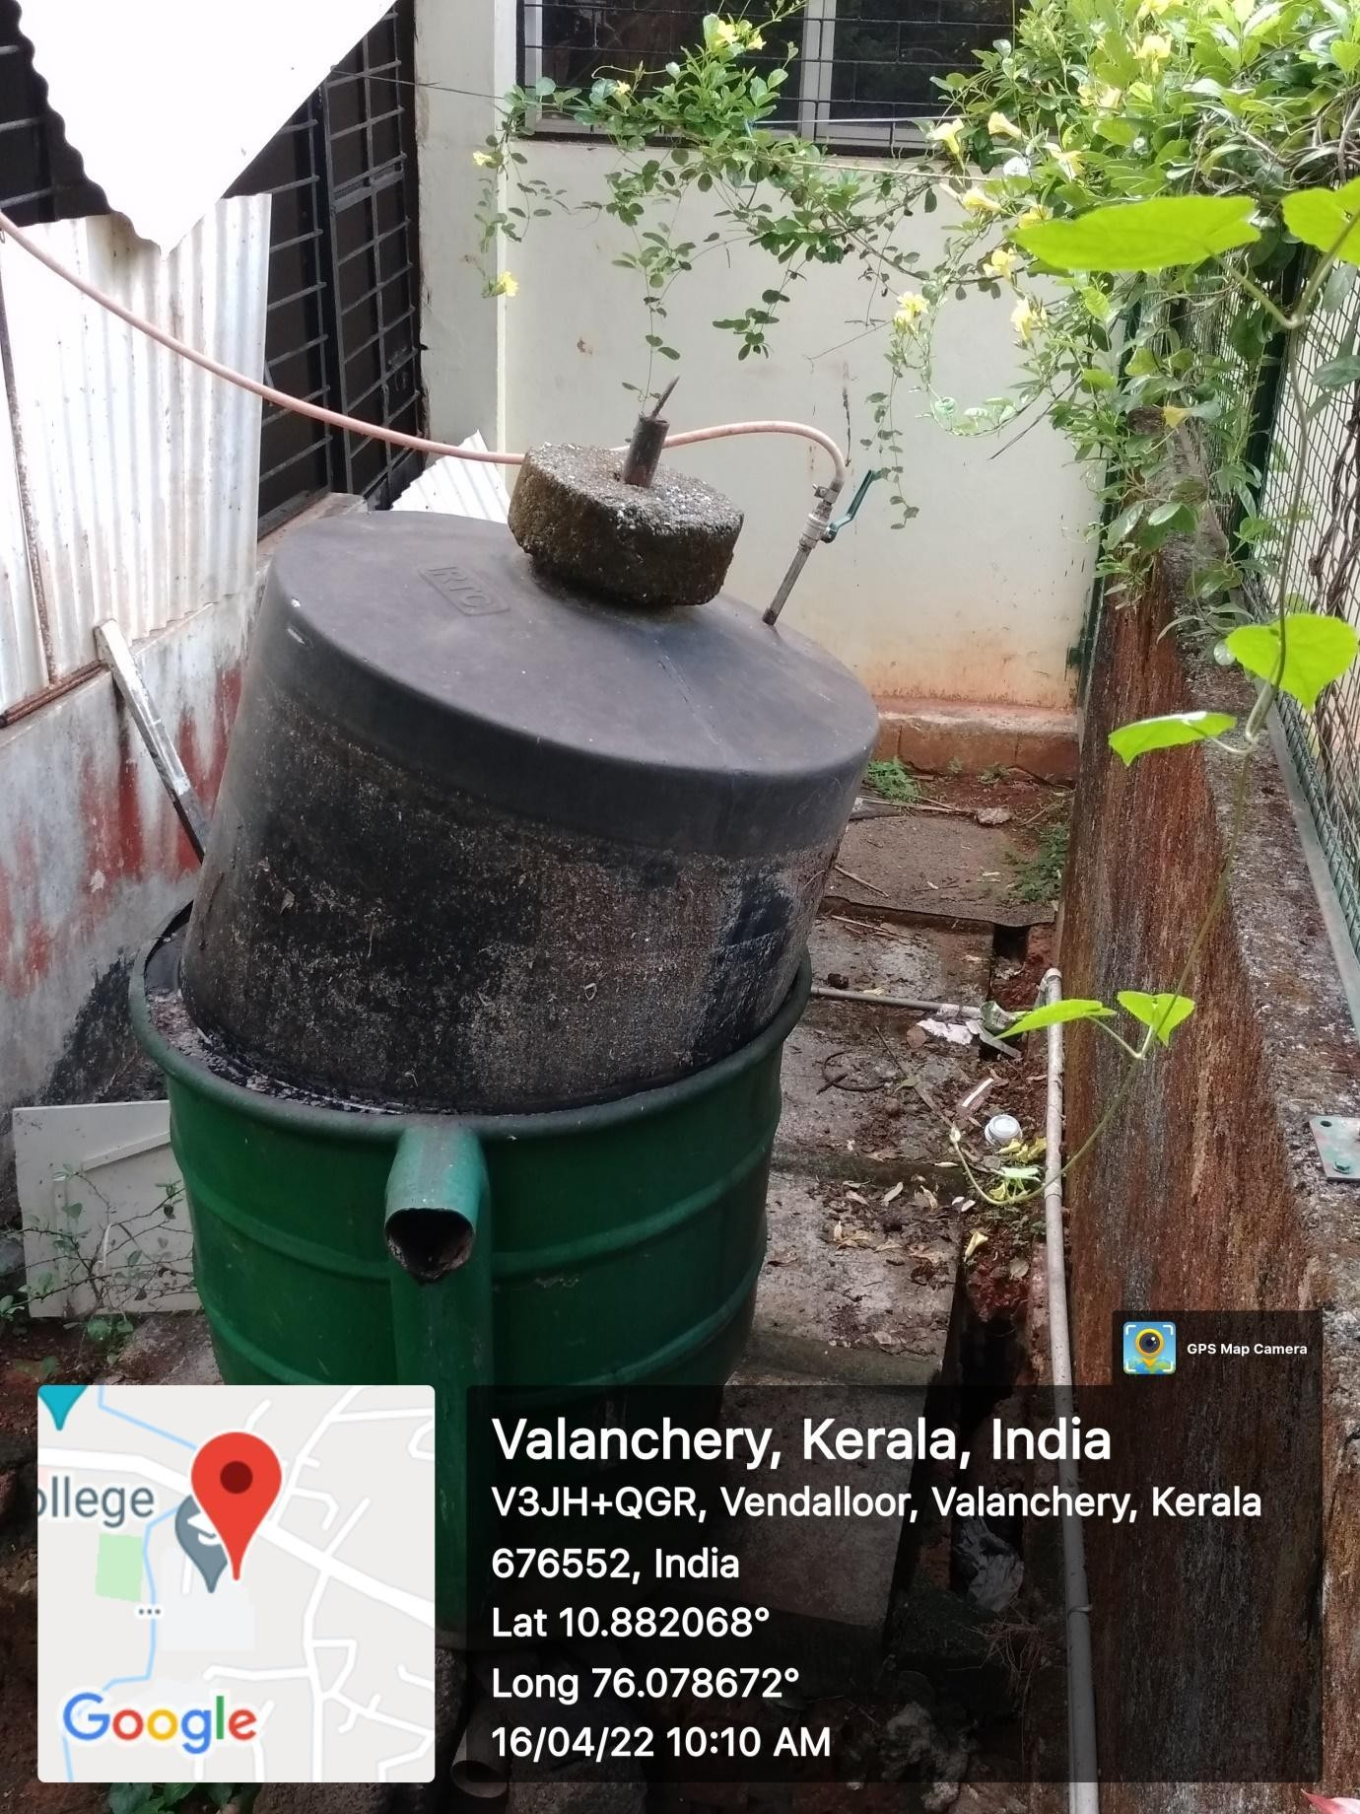

1. Incinerator.

The incinerator installed in our college canteen is essential for efficient waste management, particularly for non-recyclable and hazardous materials. By incinerating waste, we significantly reduce the volume that ends up in landfills, while also minimizing potential environmental hazards associated with improper disposal. This process converts waste into ash and energy, helping to maintain a cleaner and healthier campus environment. Additionally, the incinerator promotes awareness about responsible waste disposal and encourages sustainable practices within our college community.

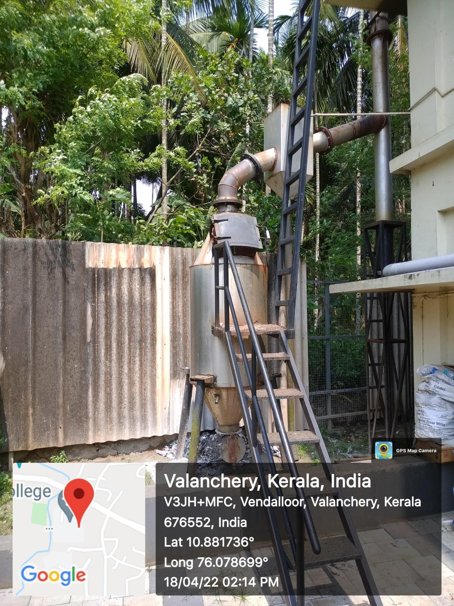

1. Drainage Canal.

The drainage canal on our campus serves a vital purpose in managing excess water and preventing flooding during heavy rainfall. By directing stormwater away from key areas, the canal helps to mitigate potential waterlogging, protecting our facilities and green spaces. This system not only enhances campus safety but also promotes effective water management, reducing the risk of erosion and damage to infrastructure. By maintaining this drainage canal, we ensure a resilient campus environment that can better withstand extreme weather events, contributing to the overall sustainability of our campus.

