**SUPPORTING DOCUMENTS**

The institution has facilities for alternative sources of energy and energy conservation measures.

1. Solar energy.

2. Biogas plant.

3. Wheeling to the Grid.

4. Sensor-based energy conservation.

5. Use of LED Bulbs/Power efficient equipment.

**LIST OF FACILITIES**

|  |  |
| --- | --- |
| Figure No. | Facility |
| 1 | **Alternate sources of Energy** – Solar panel on the roof of the college building |
| 2 | **Energy conservation measures** - Biogas Plant |
| 3 | **Energy conservation measures** - LED Lamps in the office rooms |
| 4 | **Energy conservation measures** - Star rated Refrigerators & Awareness Signs |

**Alternative Energy and Environmental consciousness**

1. **Alternative sources of energy**

The solar panel installation at MES Keveeyam College, Valanchery, underscores the institution’s dedication to sustainability and renewable energy. By harnessing solar power, the college reduces its reliance on conventional energy sources, lowering its carbon emissions and energy costs. This initiative not only supports the environment but also educates students on the importance of adopting clean energy solutions for a greener future. The work is in progress the solar panel installation and the work is in progress to wheeling the grid.

1. **Energy Conservation Measures**

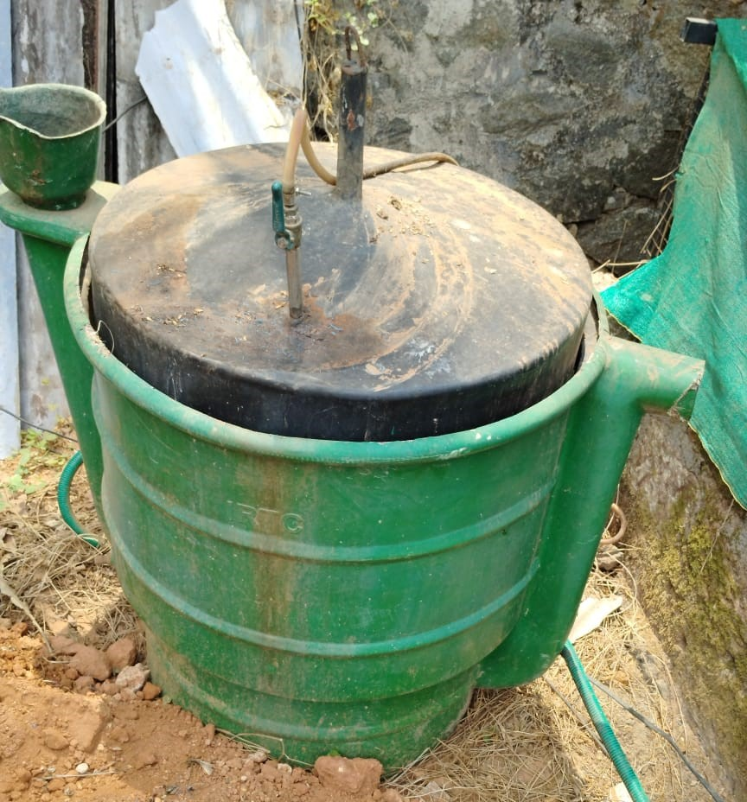



***Fig 2 and 3- Biogas Plant***

The biogas plant at MES Keveeyam College, Valanchery, serves as a vital component of the institution's commitment to sustainable development and environmental conservation. By utilizing organic waste generated on campus, the plant not only reduces the college's carbon footprint but also provides a renewable source of energy. This initiative promotes eco-friendly practices among students and staff, fostering awareness about waste management and clean energy solutions, while contributing to the college’s green campus initiatives.

At MES Keveeyam College, Valanchery, the adoption of LED bulbs and lights throughout the campus reflects our commitment to energy efficiency and sustainability. LED lighting not only consumes significantly less energy compared to traditional bulbs, but it also has a longer lifespan, reducing maintenance costs and waste. This initiative contributes to lower electricity bills, minimizes our environmental impact, and creates a well-lit, conducive learning environment for students and staff. By prioritizing LED technology, the college sets a benchmark for eco-friendly practices in educational institutions.

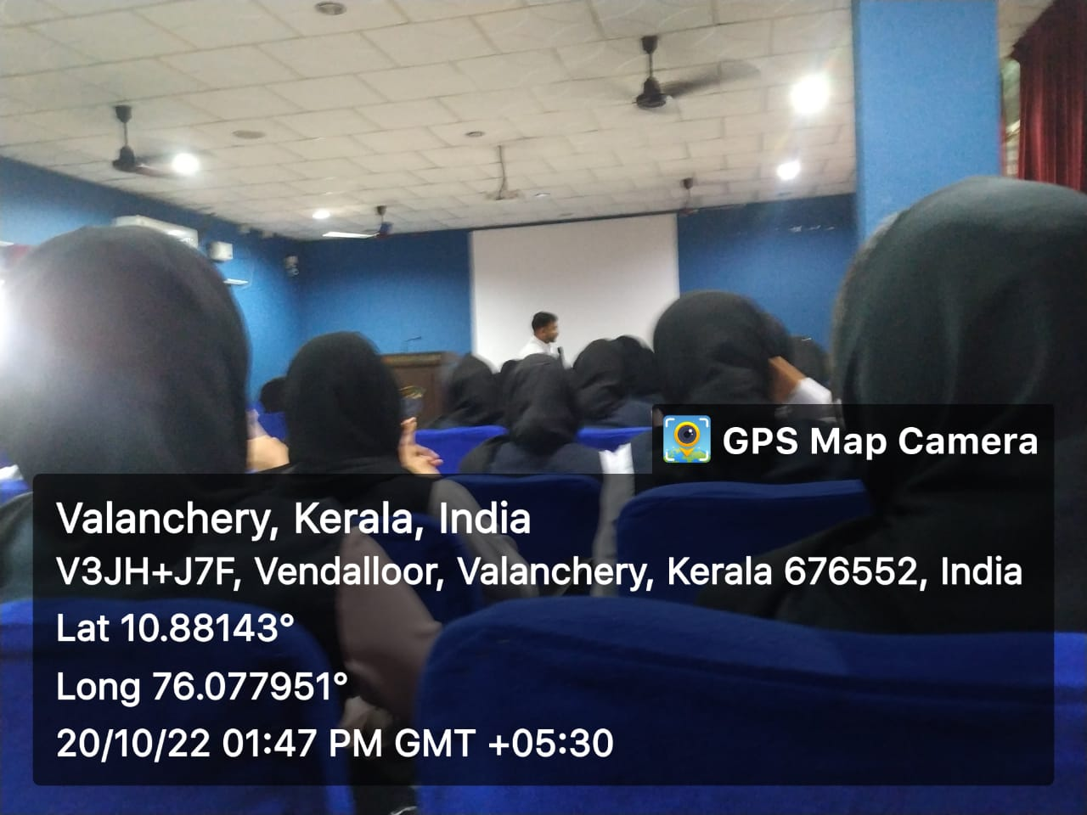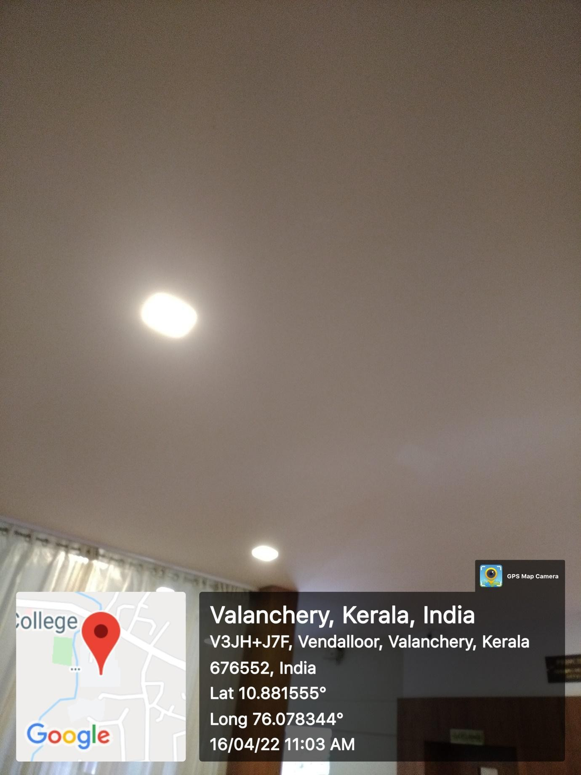



***Fig 4 and 5 – Sensor Lights and LED Bulbs in the College***

MES Keveeyam College, Valanchery, is dedicated to energy conservation through the strategic use of 5-star rated refrigerators and air conditioners, ensuring maximum efficiency and minimal energy consumption. Additionally, awareness boards are prominently displayed near switch boxes, encouraging students and staff to switch off appliances when not in use. These measures not only reduce energy waste but also promote a culture of sustainability within the campus. By prioritizing energy-efficient appliances and fostering mindful usage, the college actively contributes to a greener environment and sets an example for responsible energy management.

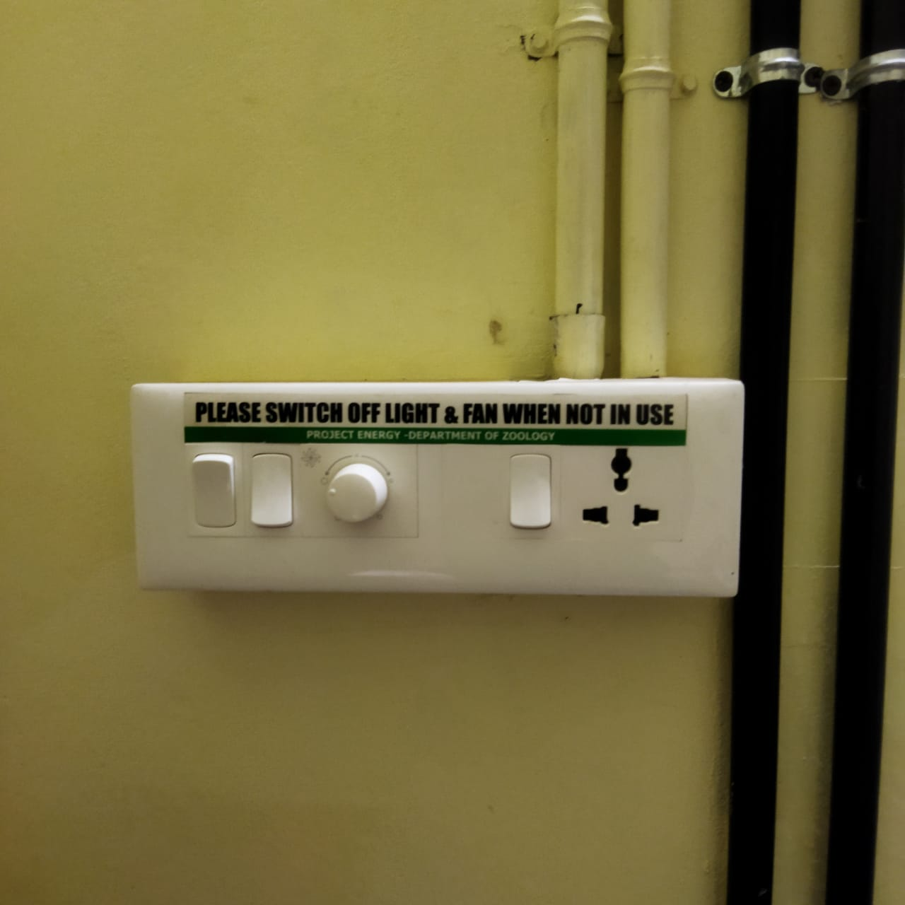

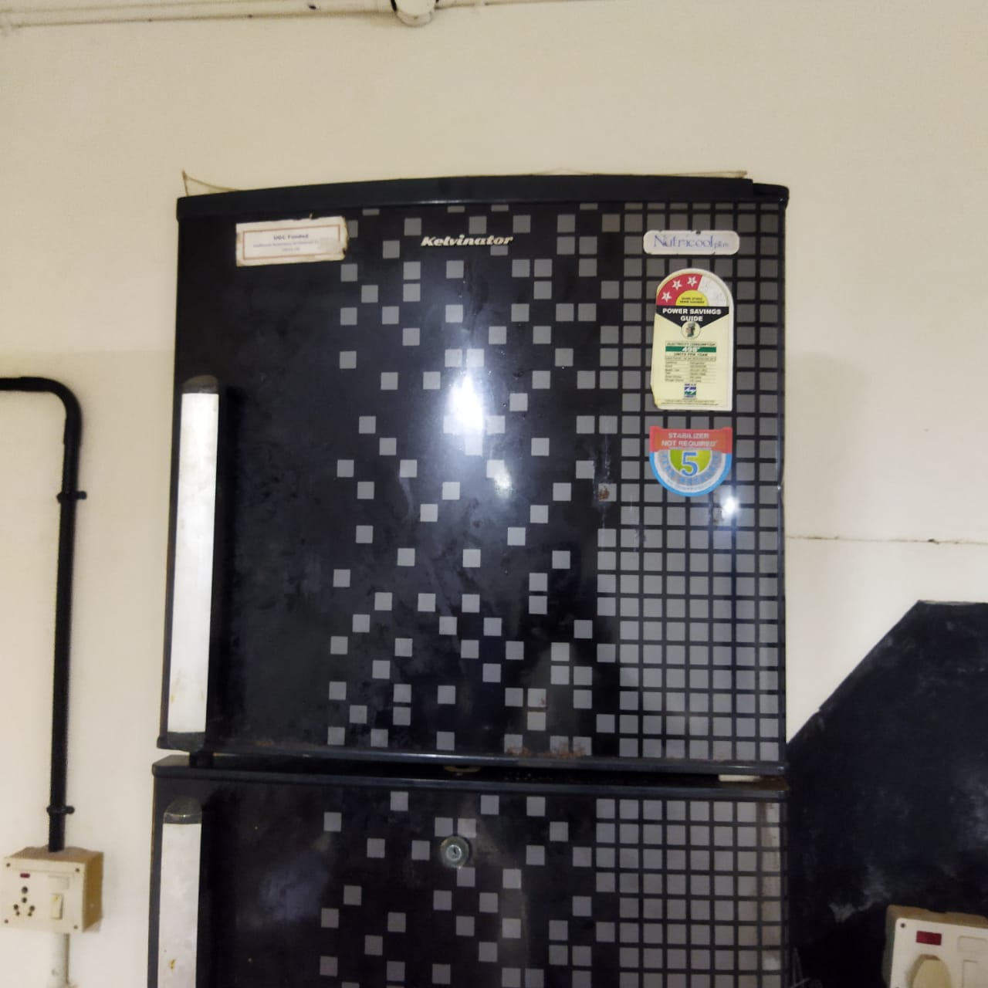

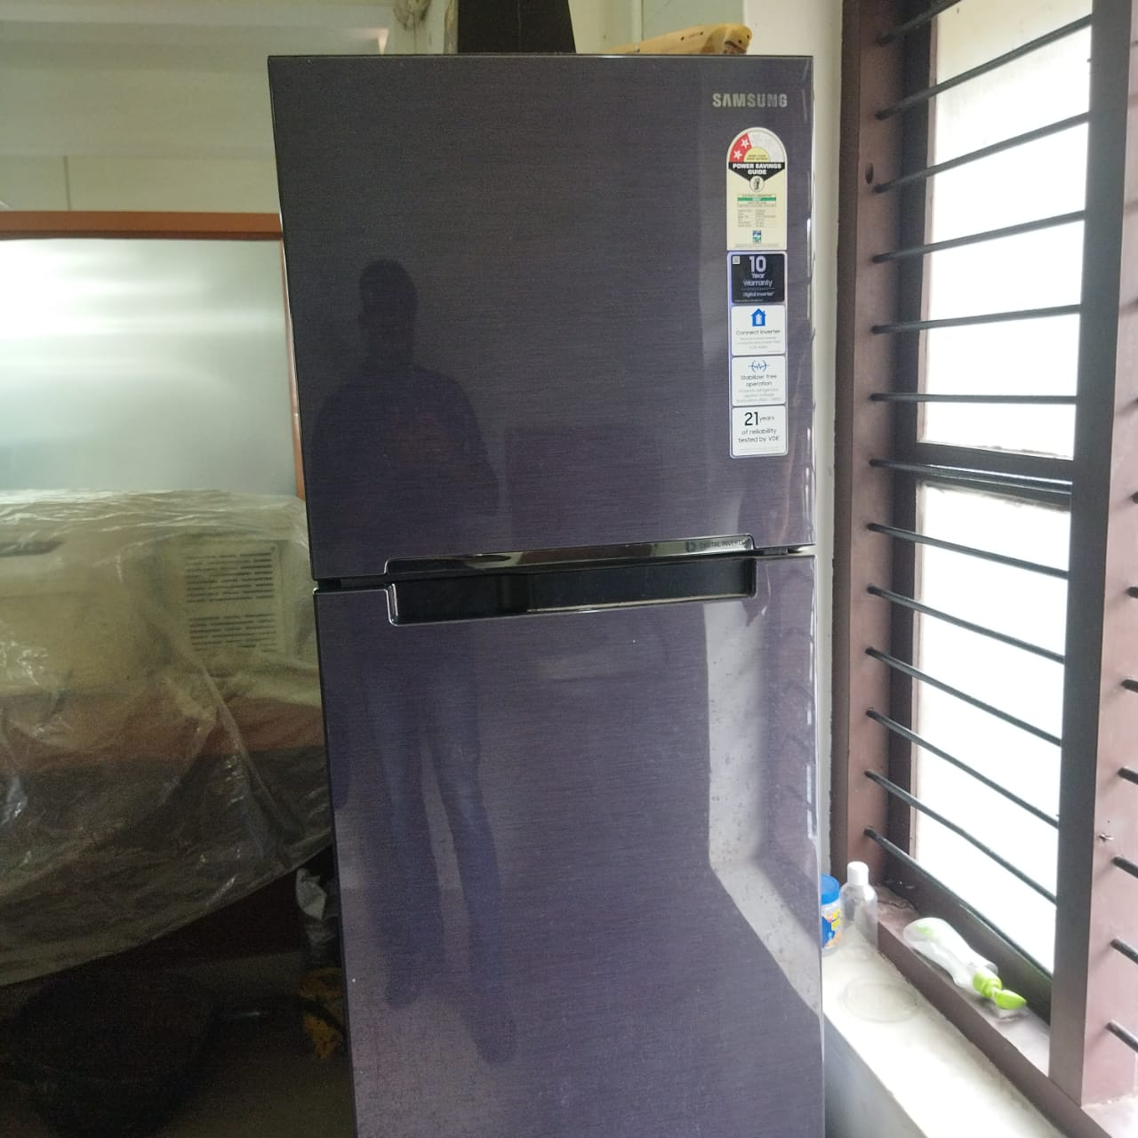

***Fig 6- Awareness Sign***

***Fig 7- Star rated Refrigerator***

***Fig 6- Star rated Refrigerator***