7.1.2 – The institution has facilities for alternative sources of energy and energy conservation measures.

1. Solar energy.

2. Biogas plant.

3. Wheeling to the Grid.

4. Sensor-based energy conservation.

5. Use of LED Bulbs/Power efficient equipment.

**LIST OF PROGRAMMES**

|  |  |
| --- | --- |
| **Sl No.** | **Programmes** |
| 1 | Observation of National Pollution Control Day |
| 2 | Observation of National energy conservation |
| 3 | Energy Auditing |

**ENERGY CONSERVATION PROGRAMMES**

**Observation of National Pollution Control Day on 02.12.2022**

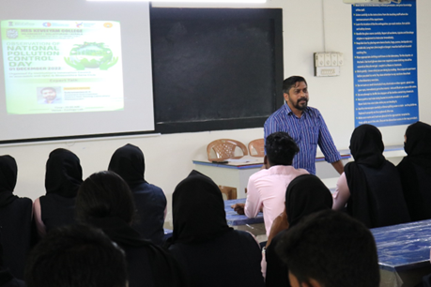

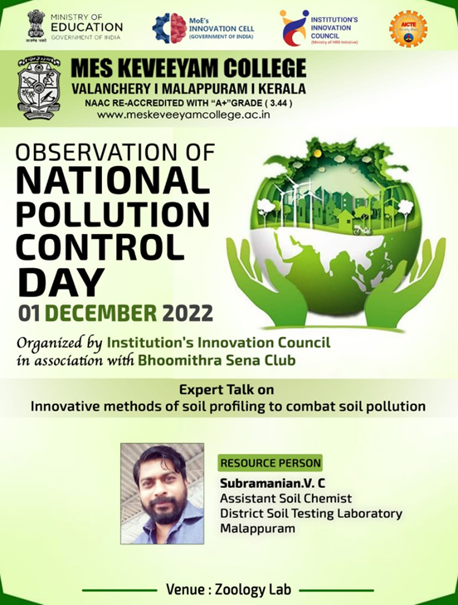



National Pollution Control Day was observed by the IIC in collaboration with the IQAC and Bhoomithra Sena Club at MES Keveeyam College, Valanchery, on December 1st and 2nd, 2022. The event featured an expert talk by Mr. Subramanian V. C., Assistant Soil Chemist at the District Soil Testing Laboratory, Malappuram, on December 1st. He discussed the crucial role of soil in the ecosystem, the various ways soil is polluted, and innovative soil profiling and testing methods to assess pollution levels. He highlighted the impact of soil testing on agriculture and the extension programs available for farmers. On December 2nd, an Idea Hunt was conducted through a Google form to gather innovative ideas from students and faculty on simple, actionable ways to combat pollution, attracting 116 participants who shared their valuable insights

**Observation of National energy conservation day on 14.12.2022**

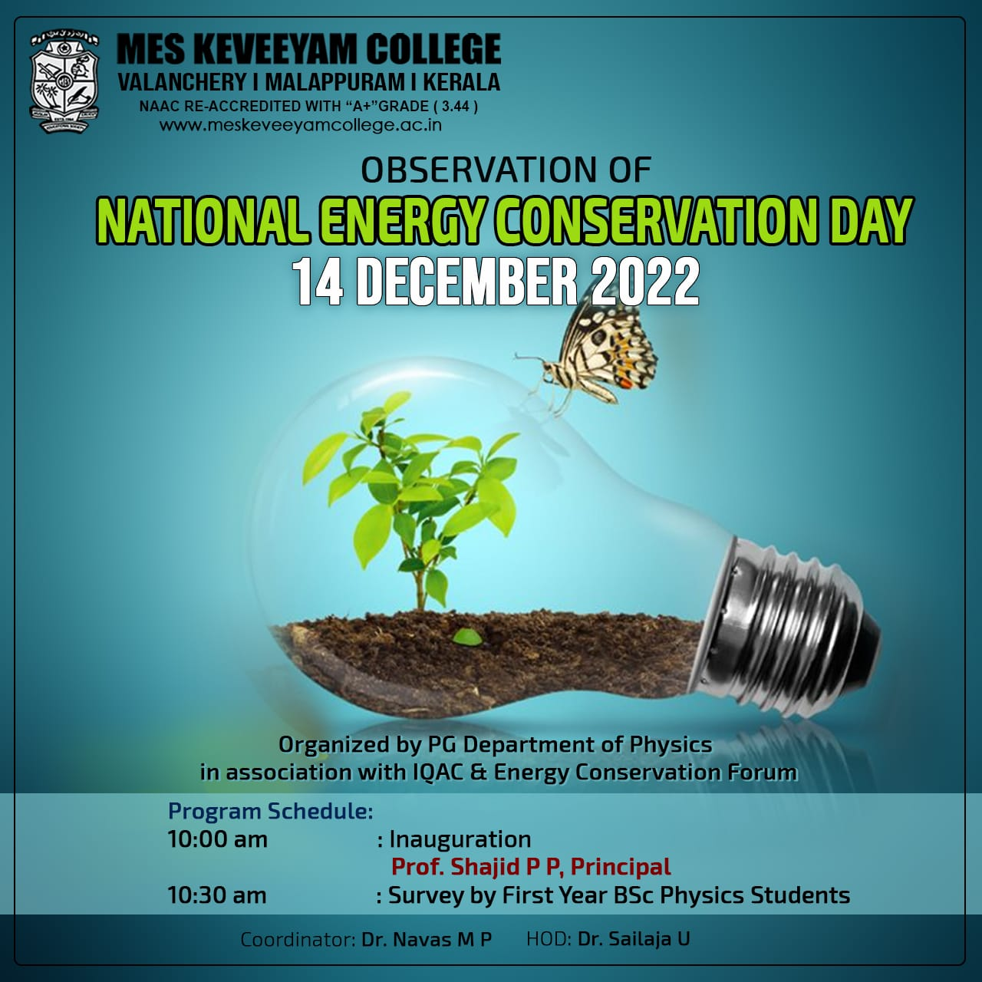

On December 14, 2022, the PG Department of Physics at MES Keveeyam College, Valanchery, conducted an Energy Conservation and Awareness Survey in celebration of National Energy Conservation Day. The program was inaugurated by Principal Prof. Shajid PP, who emphasized the critical importance of energy conservation in today's world. The survey aimed to gauge the awareness levels among students and staff regarding energy-saving practices and to promote sustainable habits within the college community. Participants were encouraged to share their insights on energy usage and conservation strategies, fostering a culture of environmental responsibility. This initiative not only highlights the college's commitment to sustainability but also aims to educate the community on the significance of conserving energy for a greener future. The results of the survey will help inform future programs and initiatives aimed at reducing energy consumption on campus.