**MES KEVEEYAM COLLEGE VALANCHERY**

**STUDENTS PARTICIPATION IN CULTURAL EVENTS AND SPORTS**

REPORT OF ARTS FESTIVAL 2023

The annual arts festival “Thakathimi” held from 30/01/2023 to 03/02/2023 at MES KEVEEYAM college valanchery was a vibrant showcase of the diverse talents of students in various departments. The event inaugurated by the chief guest Noorjaleela ,motivating the students to embrace and celebrate their creativity. Over the course of two days, the arts fest featured a wide array of competitions including classical and folk dance, solo and group singing, drama, skit, mime, oppana, thiruvathira recitation, elocution, visual arts such as painting and sculptures.

The competition were intense, and after spirited performances, the department of chemistry emerged as overall champion. While the department of physics secured the second prize. The arts fest concluded with an inspiring closing ceremony, where Principal Vinod Kumar congratulated all participants and winners. Certificates and trophies were awarded. Thakathimi 2023 was not only a celebration of talent but also memorable event that fostered connection, expression and inspiration among students ,marking a significant highlight in the college’s cultural calender.

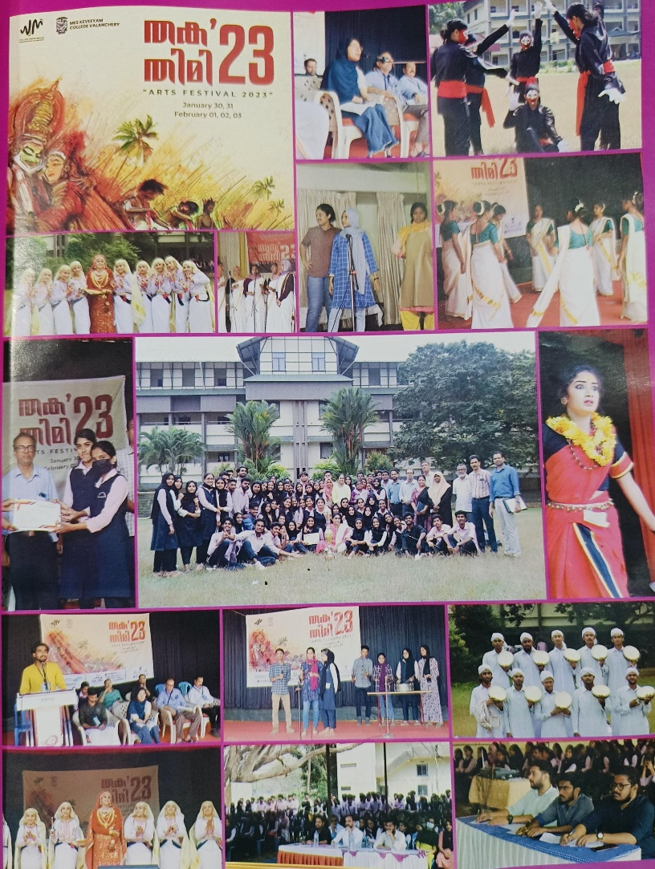

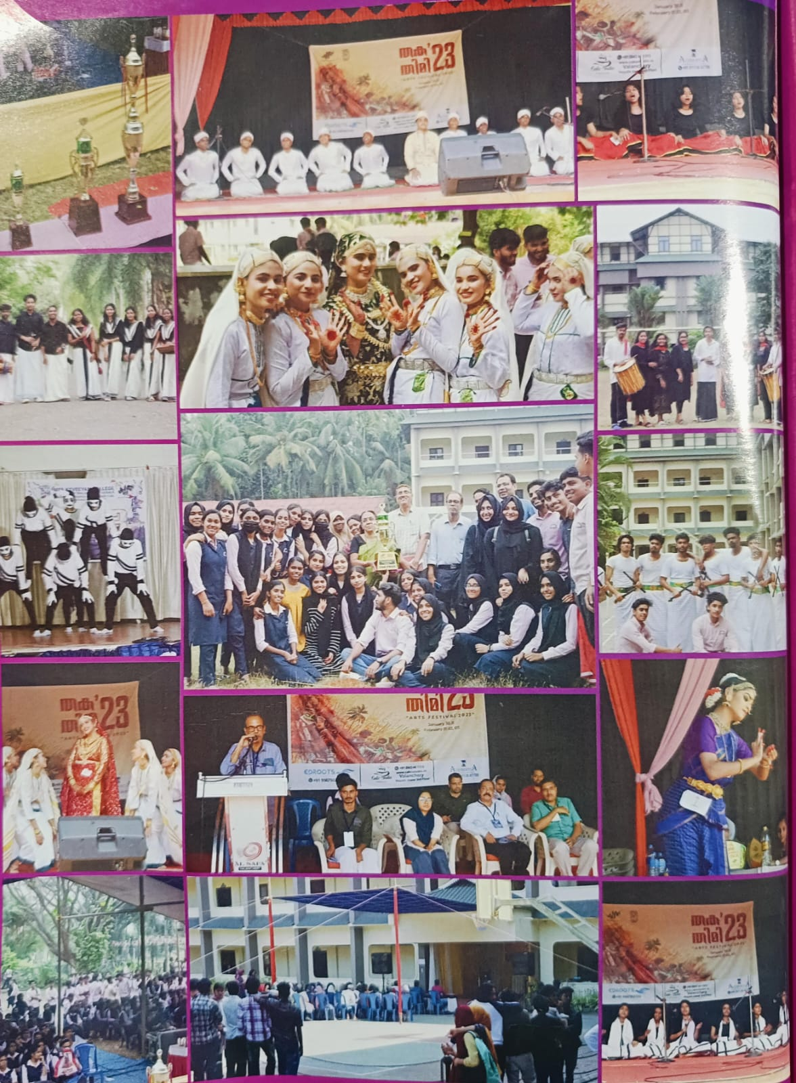

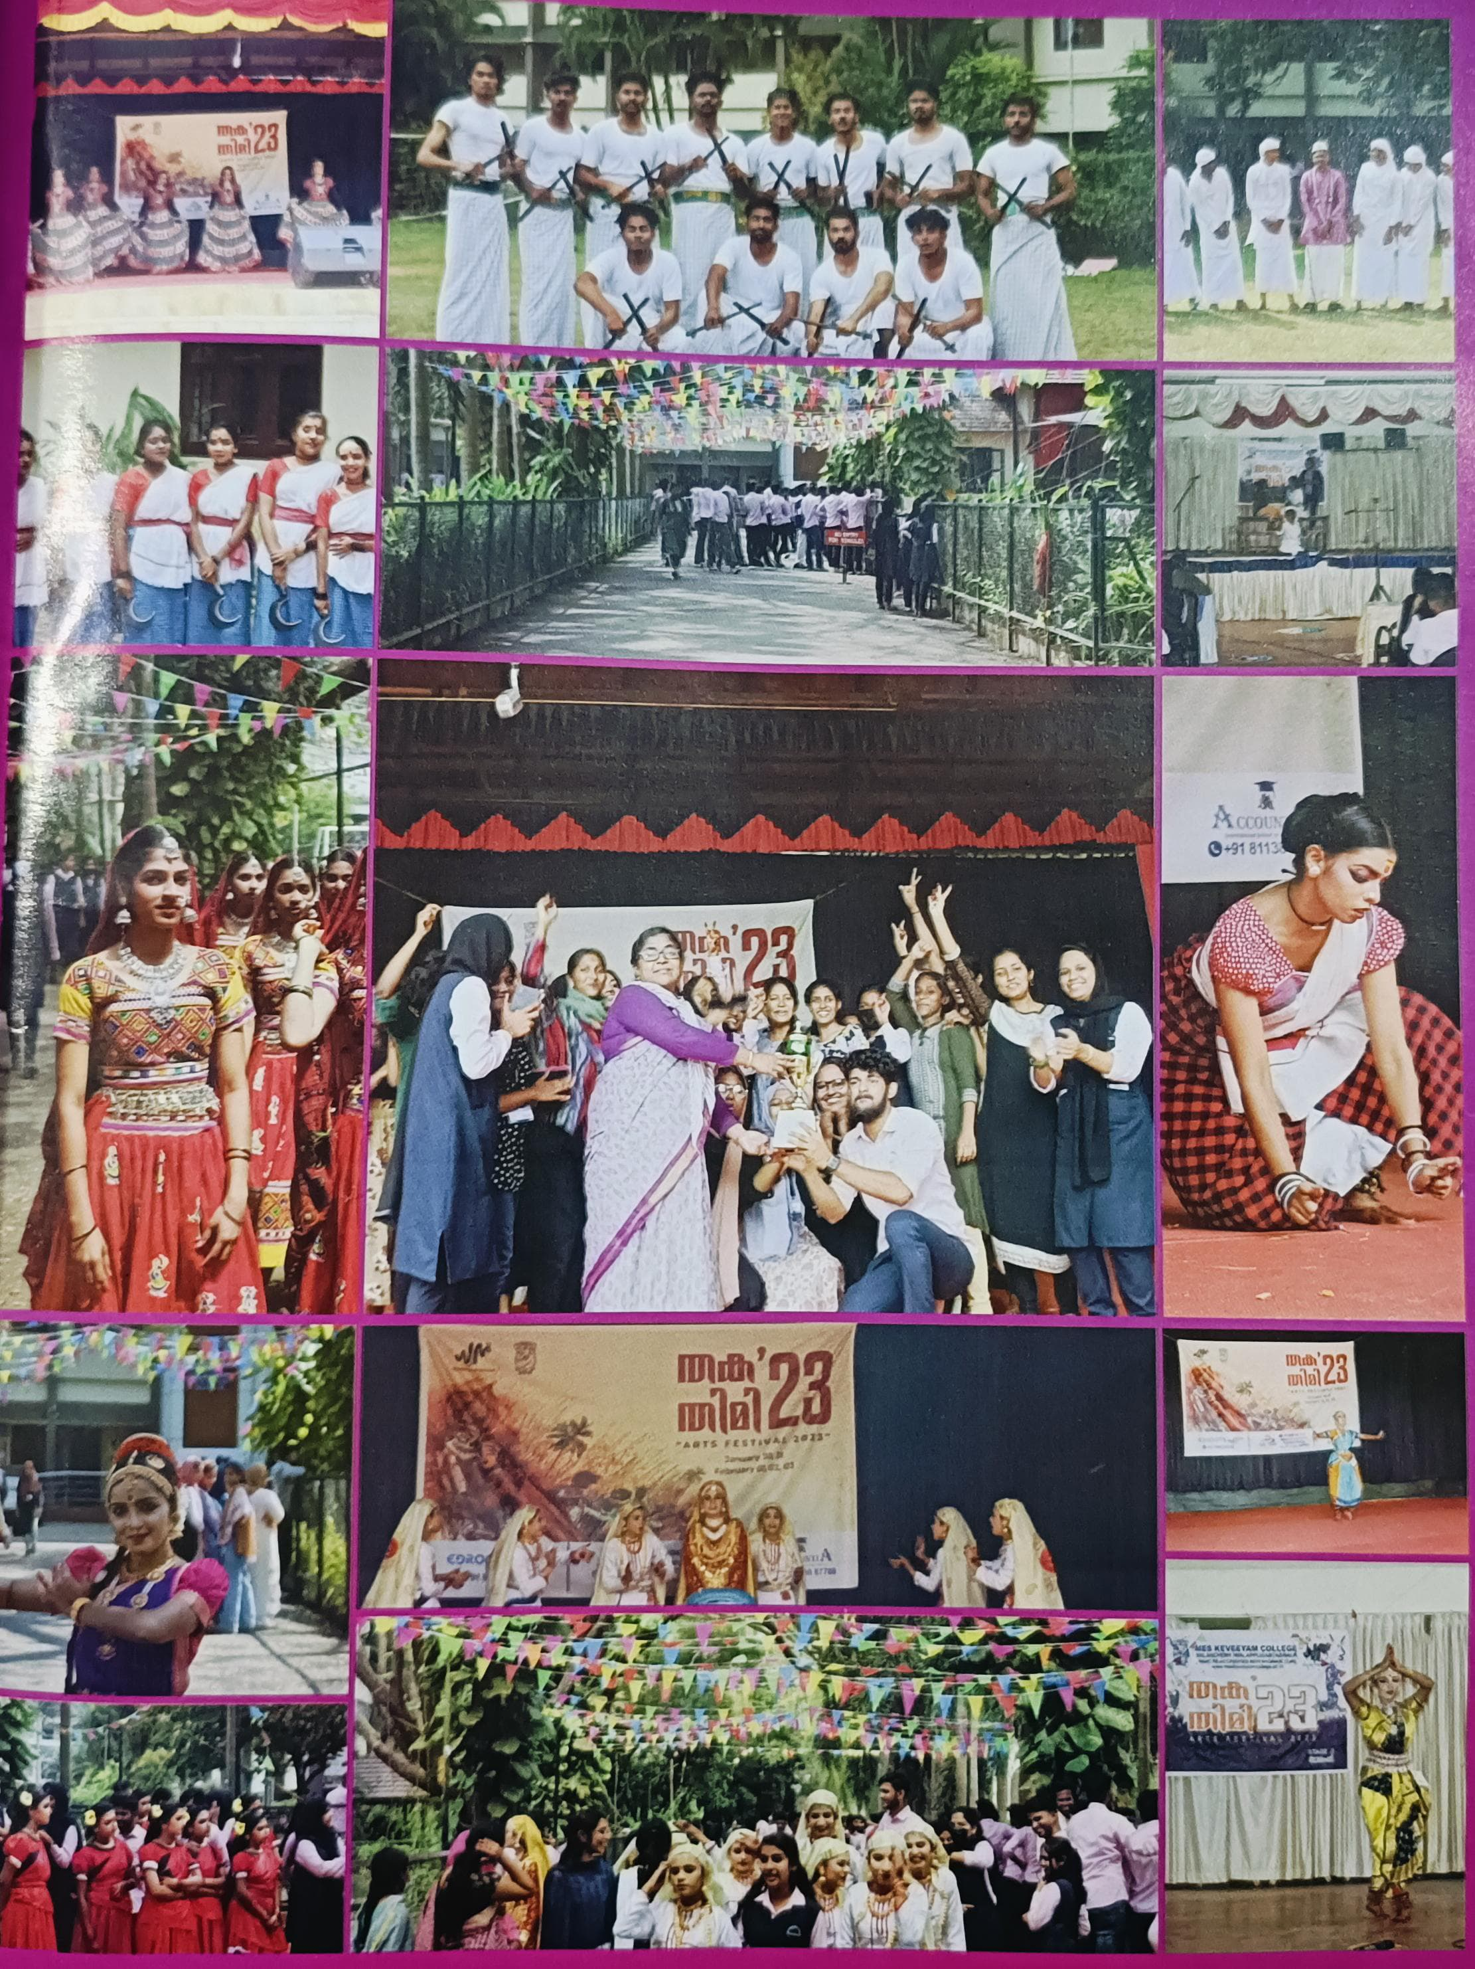

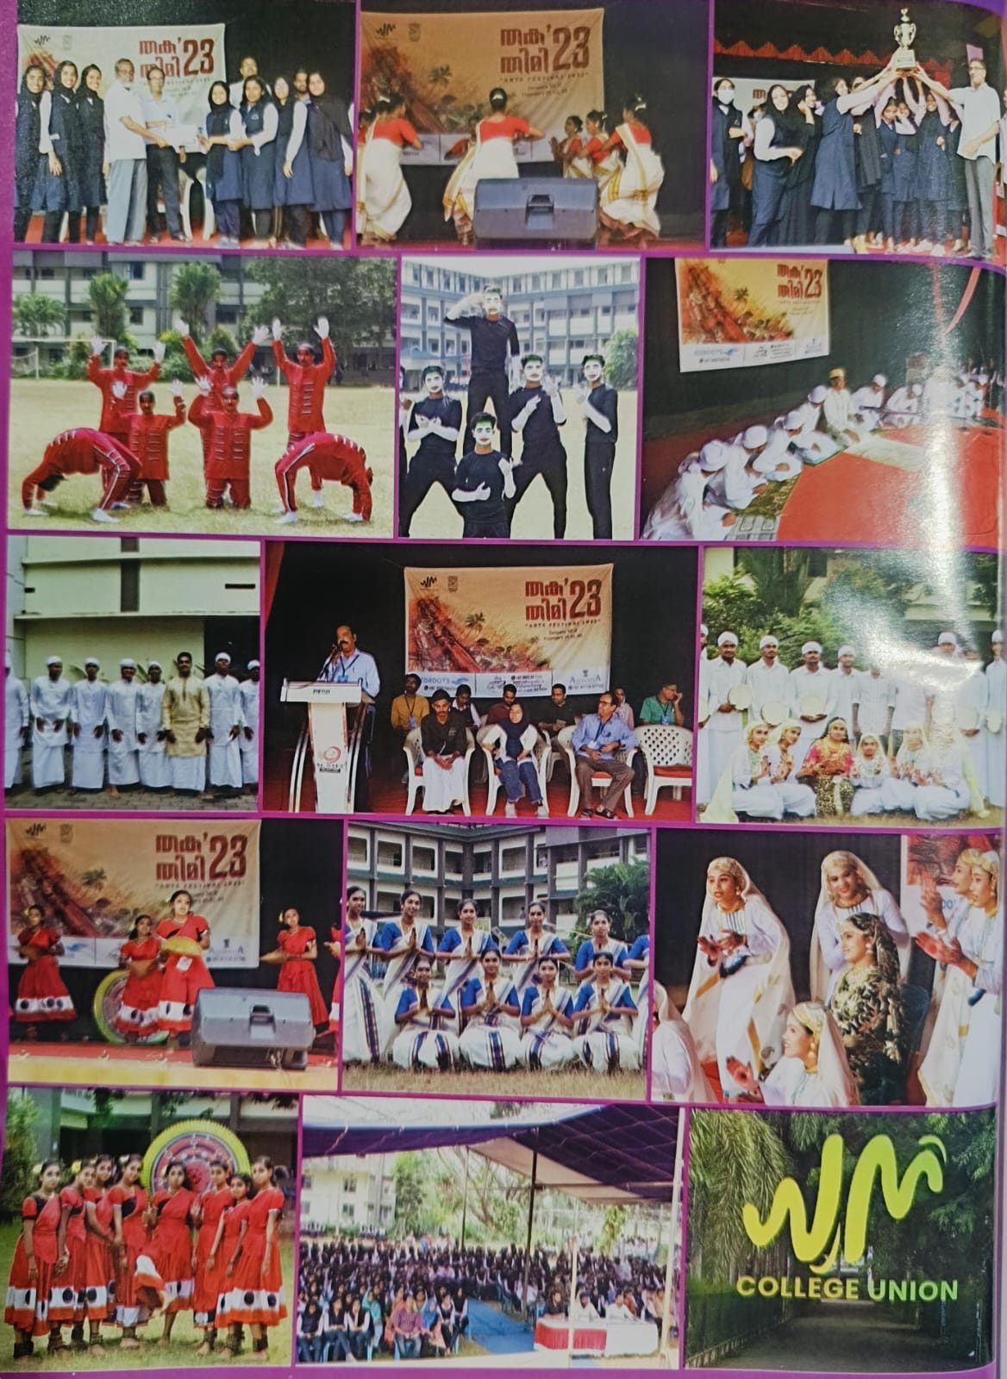

REPORT OF ANNUAL SPORTS 2023

The annual sports day, ATHLETICS 2023 at MES KEVEEYAM college valanchery was celebrated with great enthusiasm and high level of participatin,fostering team spirit and a competitive atmosphere among students. The event was officially inaugurated by Satheevan Balan, Football coach Santhosh trophy Kerala.

The day was filled with a range of sports competitions and athletic events, showcasing the students’ versatility and dedication. Track events like the 100m, 200m, and relay races were highlights of the day, along with field events such as long jump, high jump, shot put, and discus throw. Each event saw fierce competition, with athletes giving their best performances.at the end of the event, winners were awarded for their outstanding achievements. The First Prize for overall performance was secured by the Department of B.Voc Retail management, who excelled in both track and field events. The Department of Chemistry secured the Second Prize

